**PROJECT PROGRESS WITH SCREENSHOTS:**

1. **Terraform Script to Create EC2 Instance for Jenkins, Docker, and SonarQube:**

**Create User in IAM:**

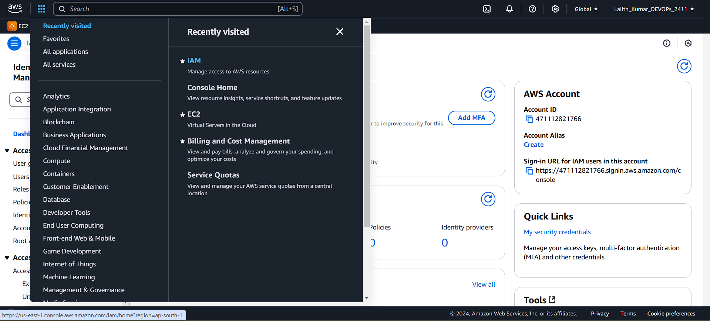

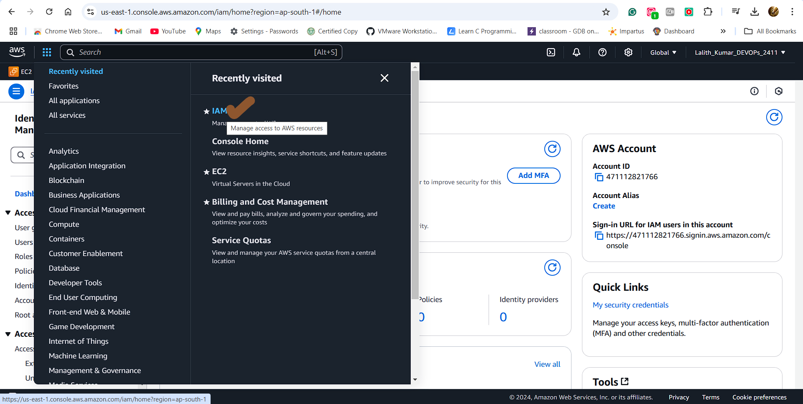

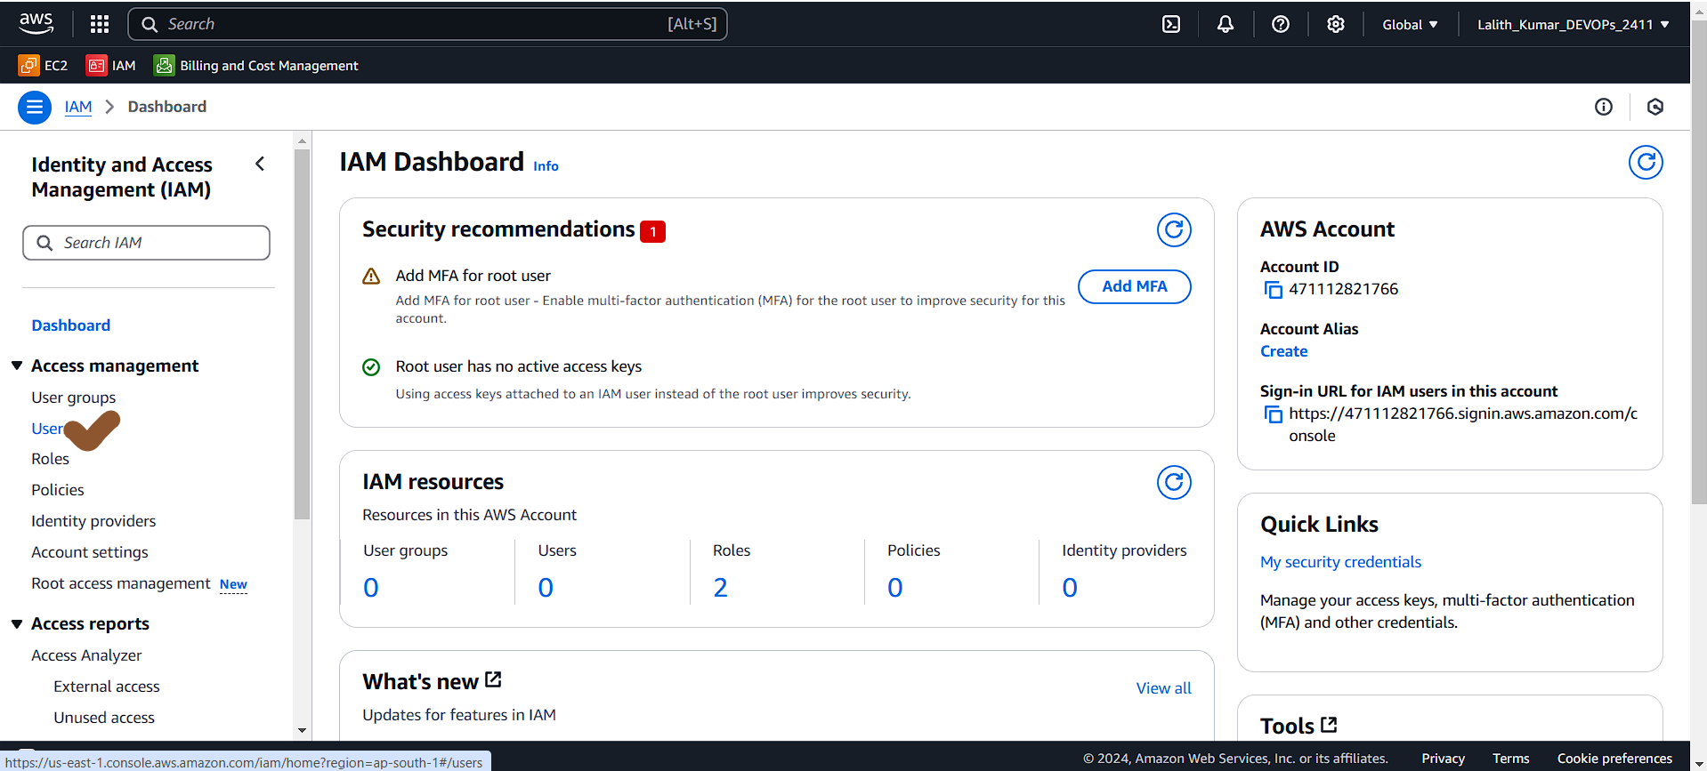

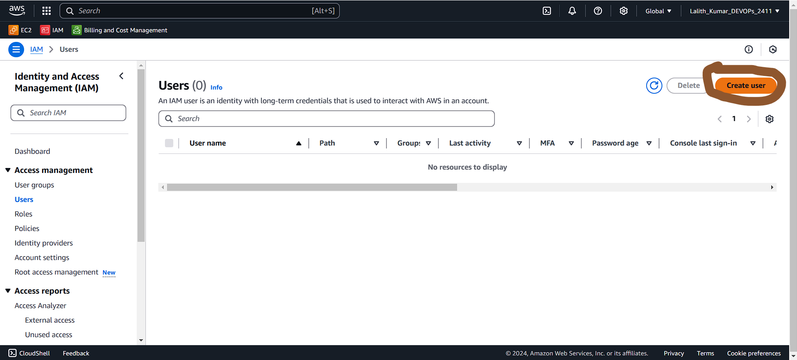

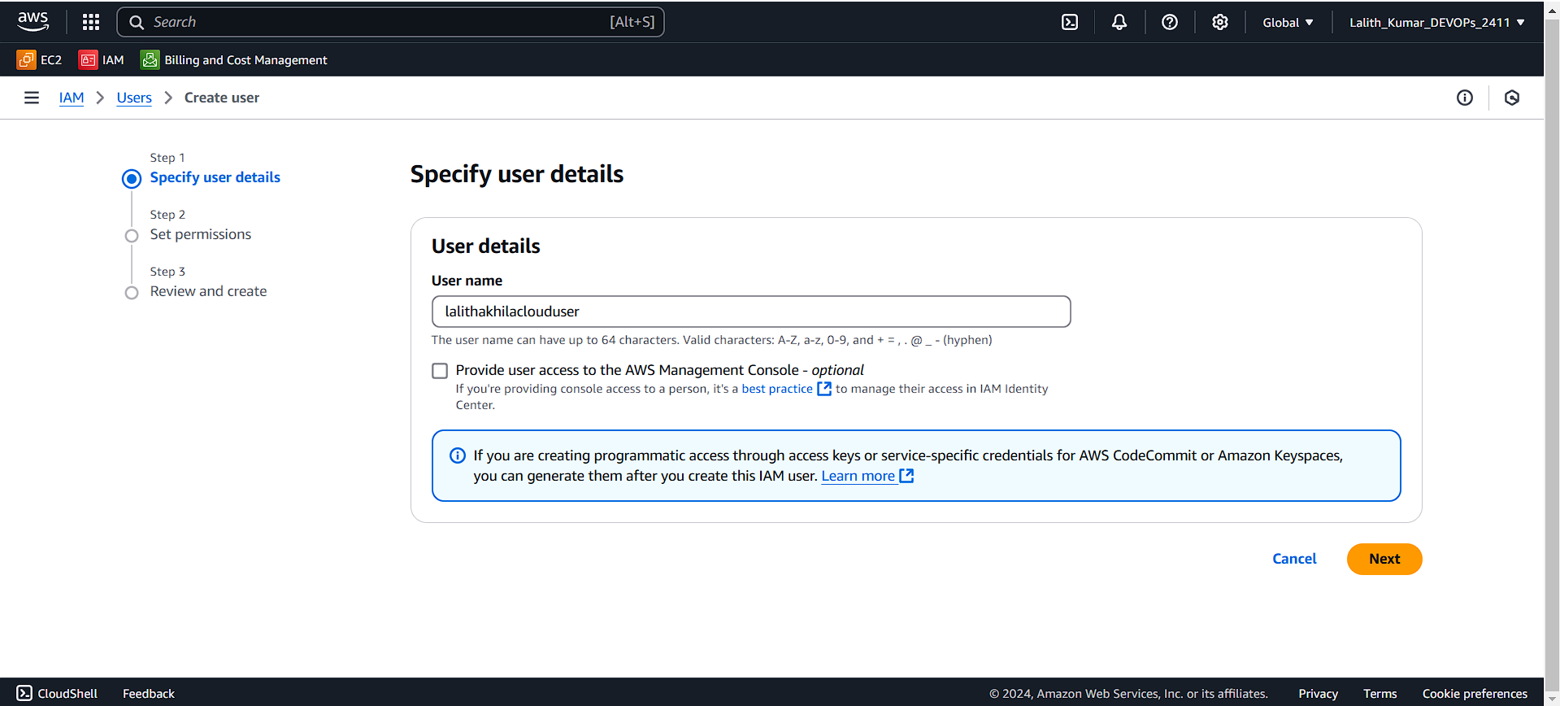

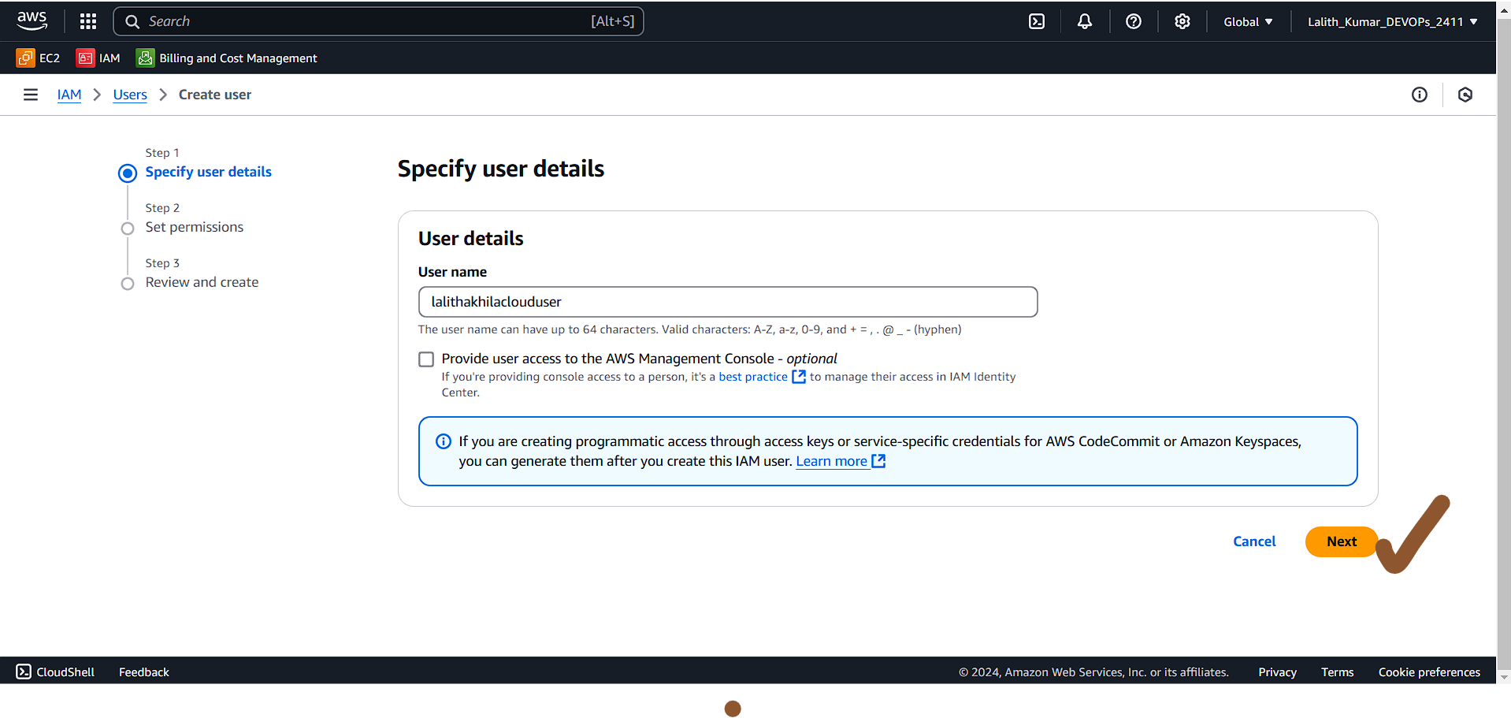

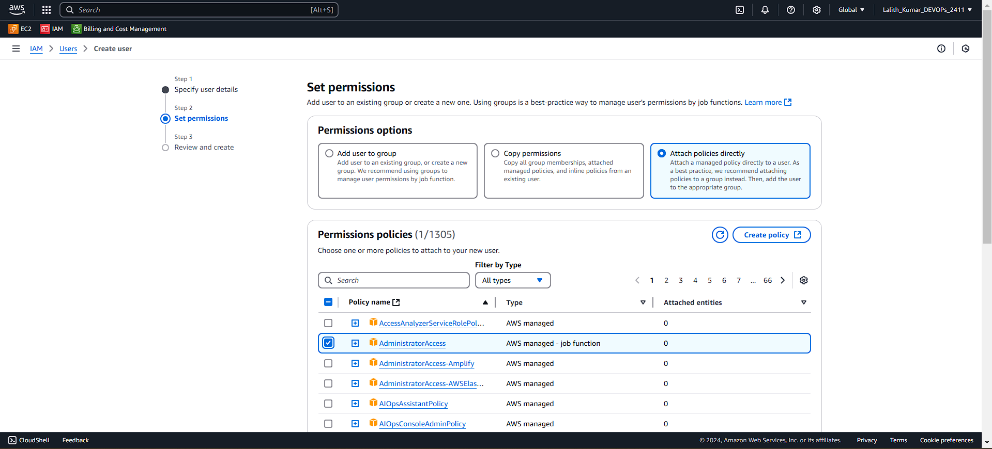

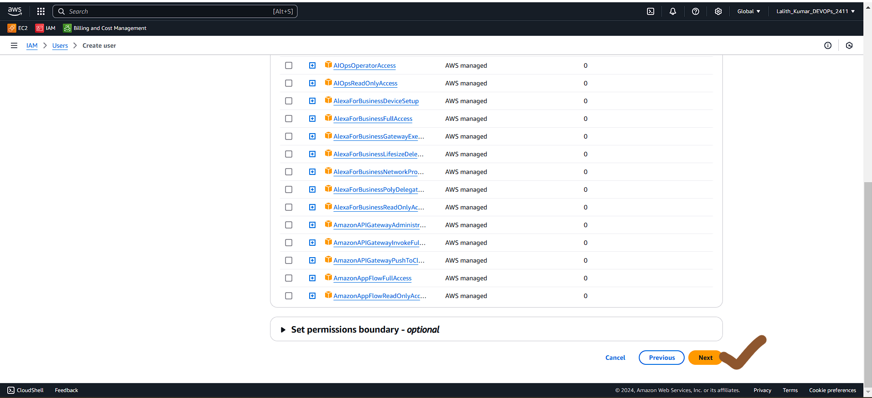

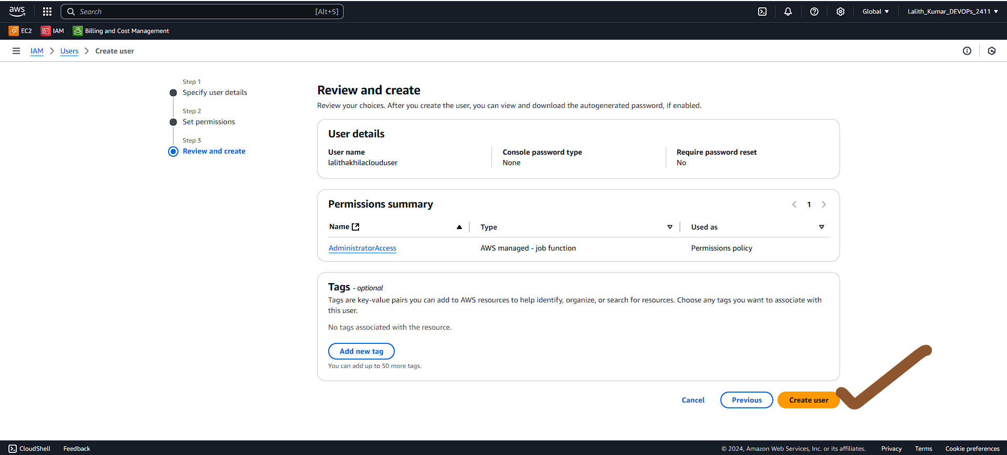

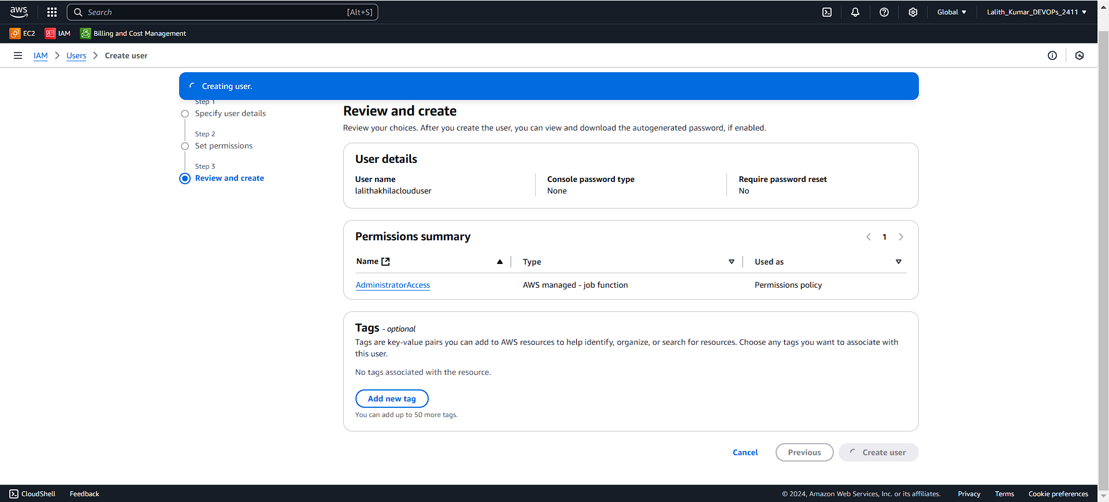

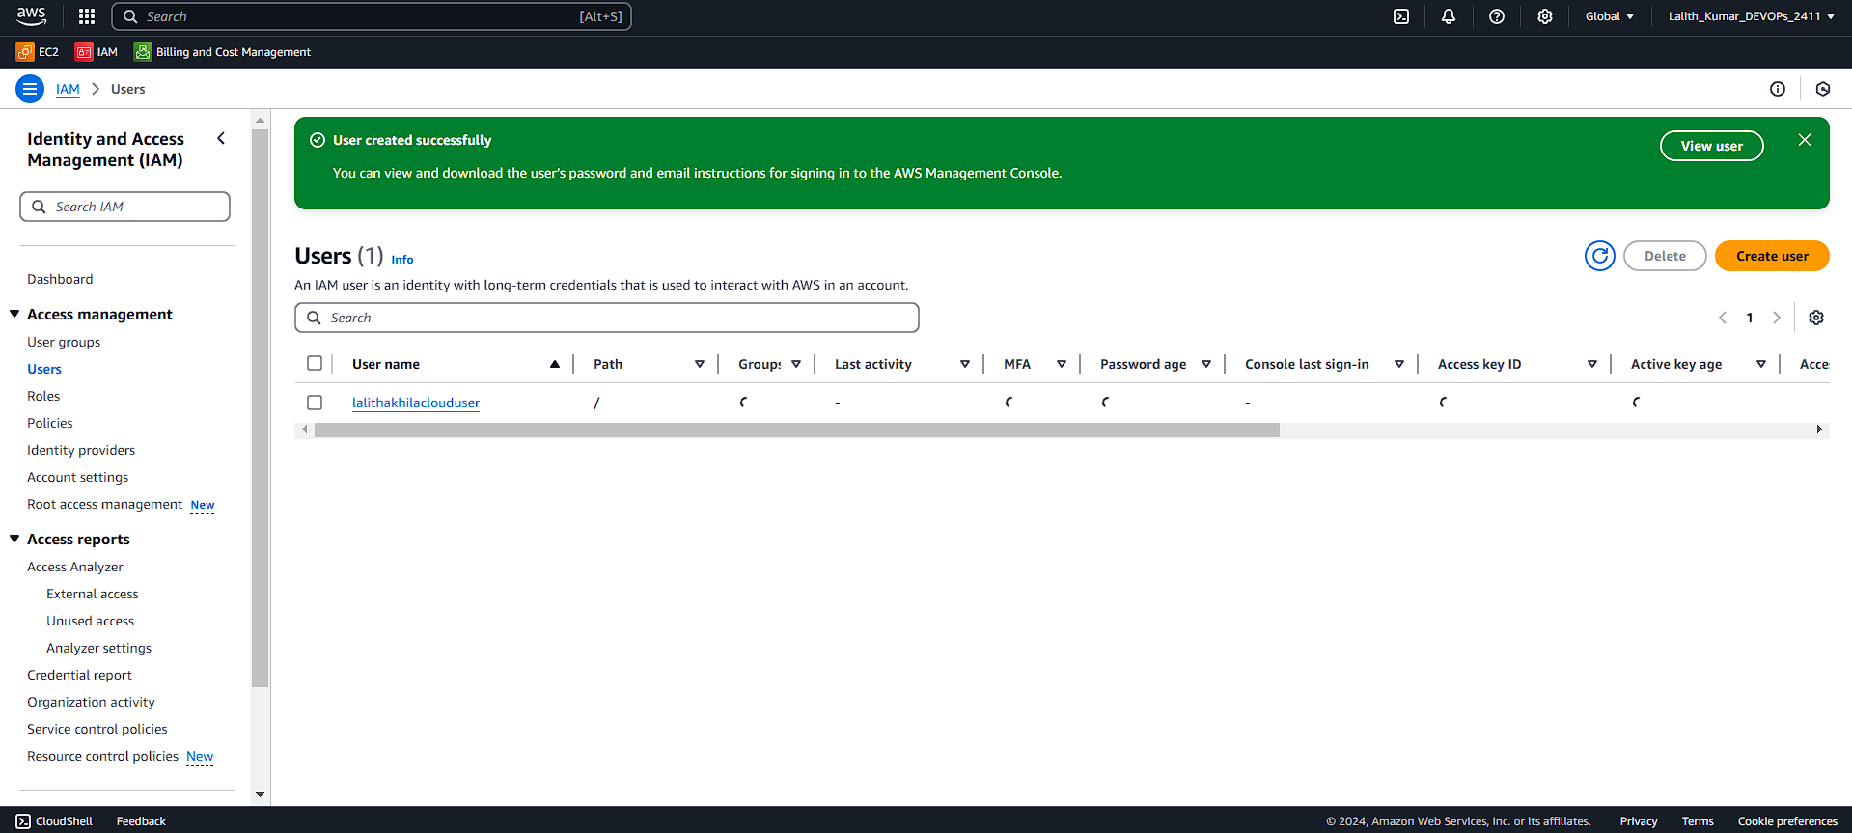

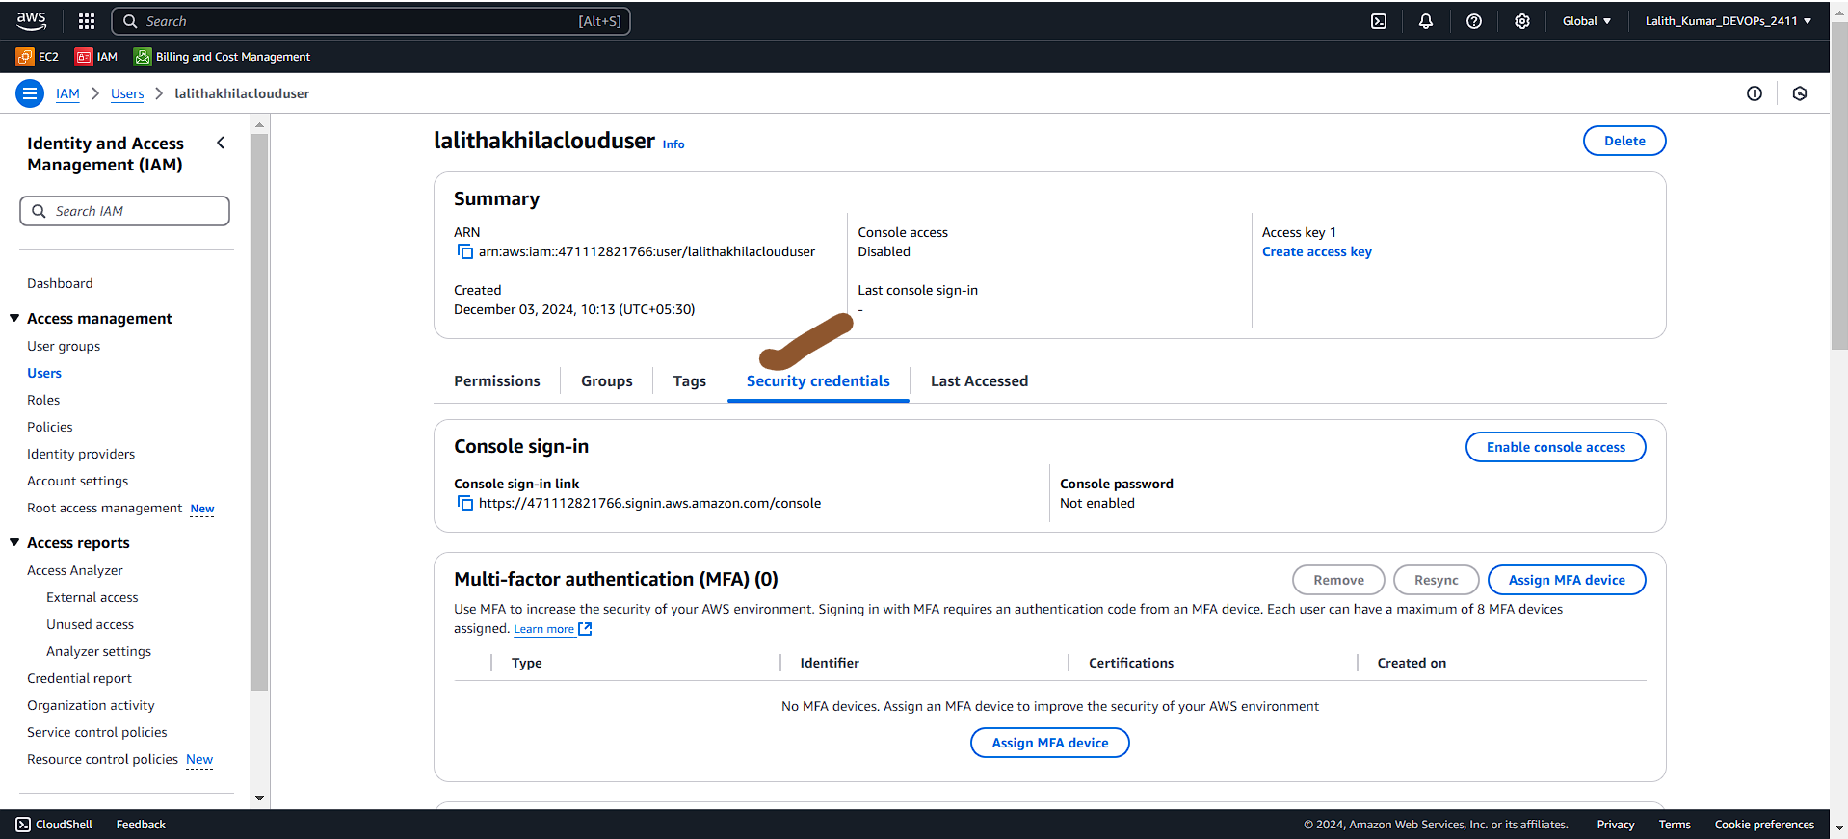

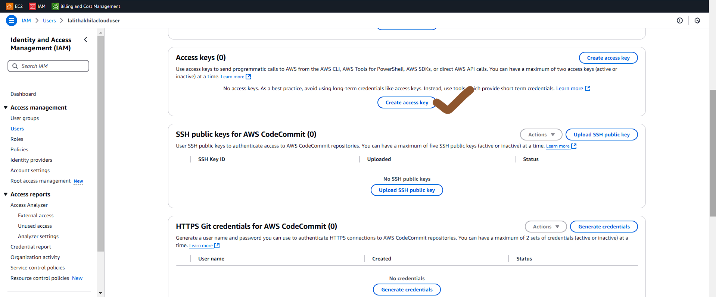

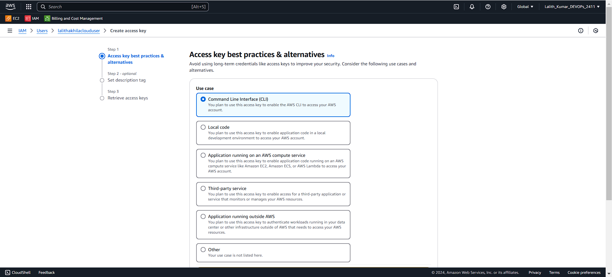

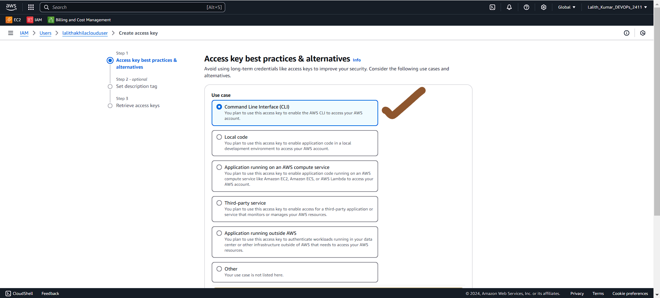

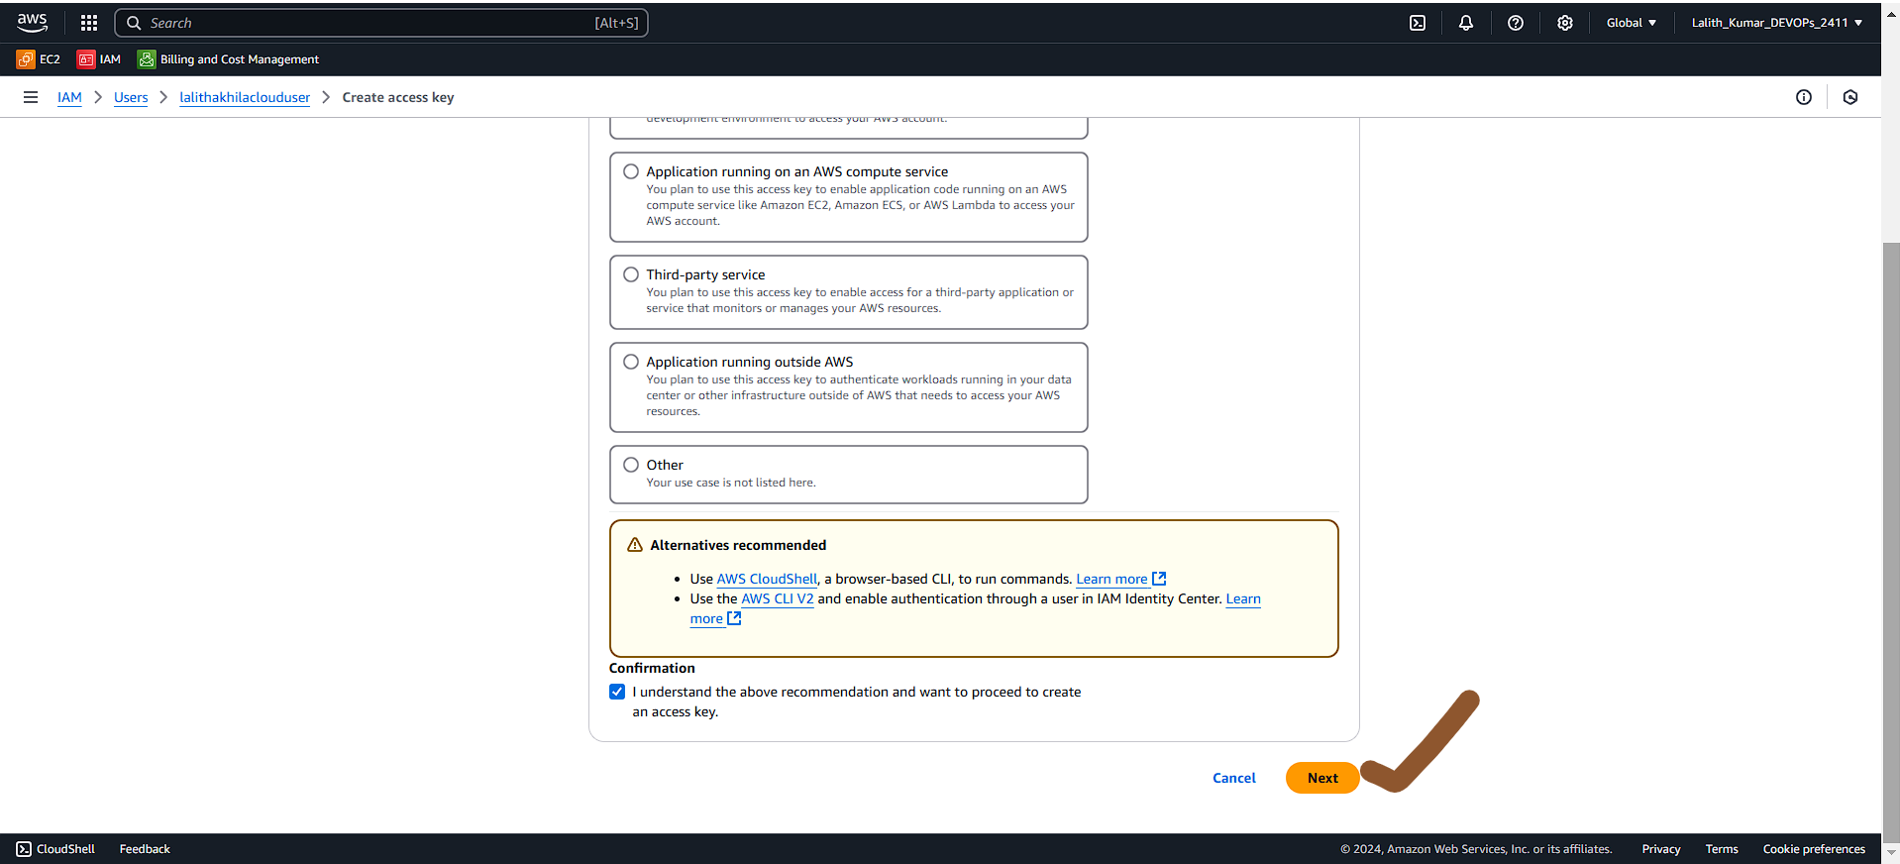

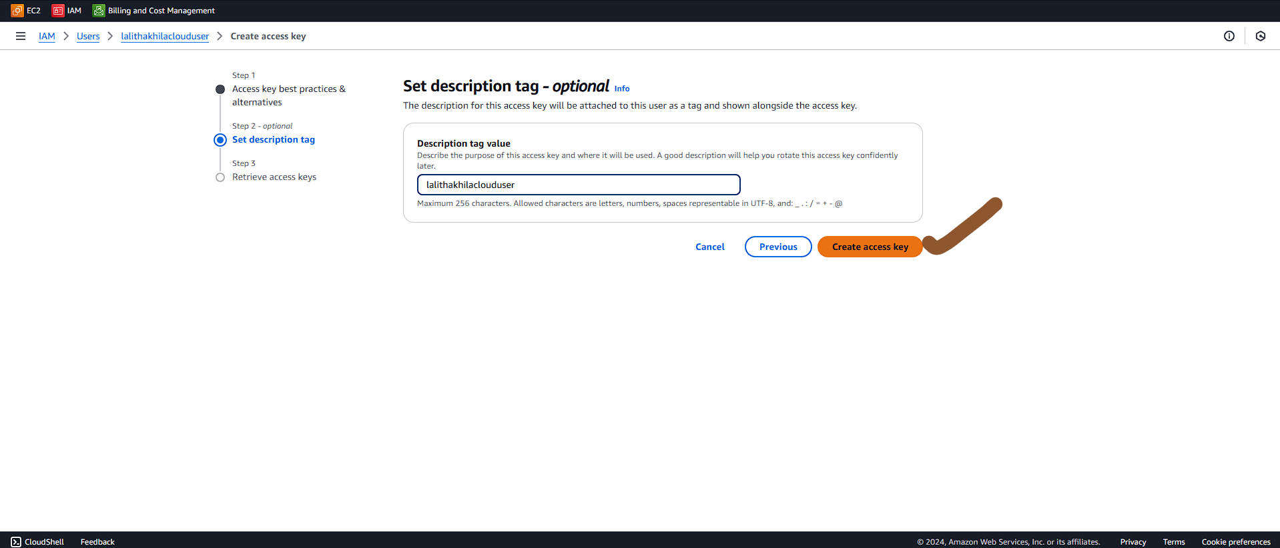

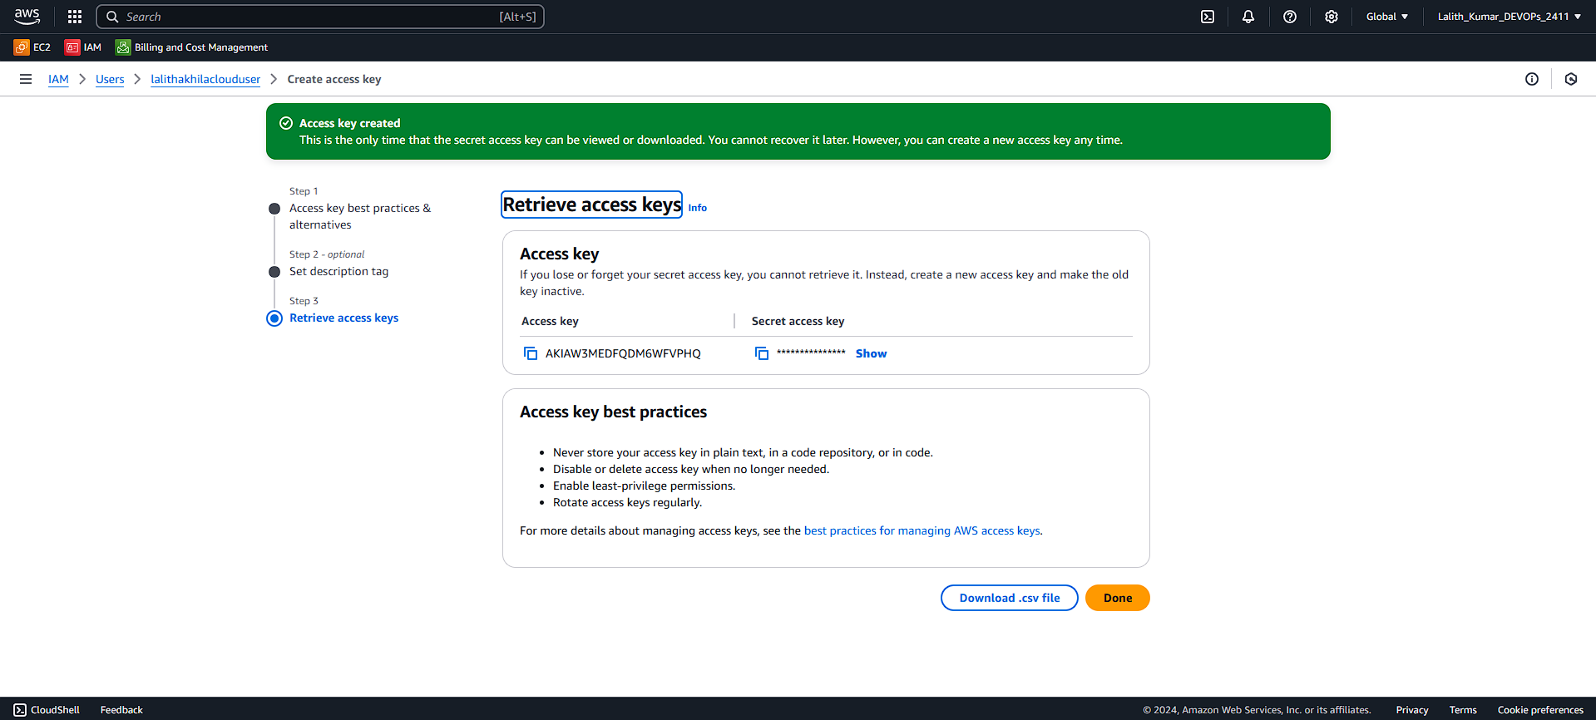

**Copy the Access Key:**

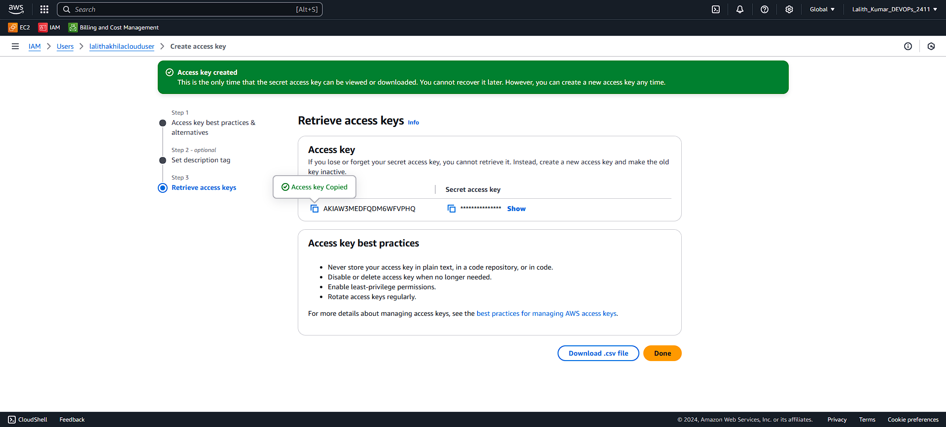

**Create Key Pair**

**Go to EC2**

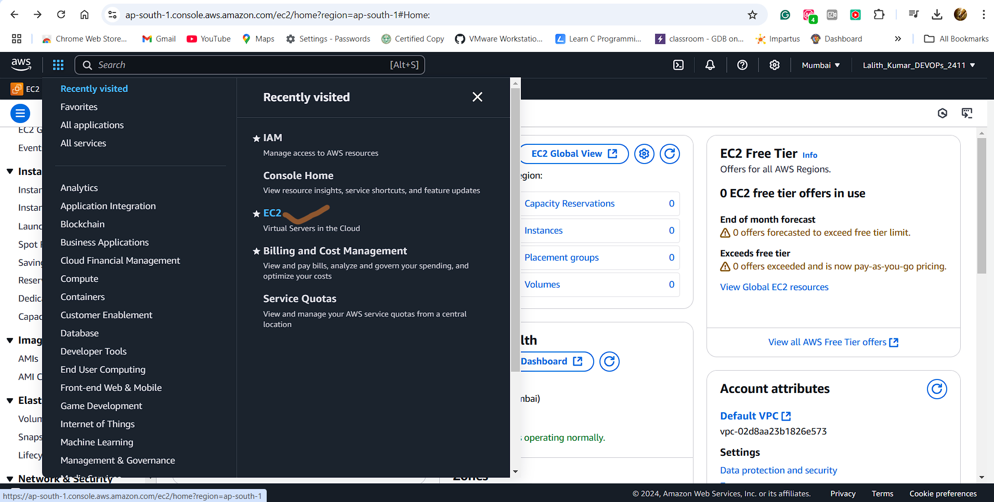

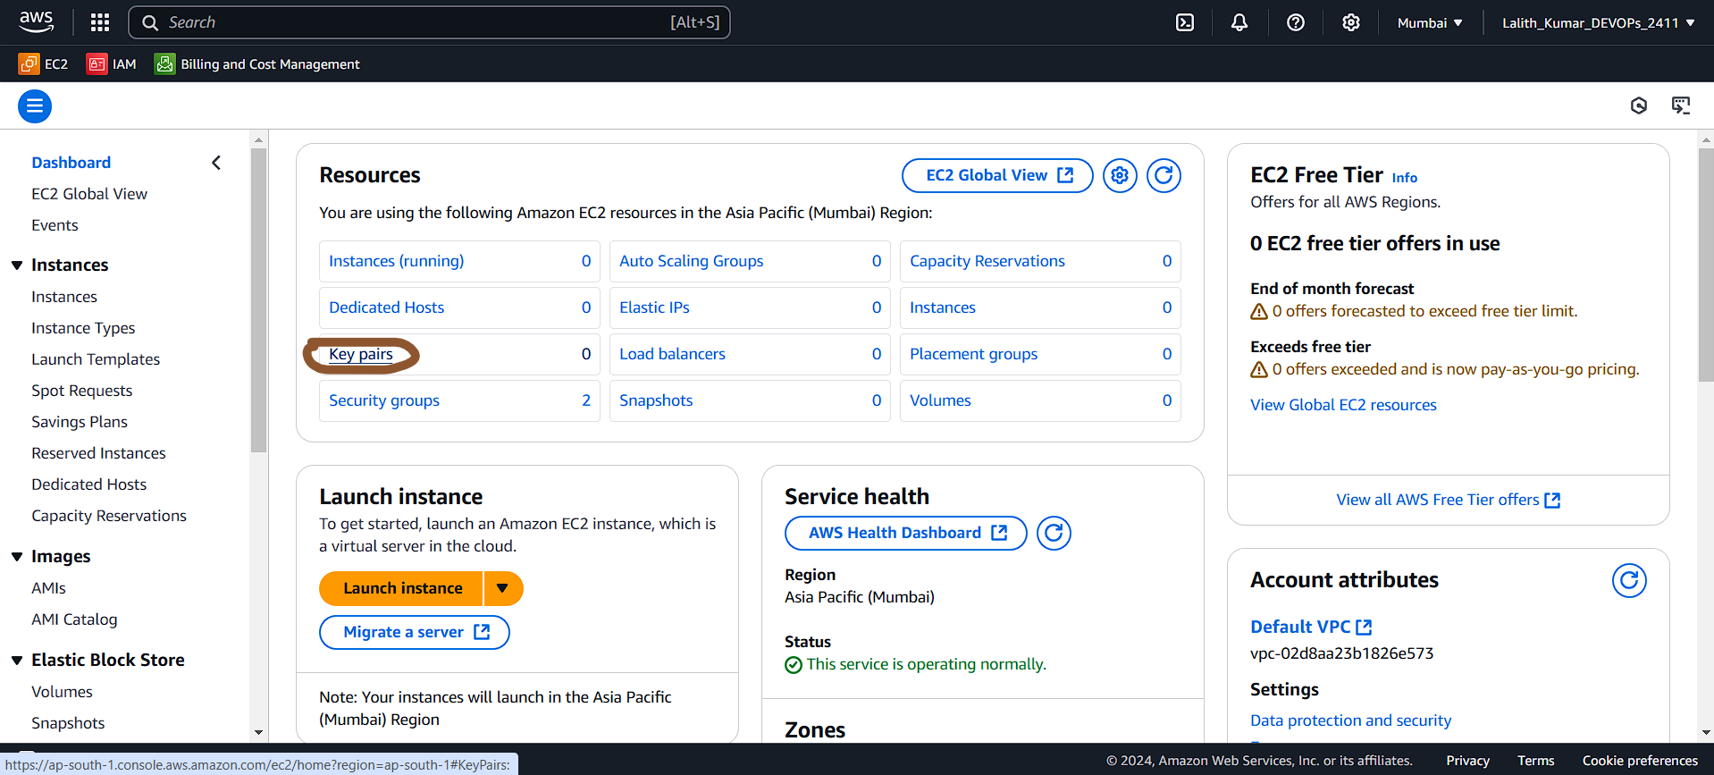

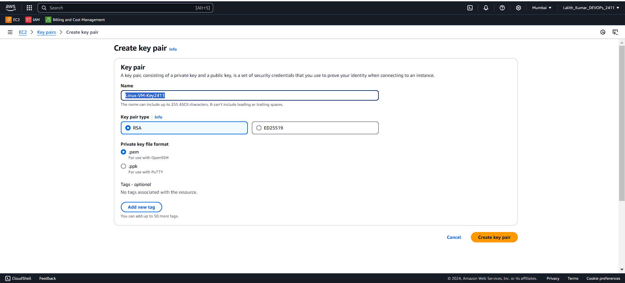

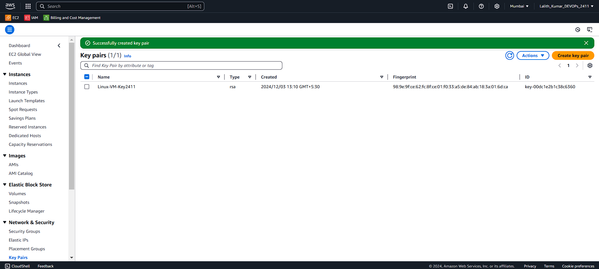

**Copy Access Key:**

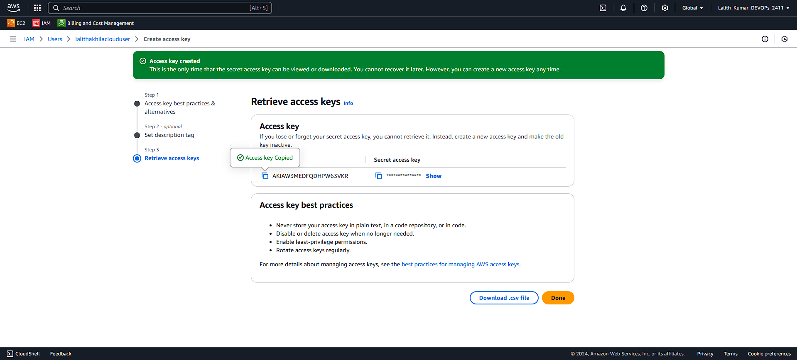

**Copy the Secret Access Key:**

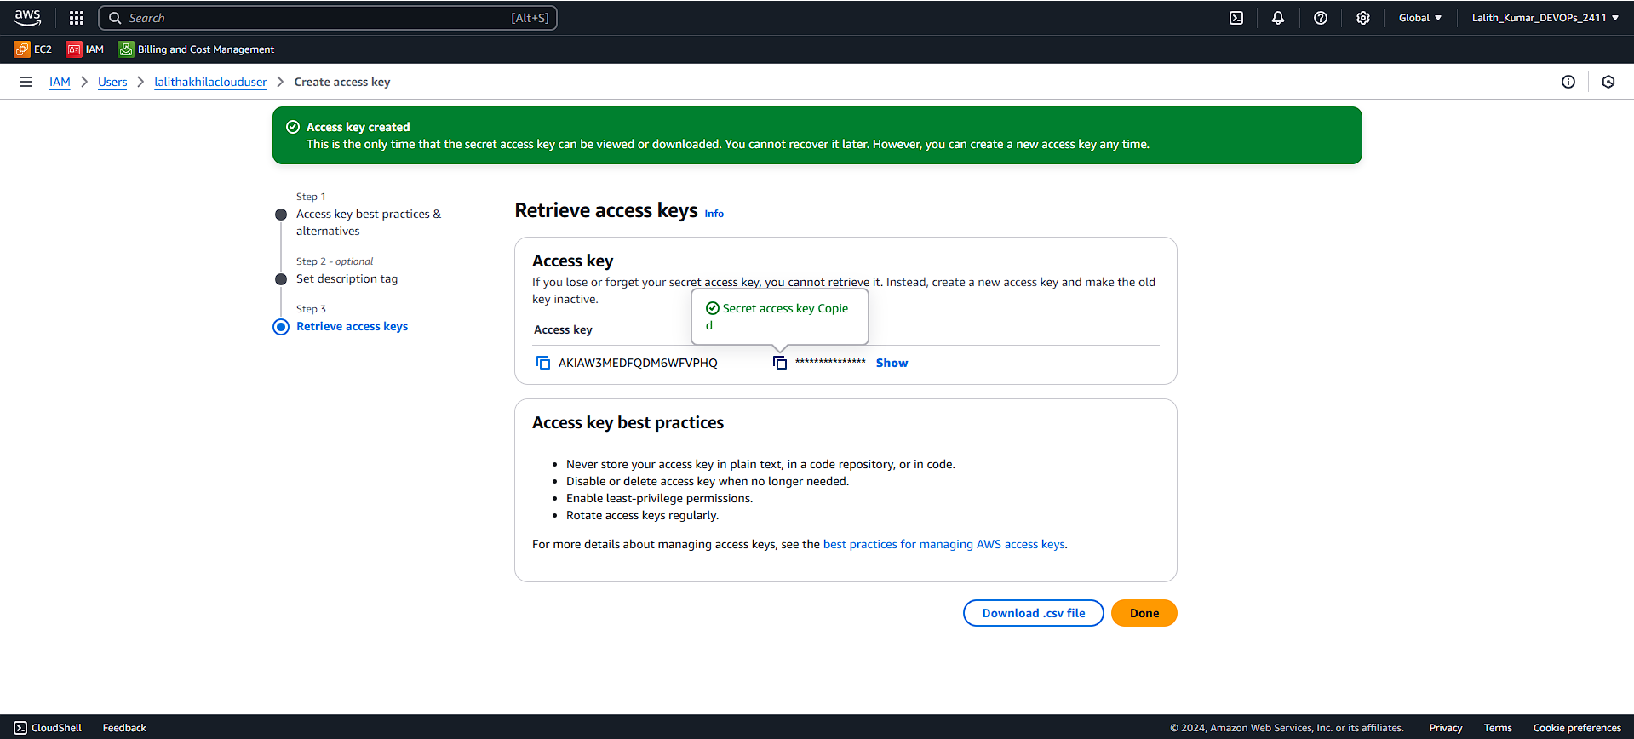

**For configuring AWS:**

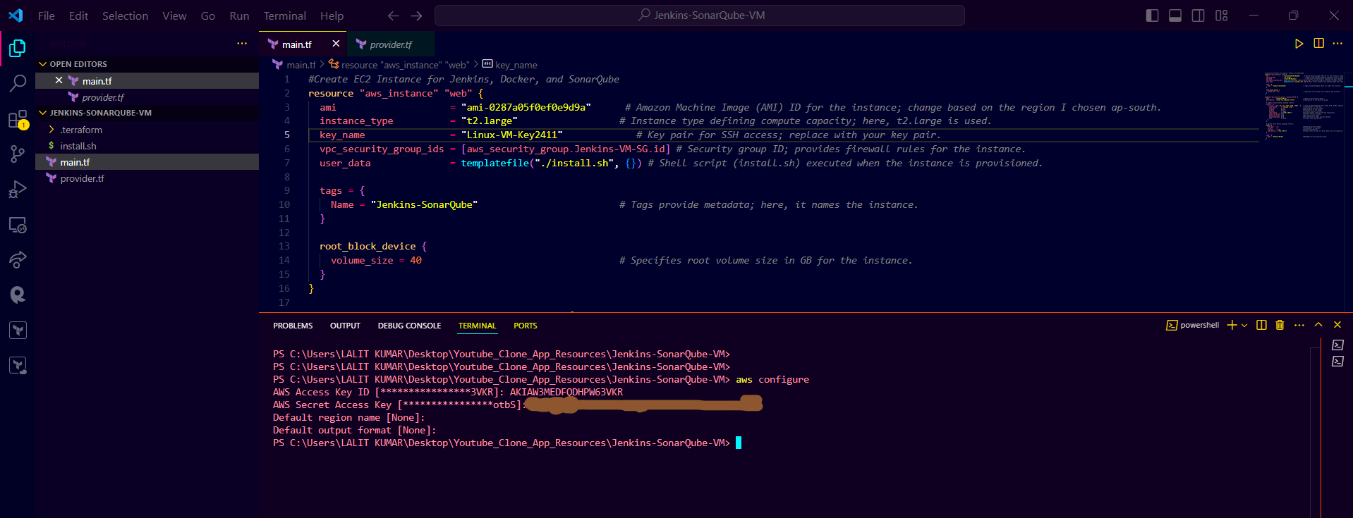

**For Terraform Initialization:**

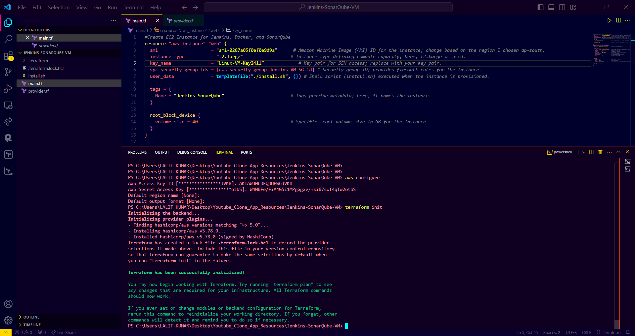

**For Planning the Resources in the EC2 Instance Using Terraform:**

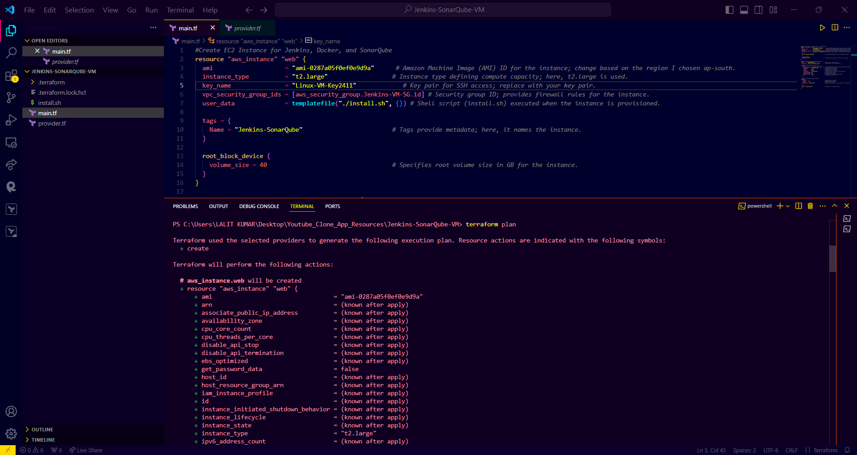

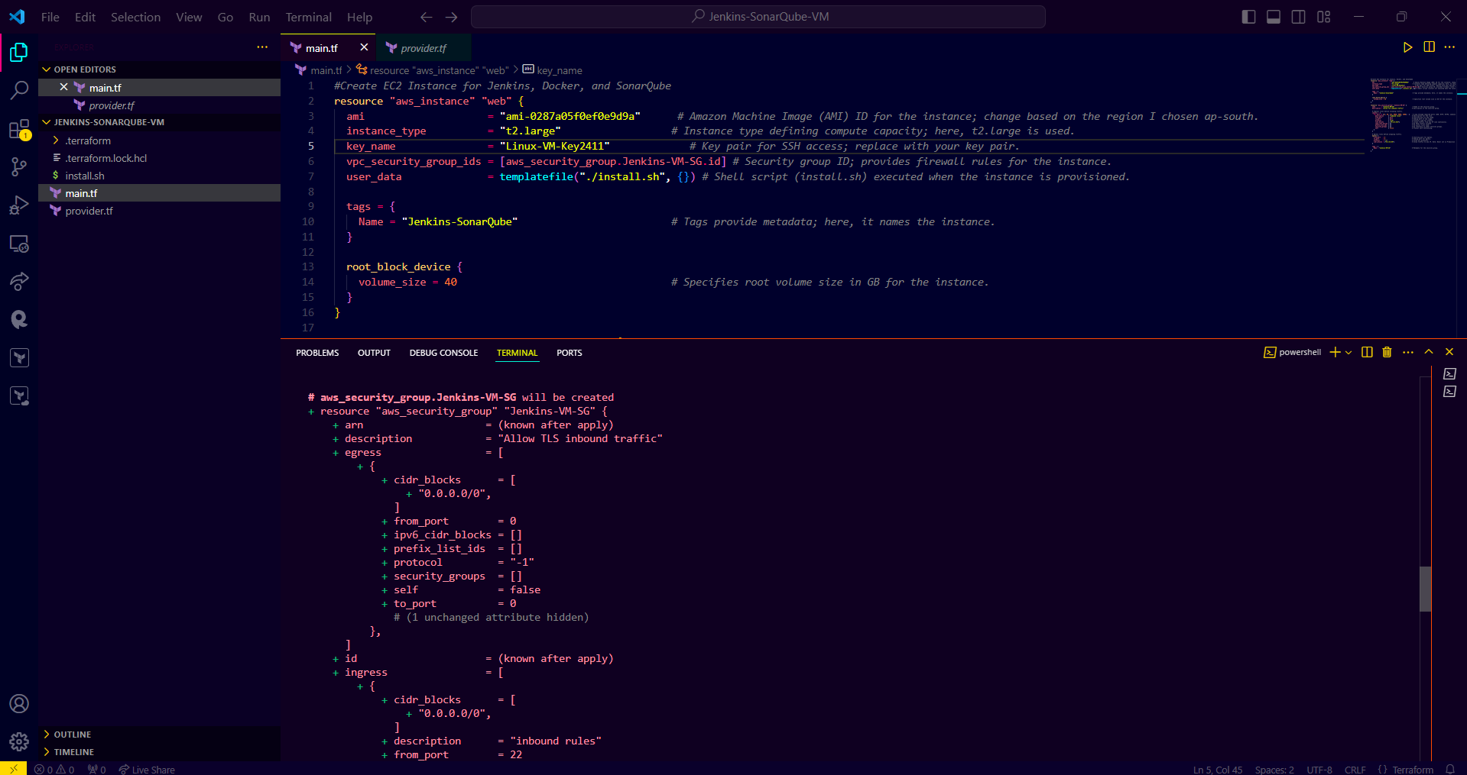

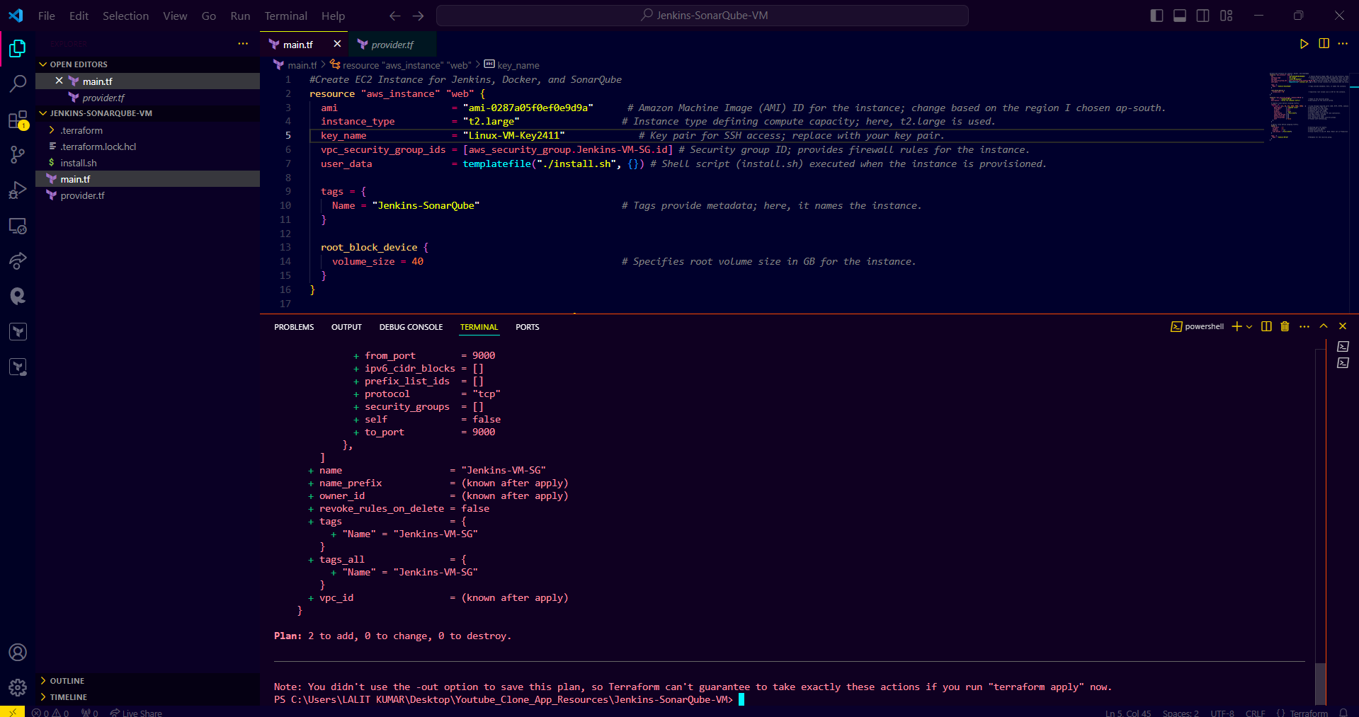

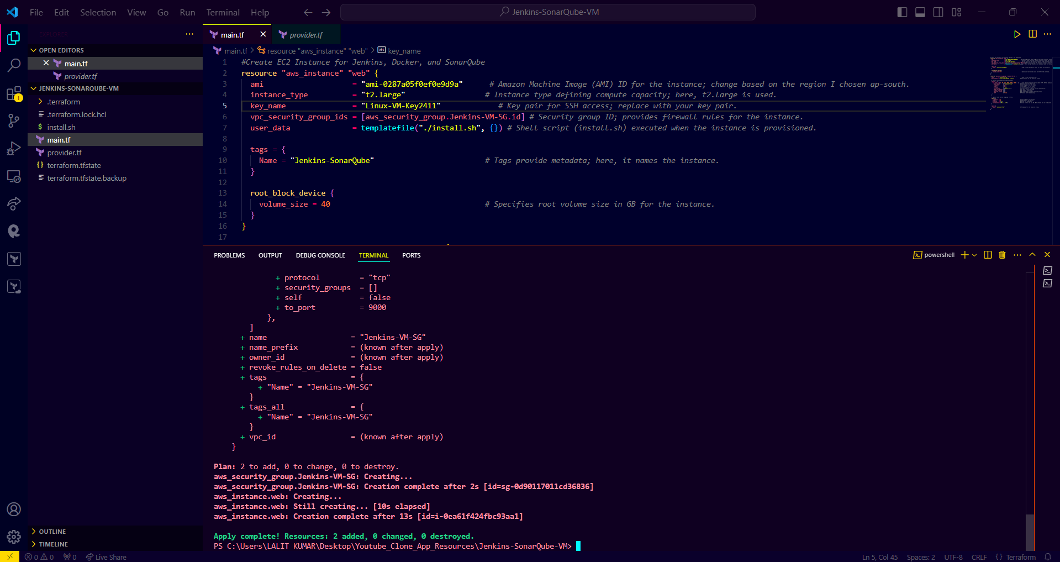

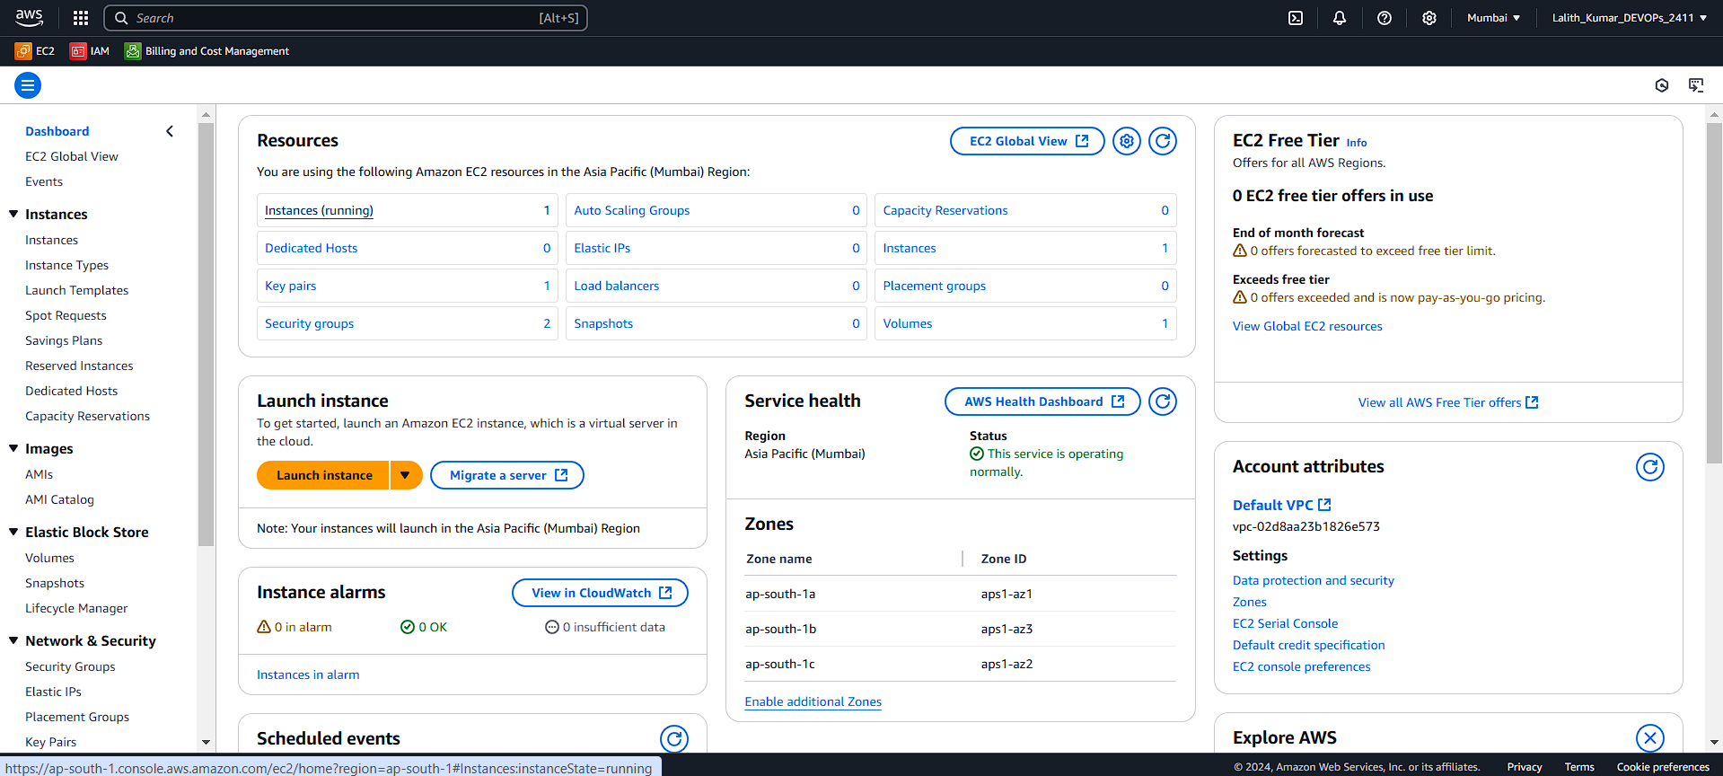

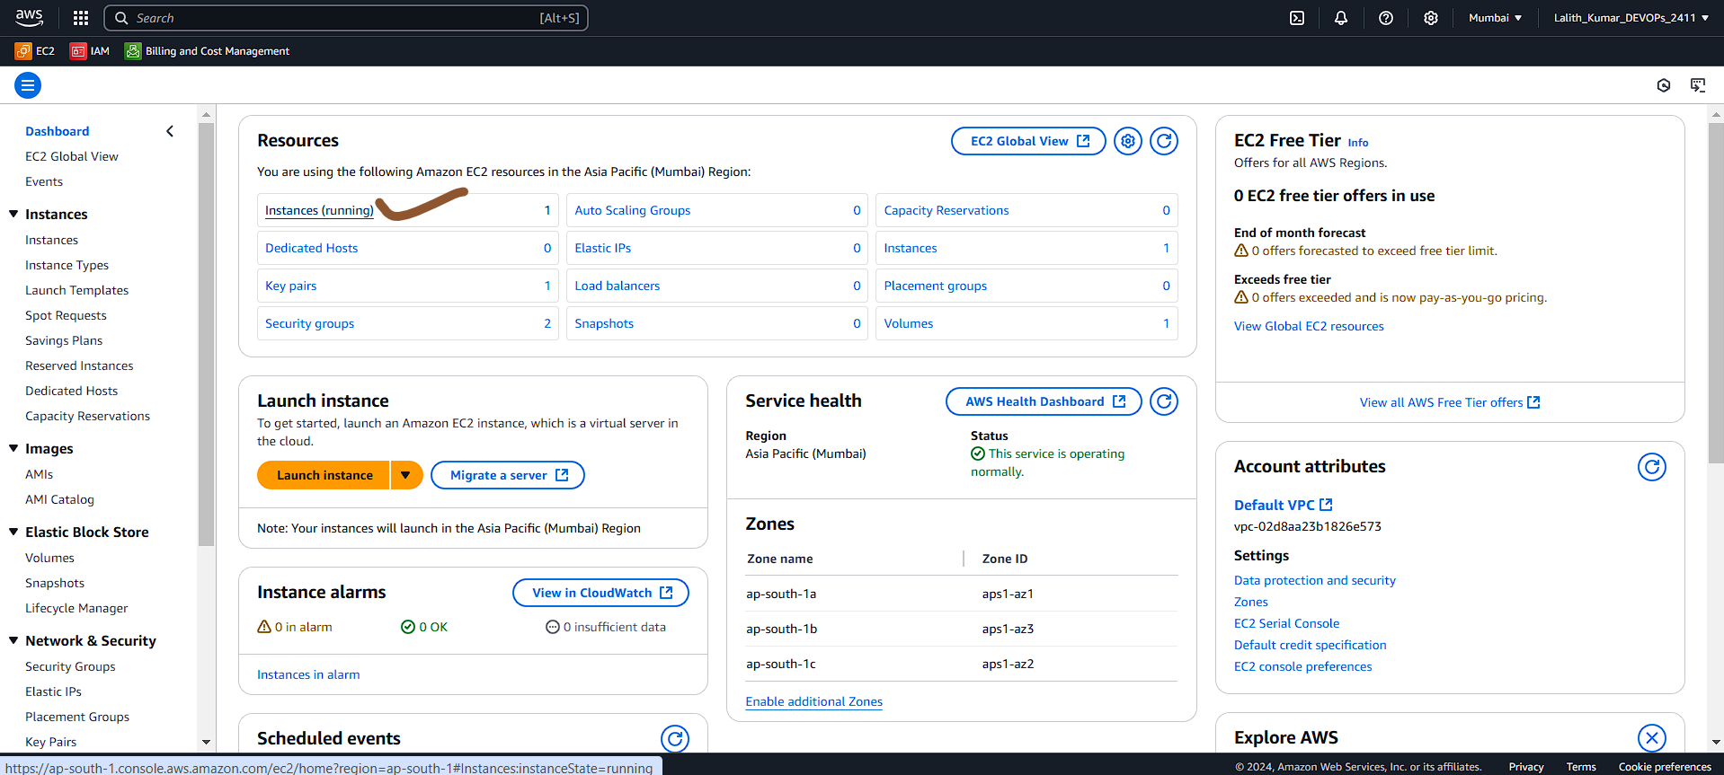

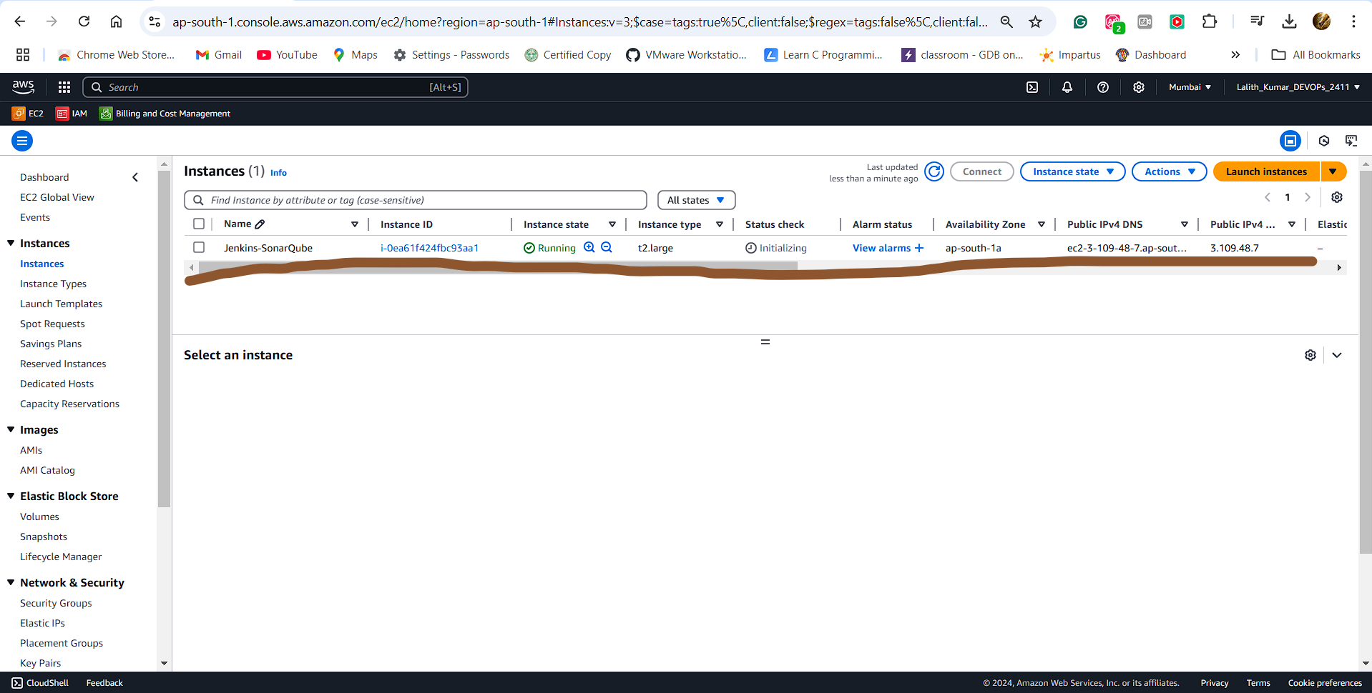

**\*\*\*\*\*\*\*\*\*\*\*\*EC2 Instance Successfully Created using Terraform Script\*\*\*\*\*\*\*\*\*\***

**Security Group:**

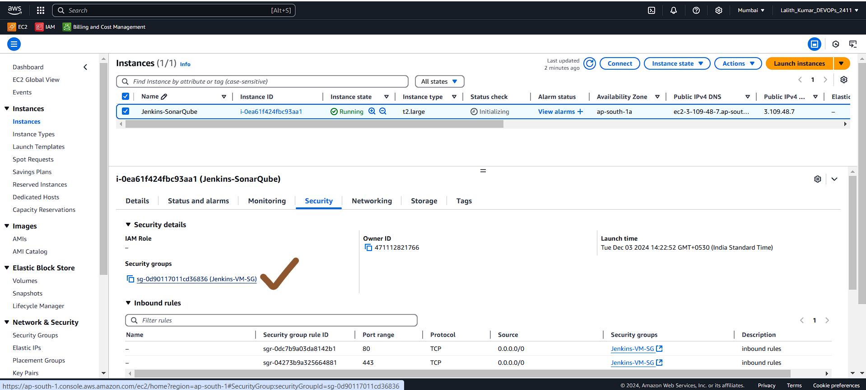

**Inbound Rules:**

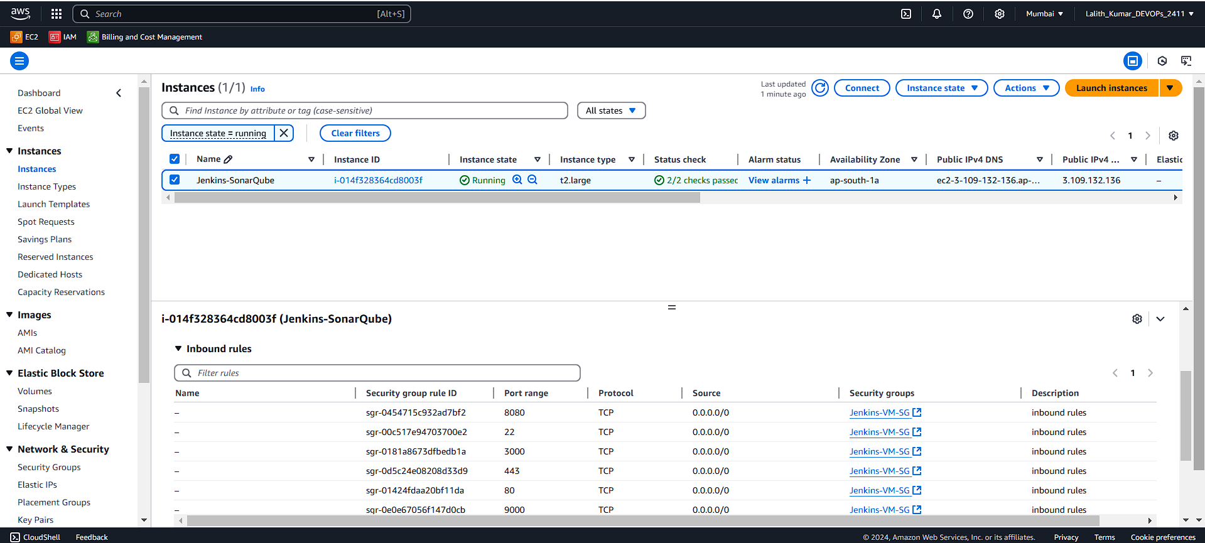

**Connecting under PuTTy:**

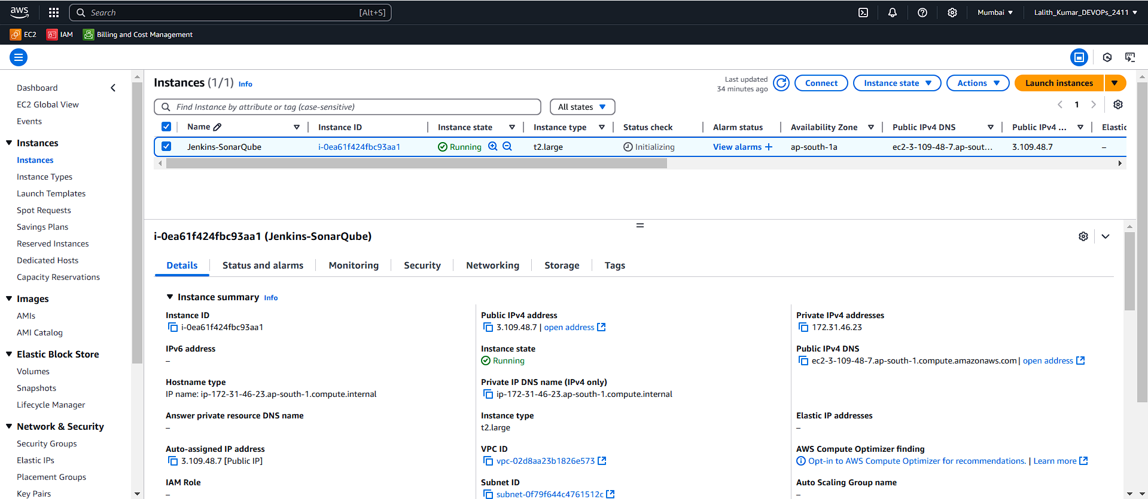

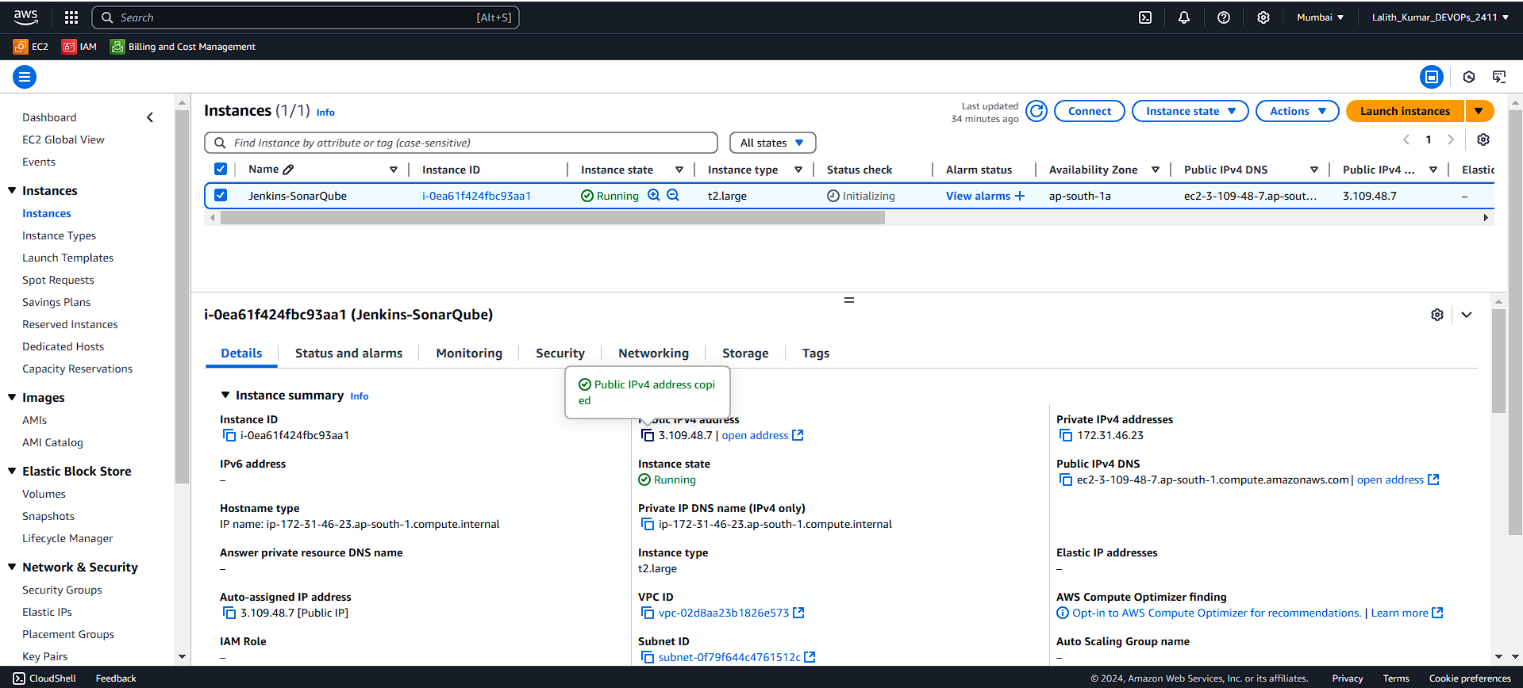

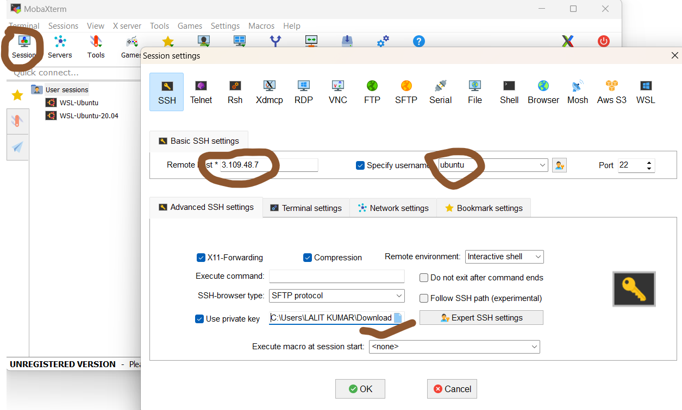

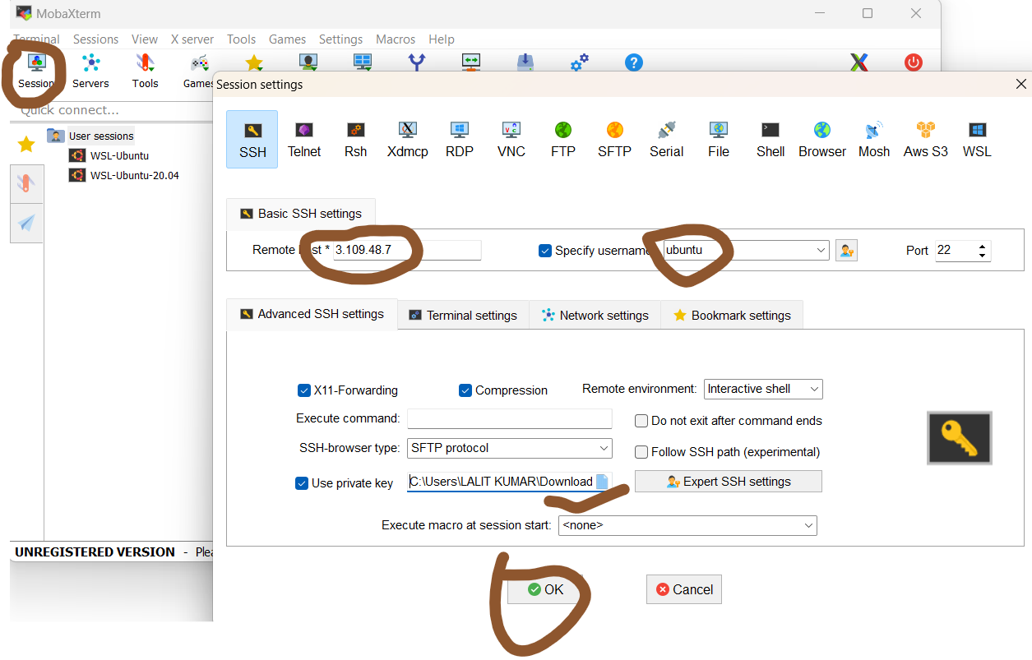

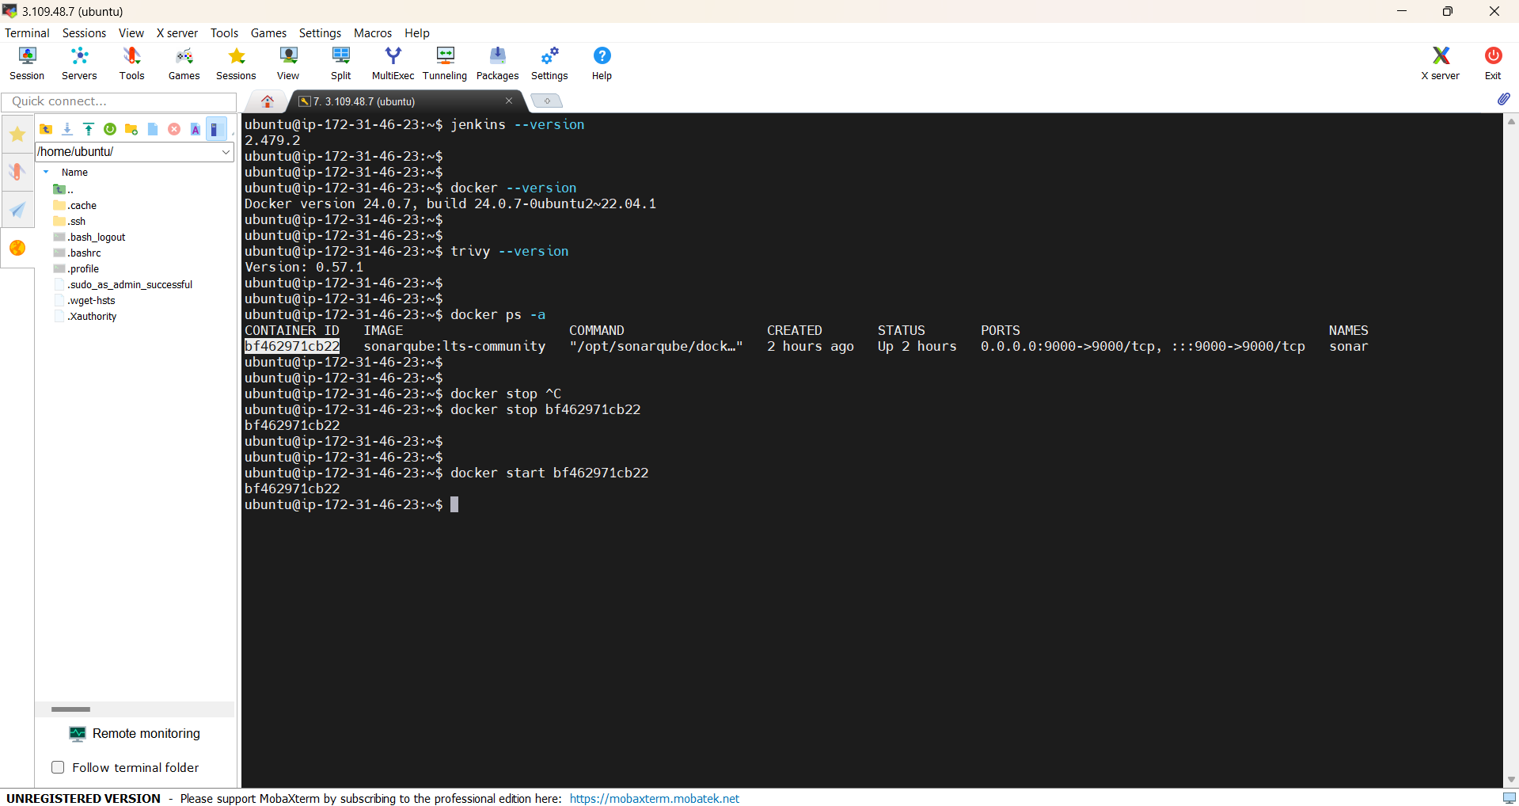

**Using Terraform Script below I created the EC2 instance with Jenkins, SonarQube, Docker preinstalled:**

**main.tf file code:**

<https://github.com/Lalith-Rockzz/Youtube_Clone_App_Main/blob/main/Youtube_Clone_App_Main/main.tf>

**provider.tf file code:**

<https://github.com/Lalith-Rockzz/Youtube_Clone_App_Main/blob/main/Youtube_Clone_App_Main/provider.tf>

**install.sh shell file code:**

<https://github.com/Lalith-Rockzz/Youtube_Clone_App_Main/blob/main/Youtube_Clone_App_Main/install.sh>

**2.Configure the Jenkins:**

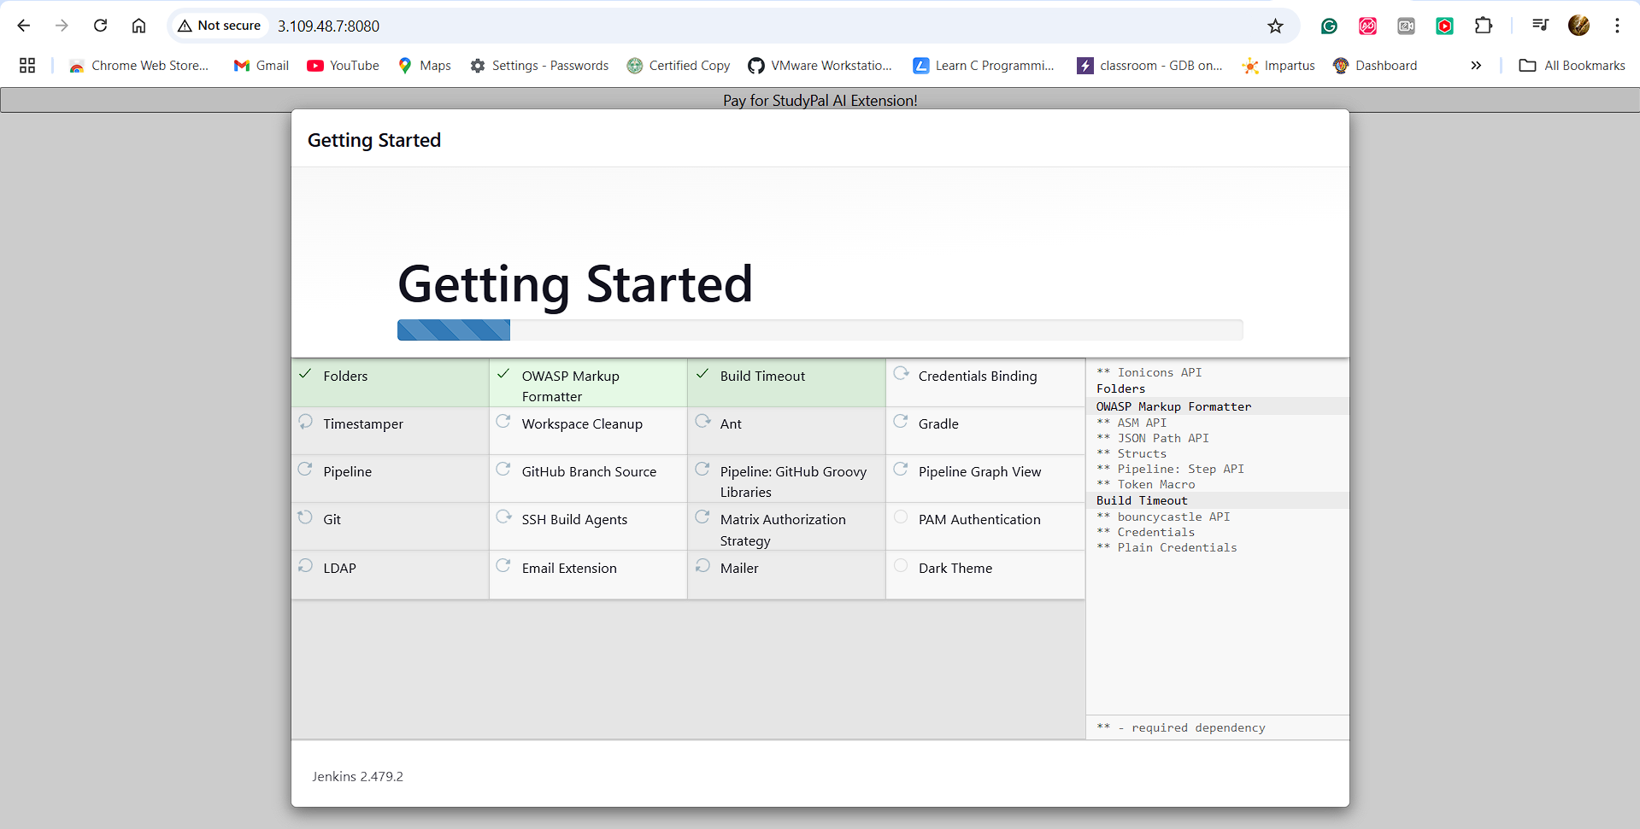

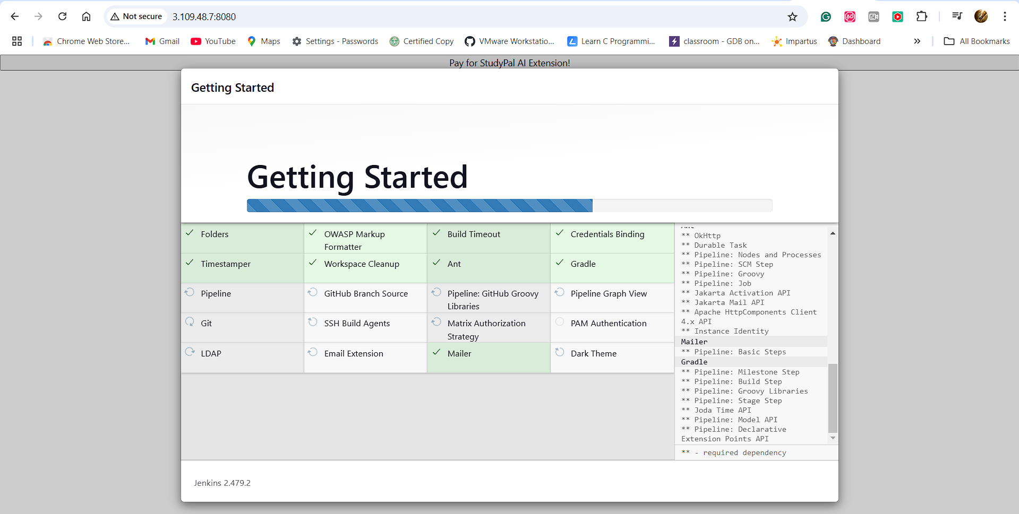

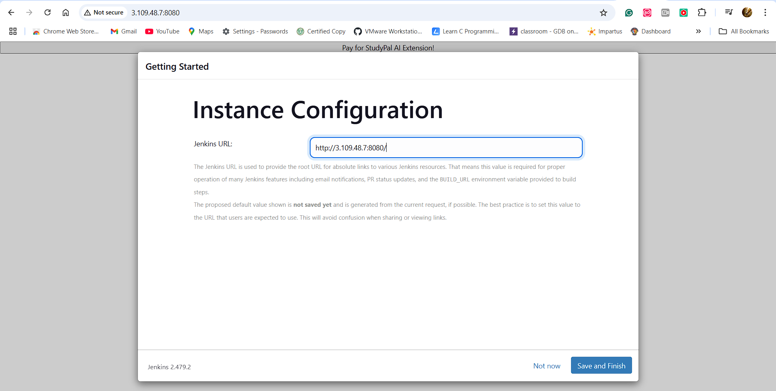

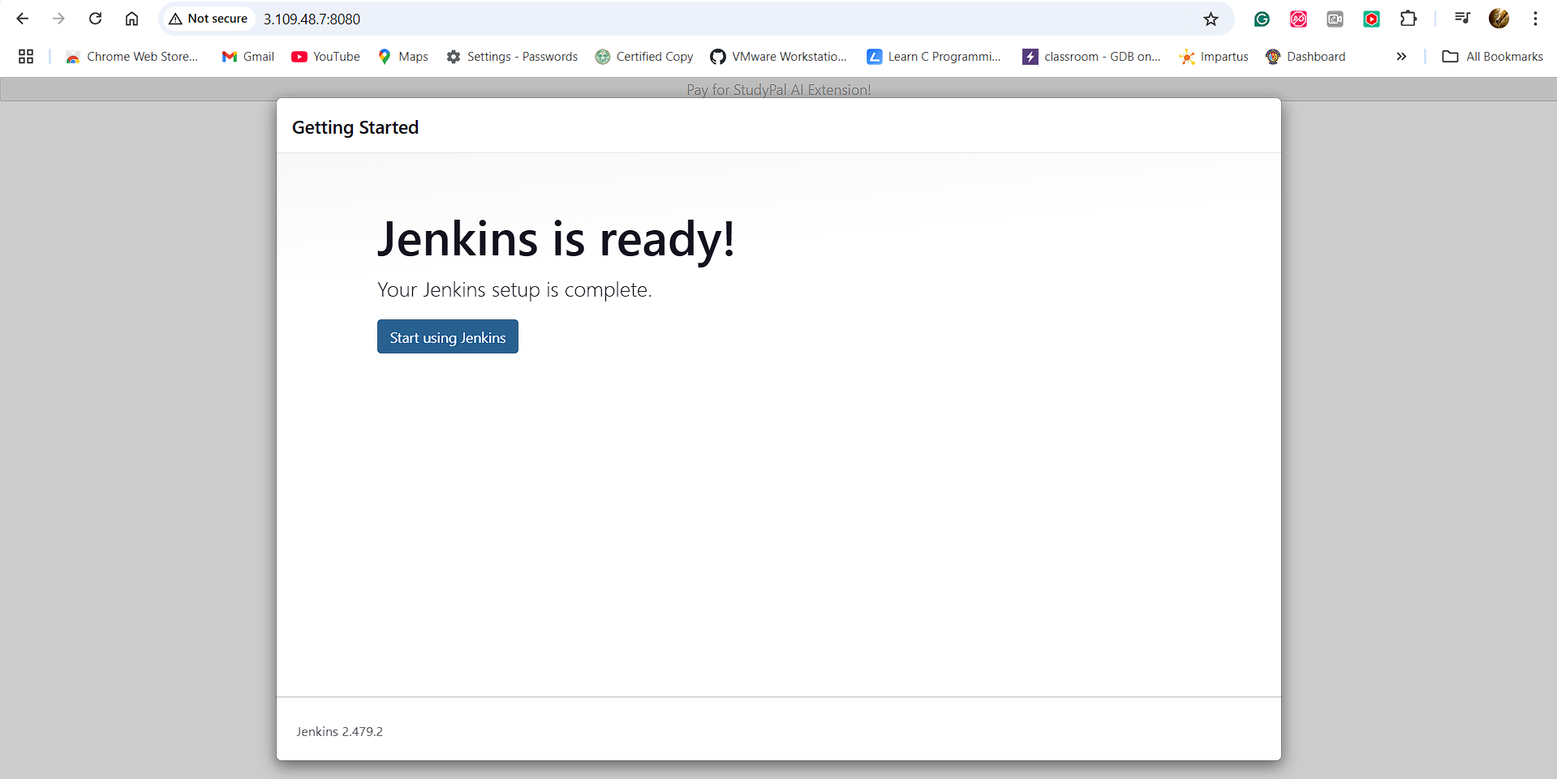

**Plugins Install:**

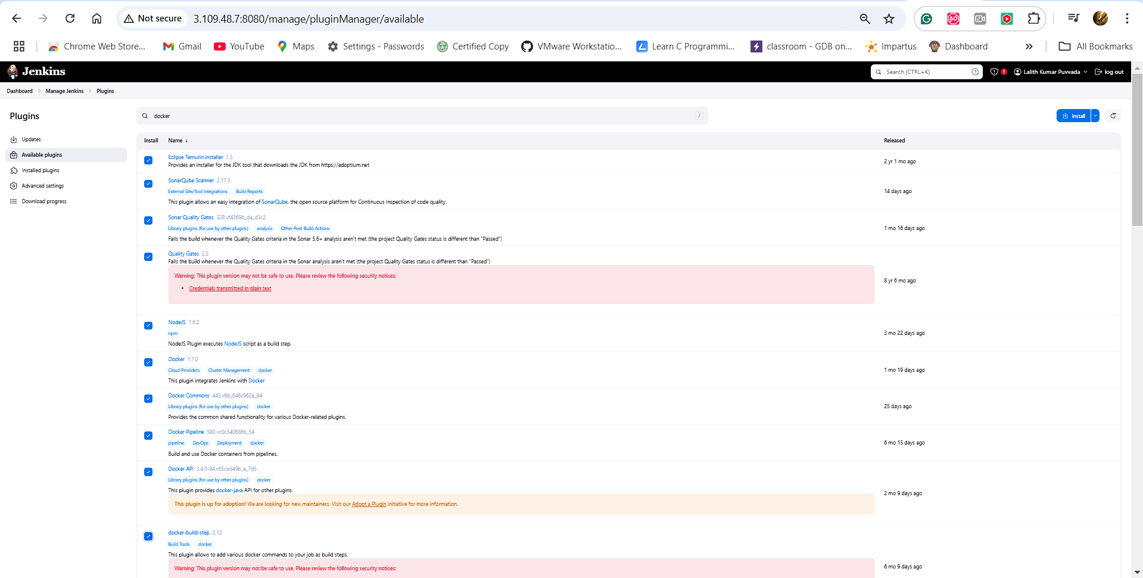

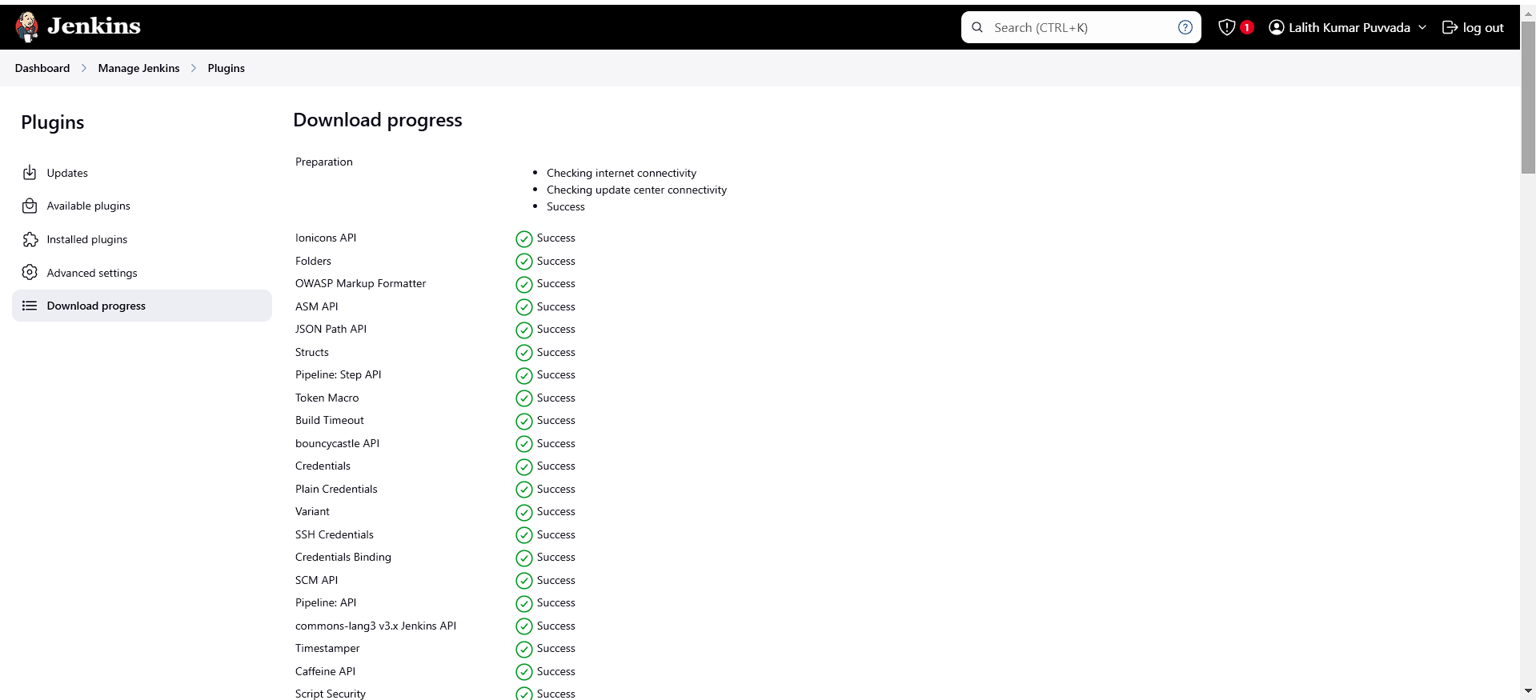

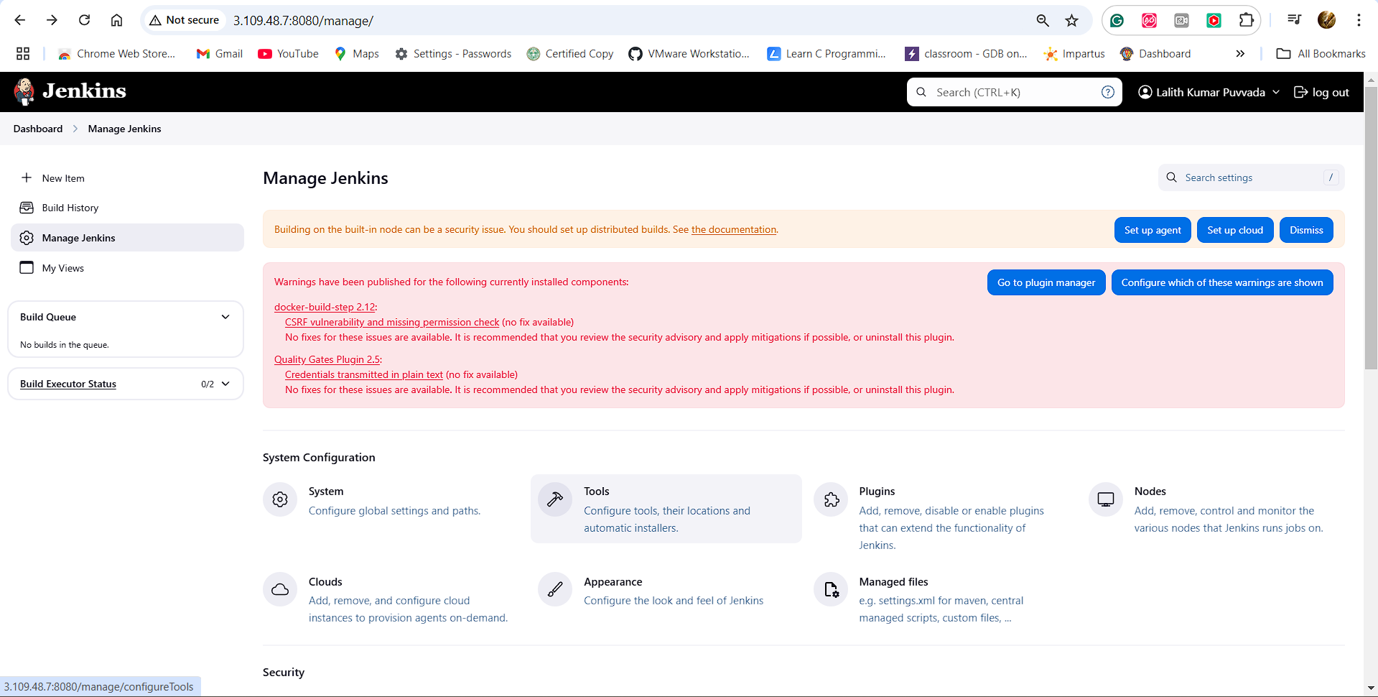 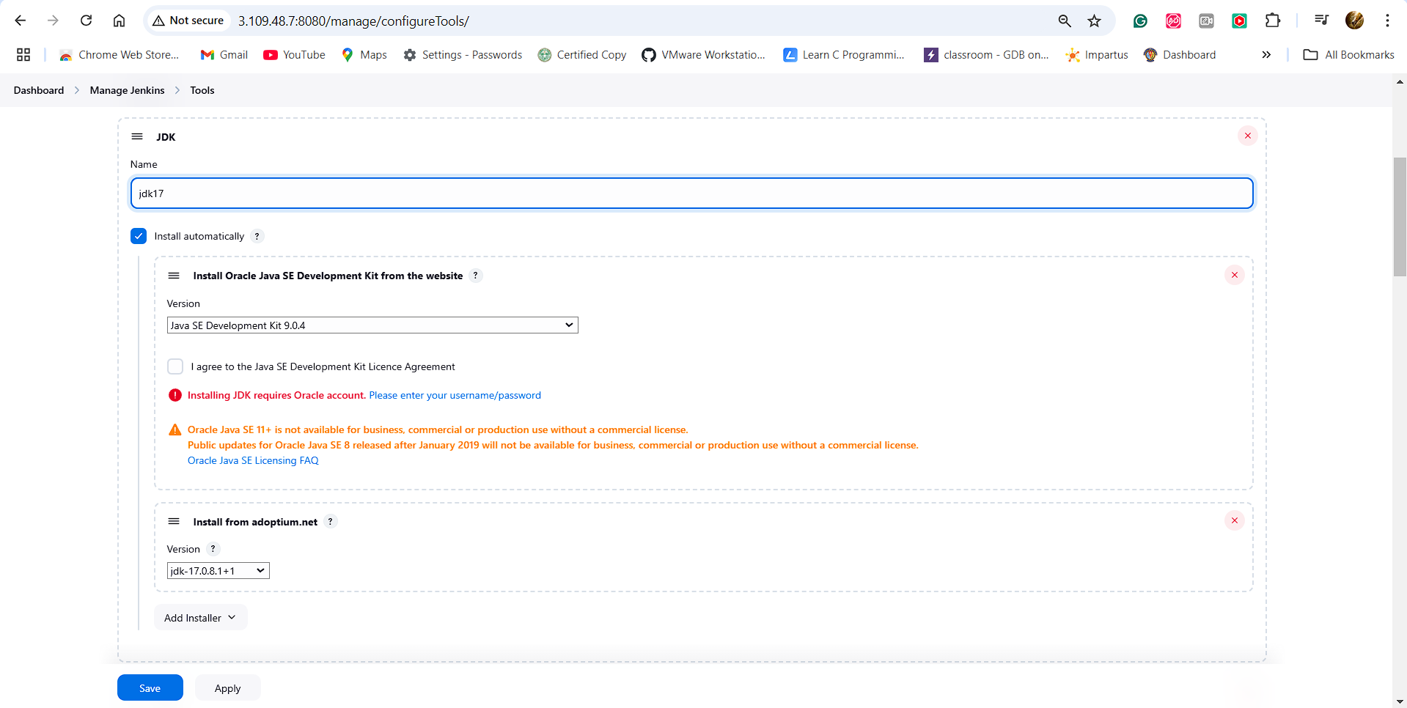

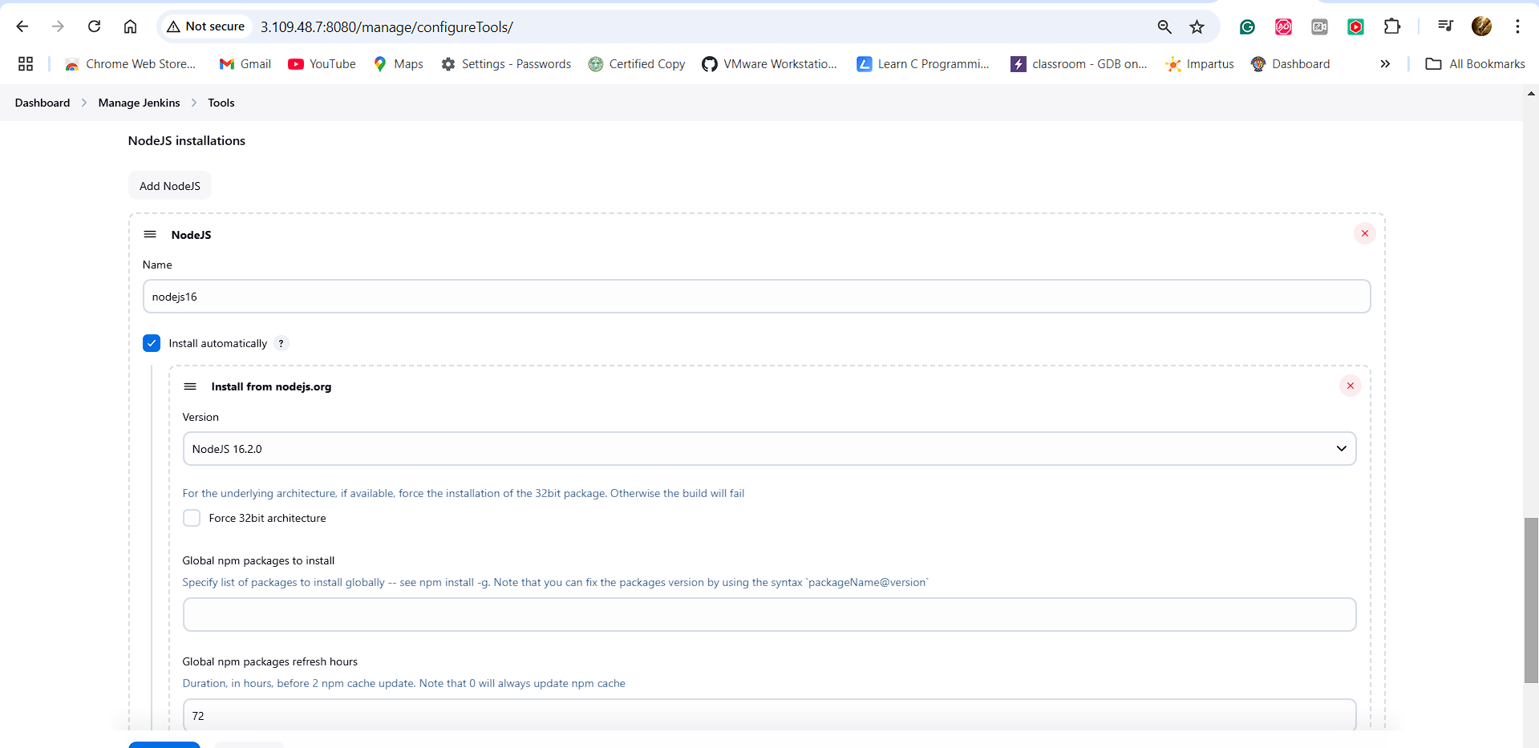

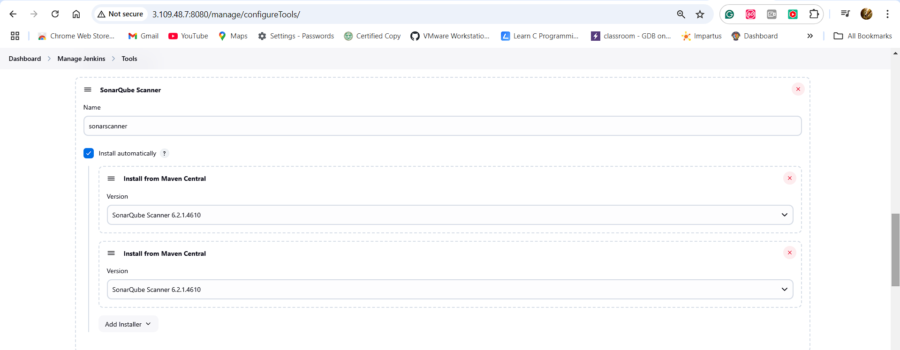

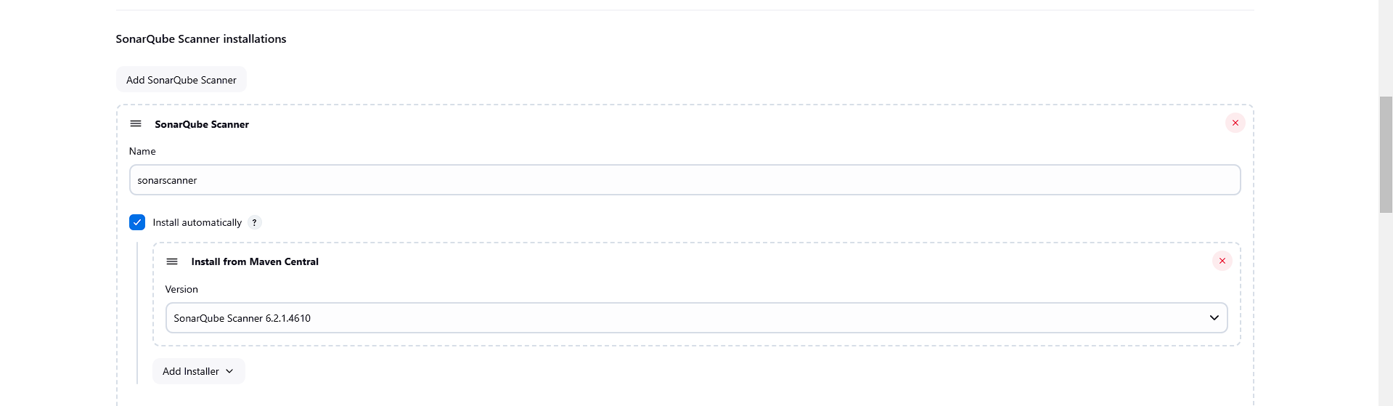

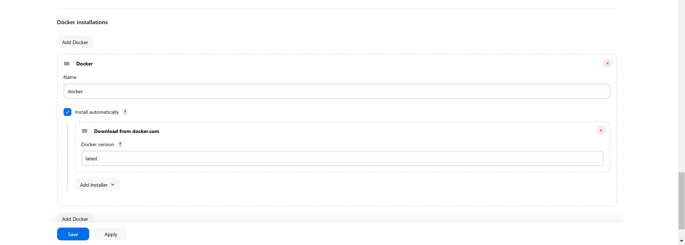

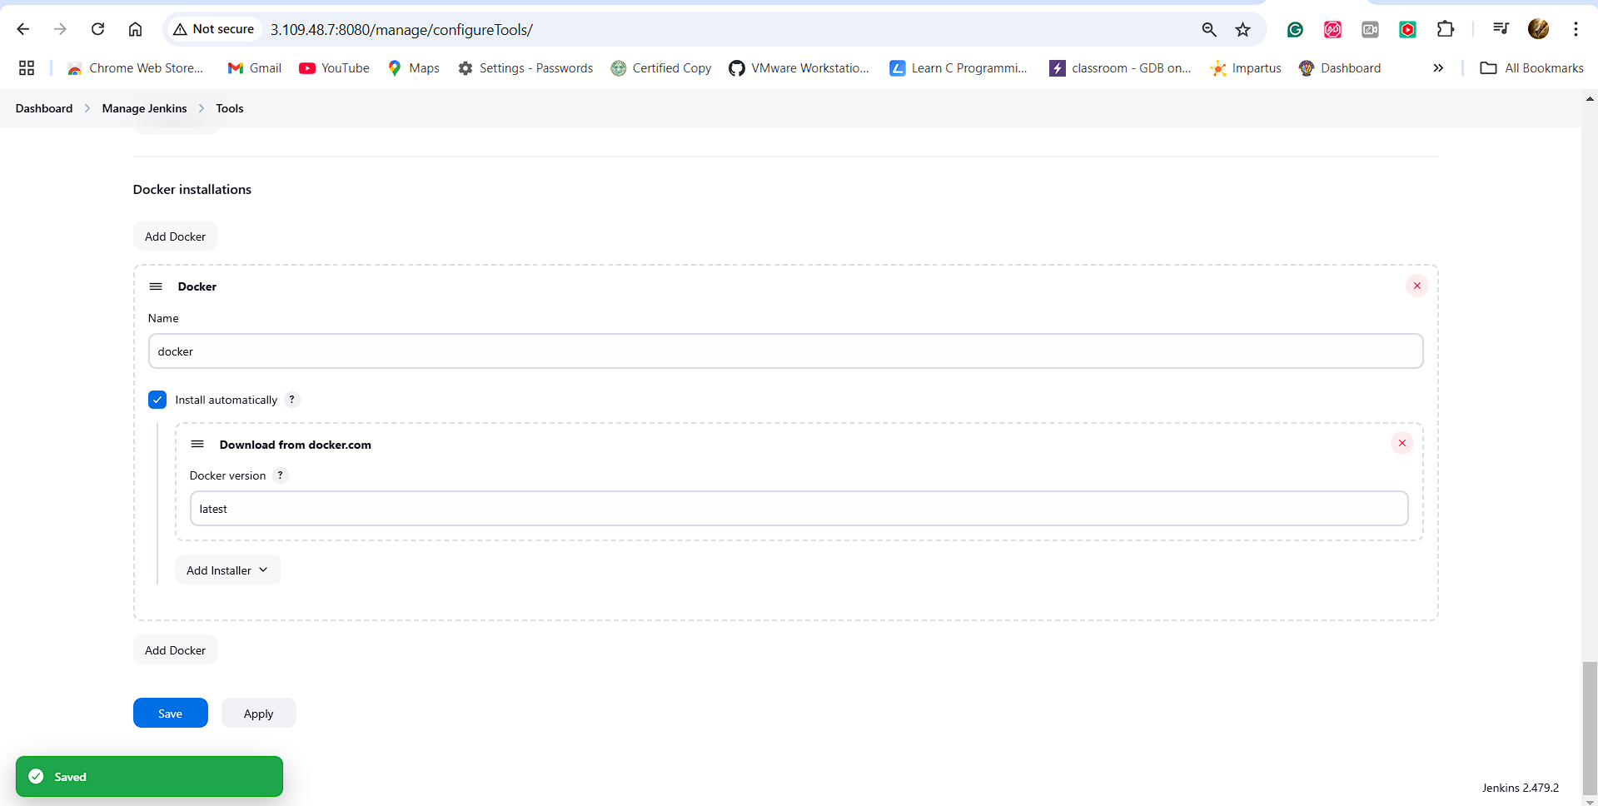

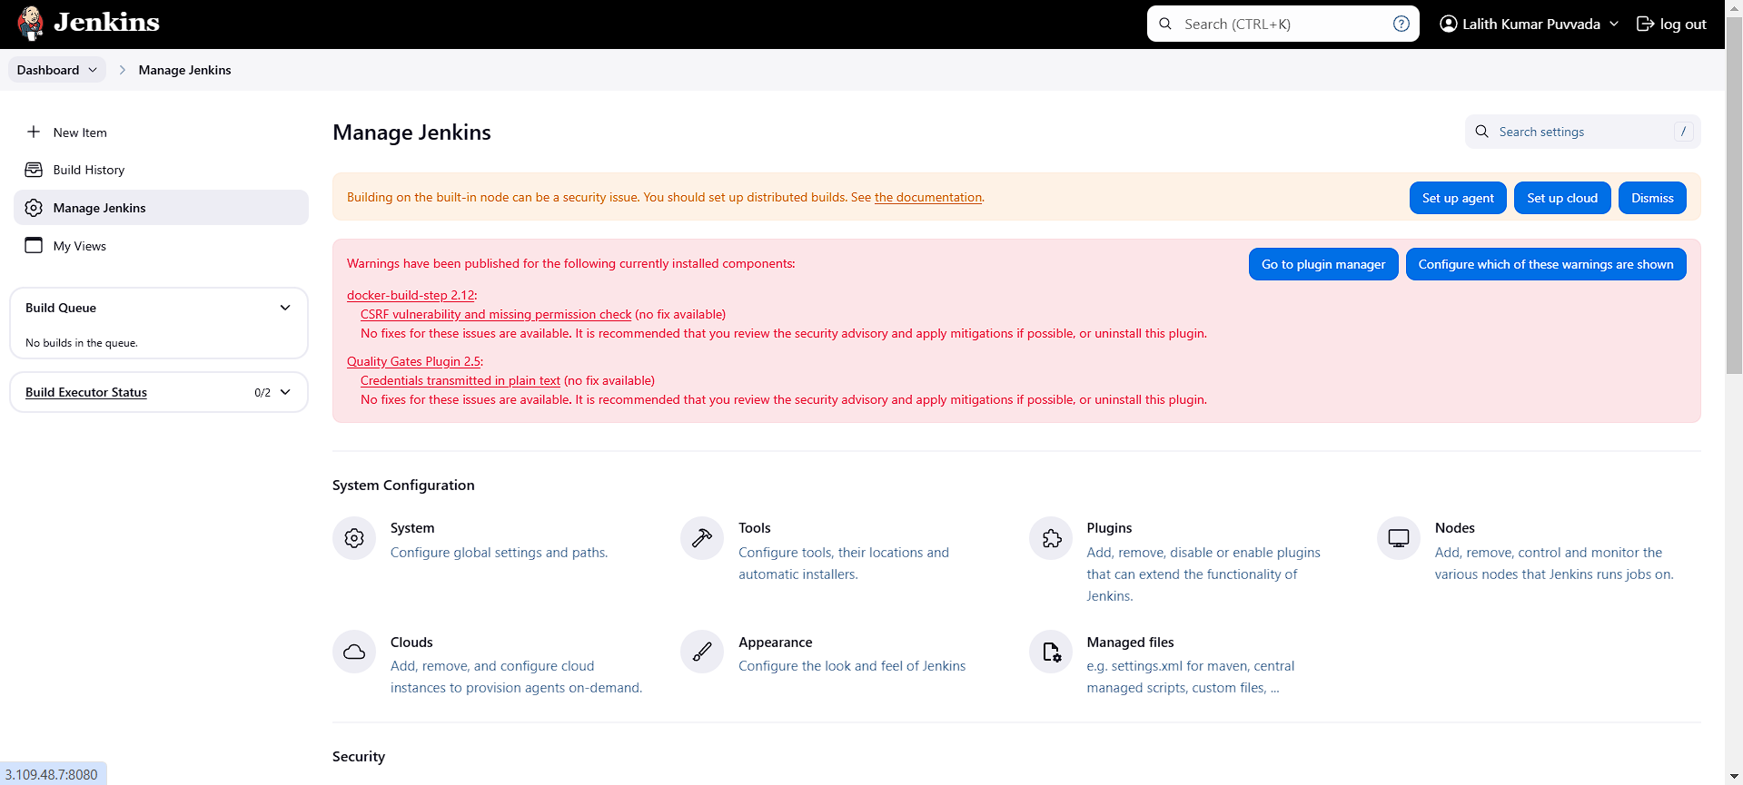

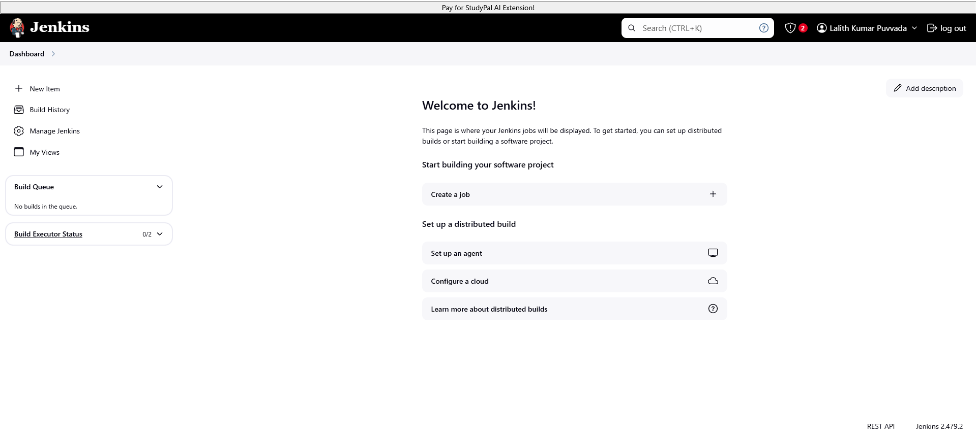

**3.Configure SonarQube and integrate SonarQube with Jenkins:**

**Default Login User Name and Password: Admin and Admin**

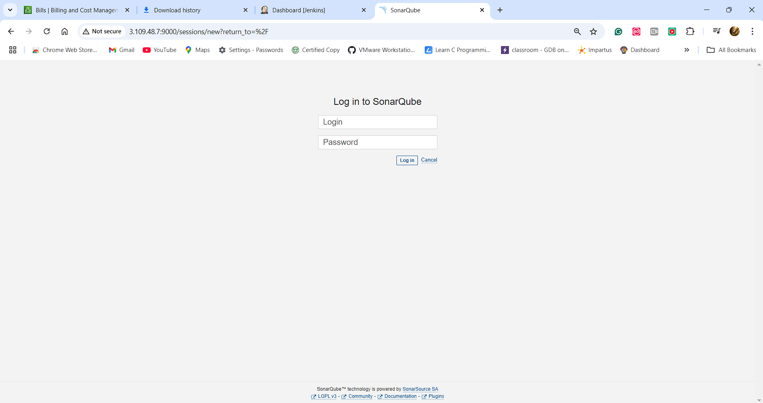

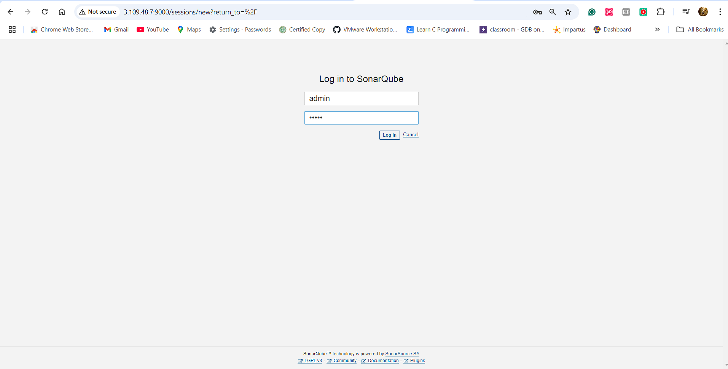

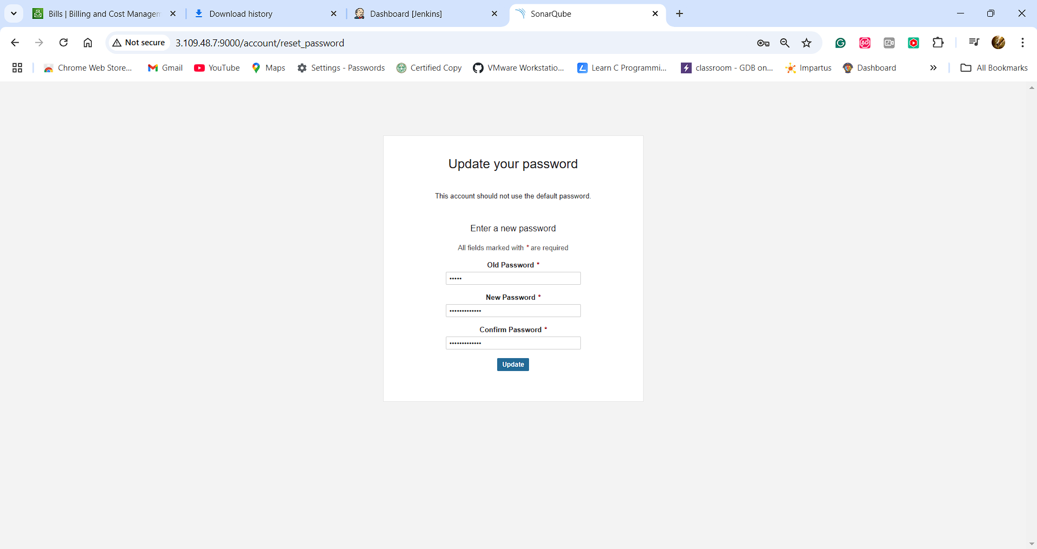

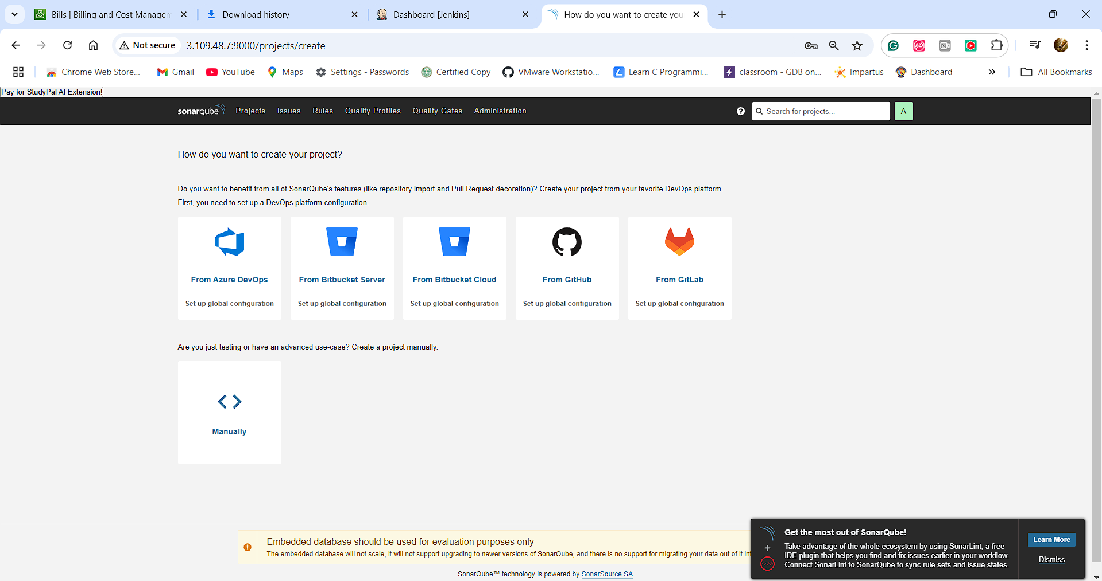

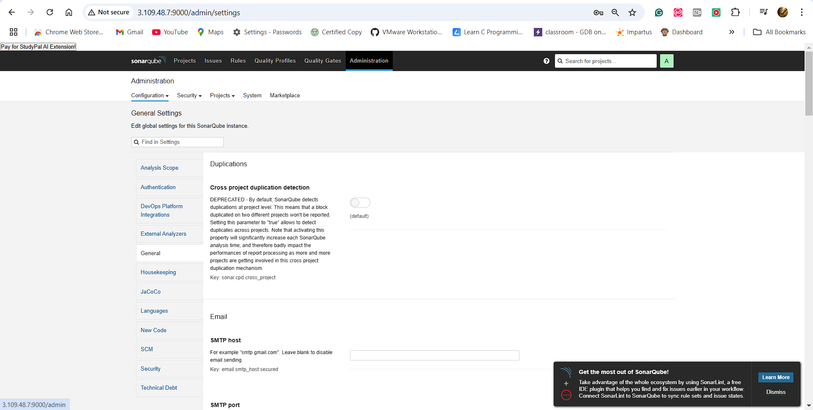

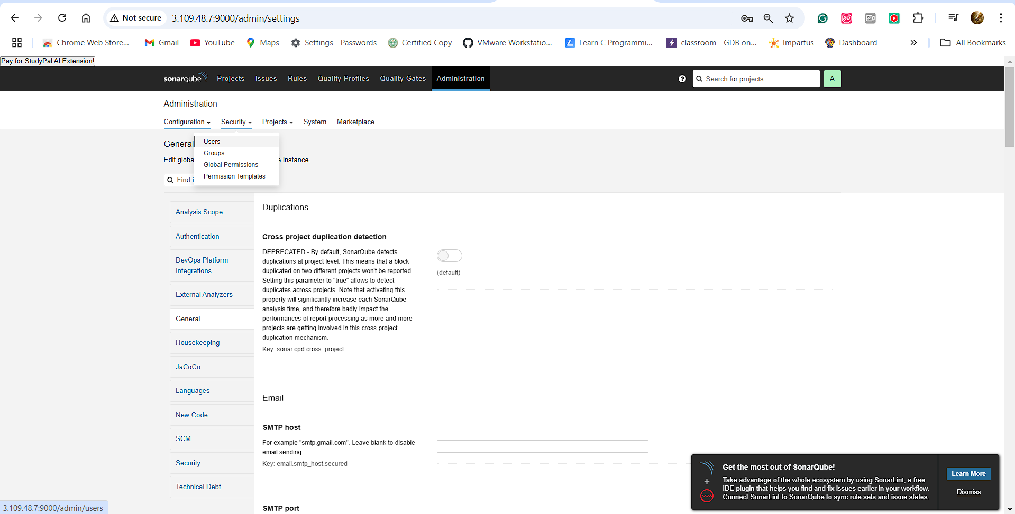

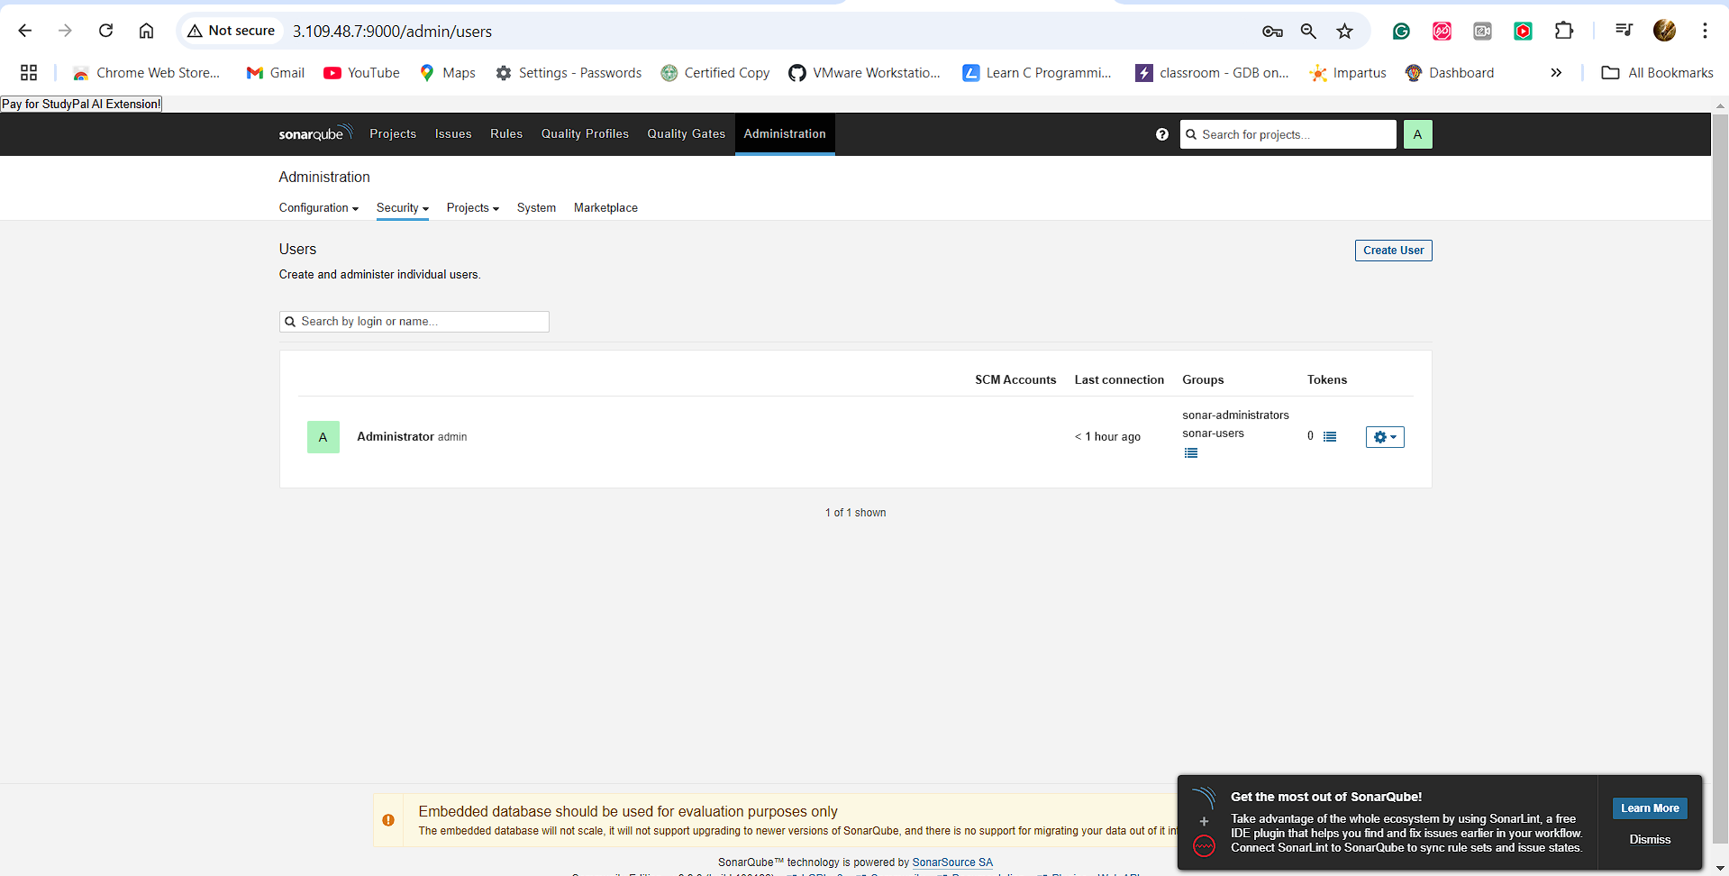

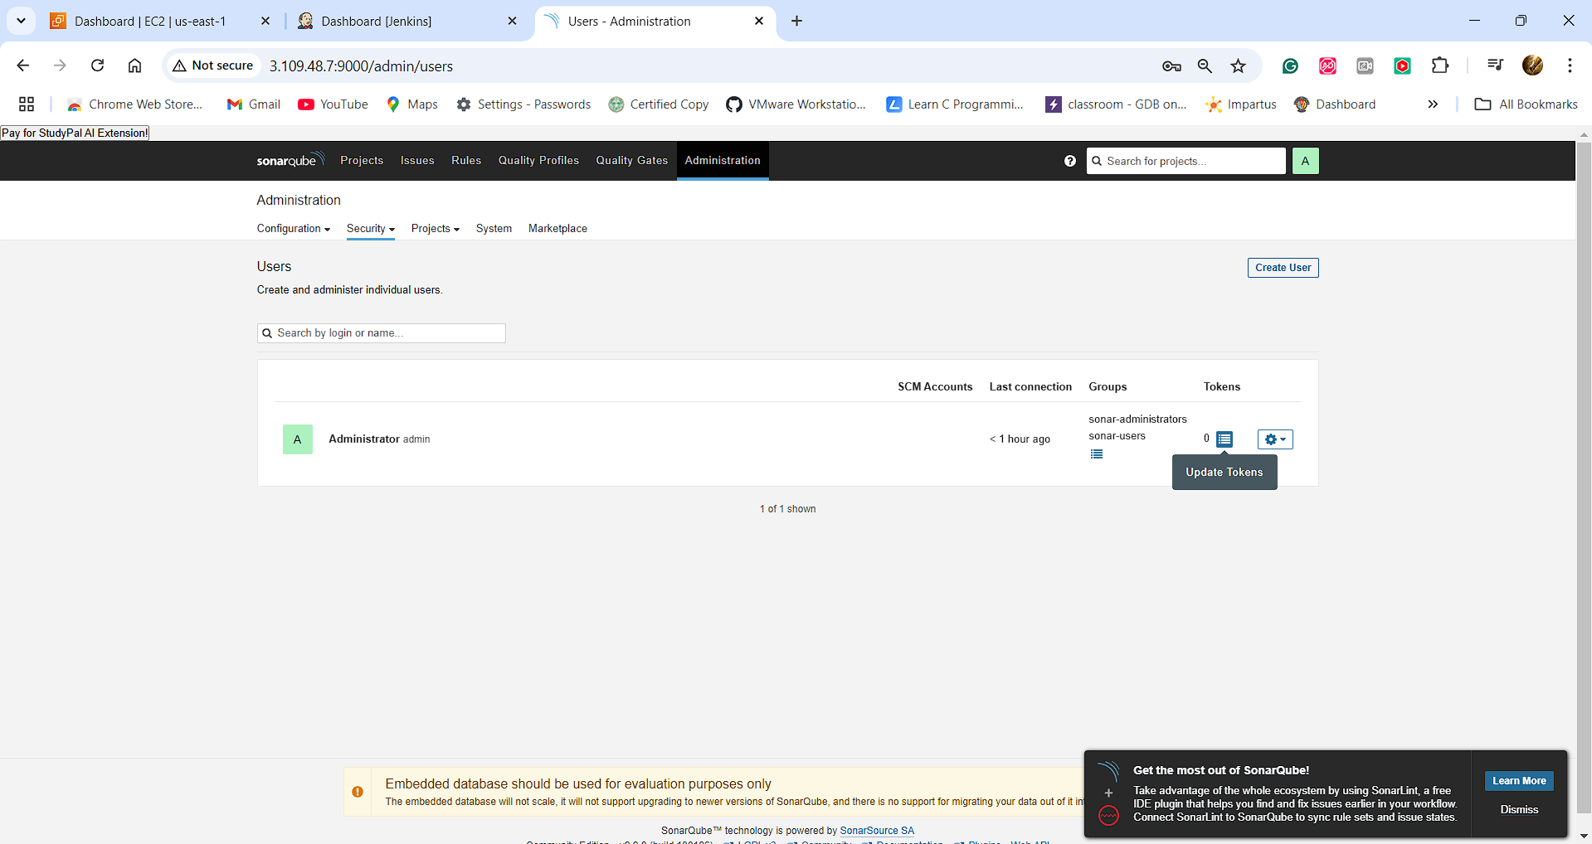

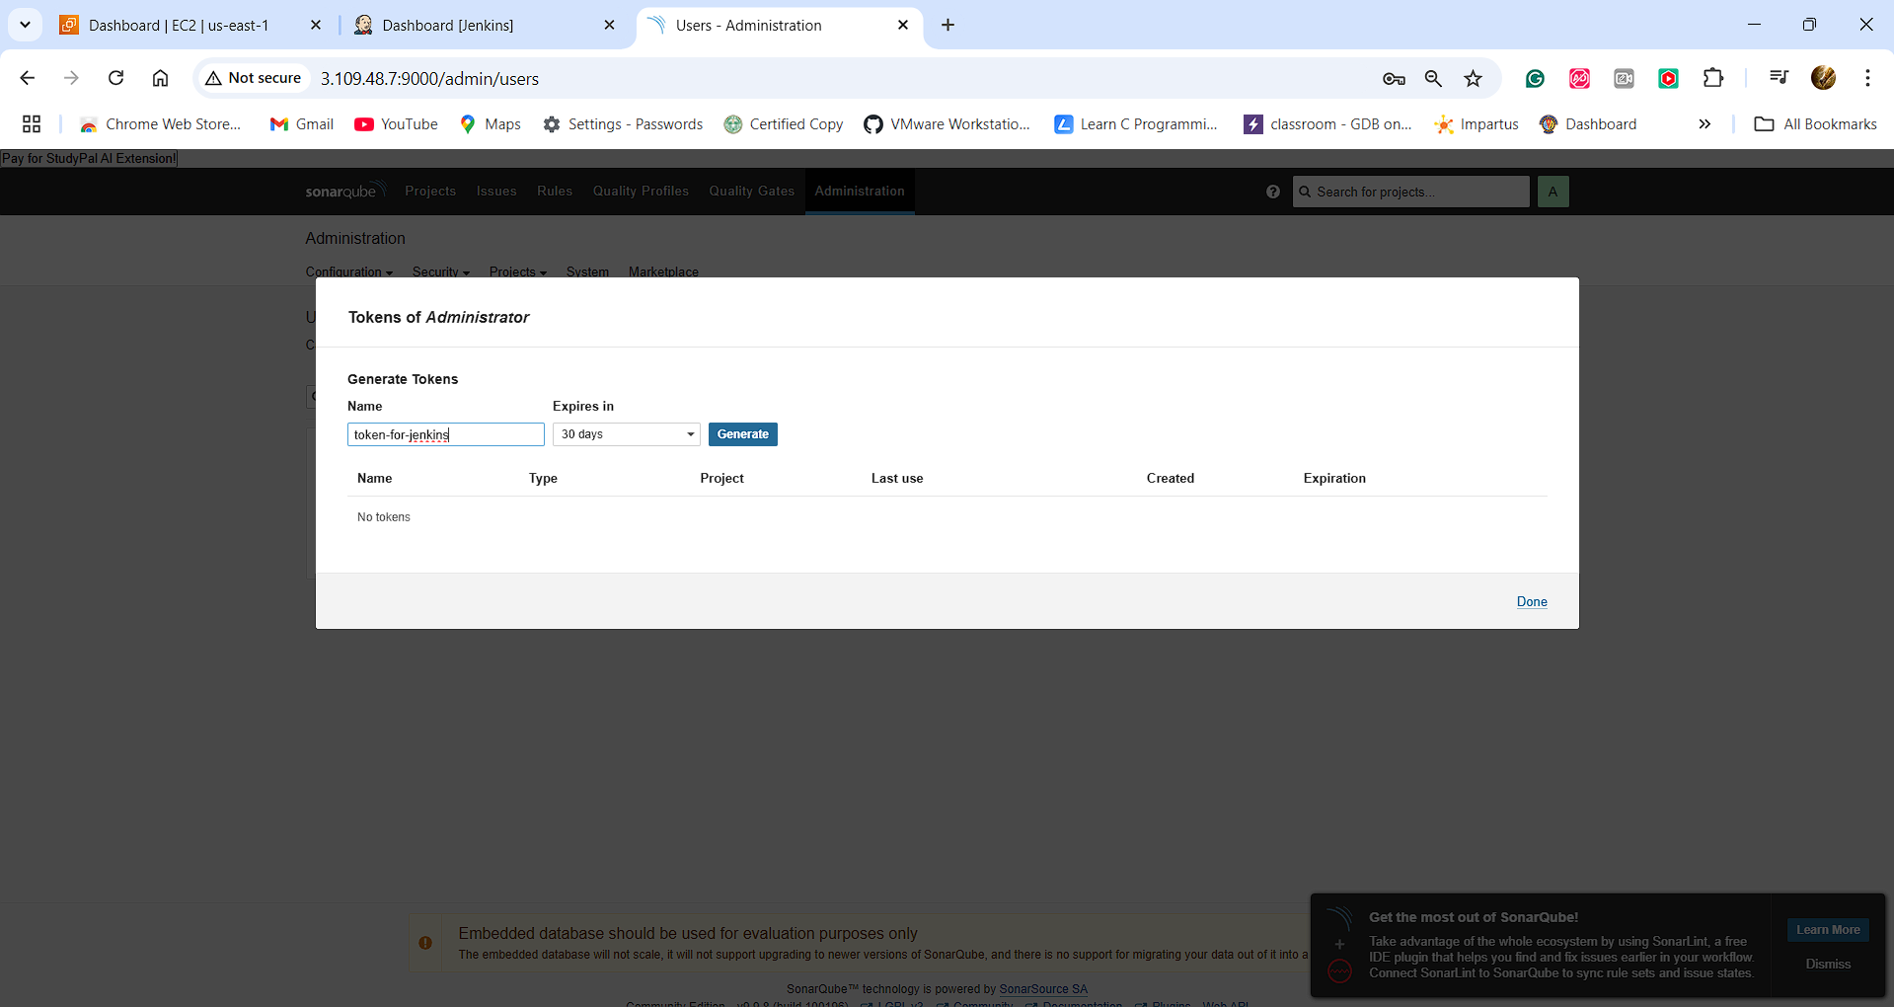

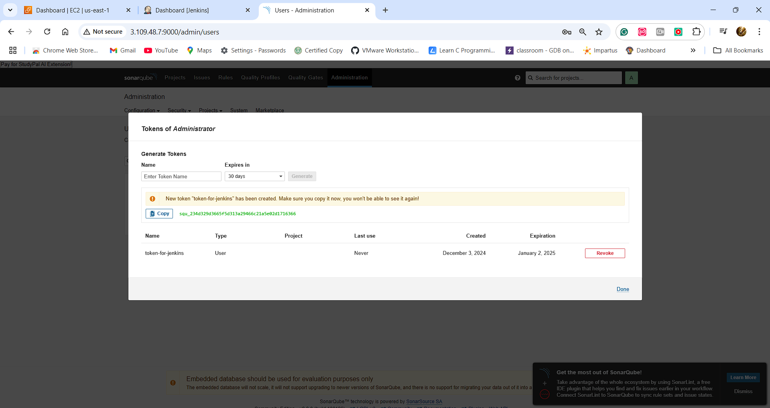

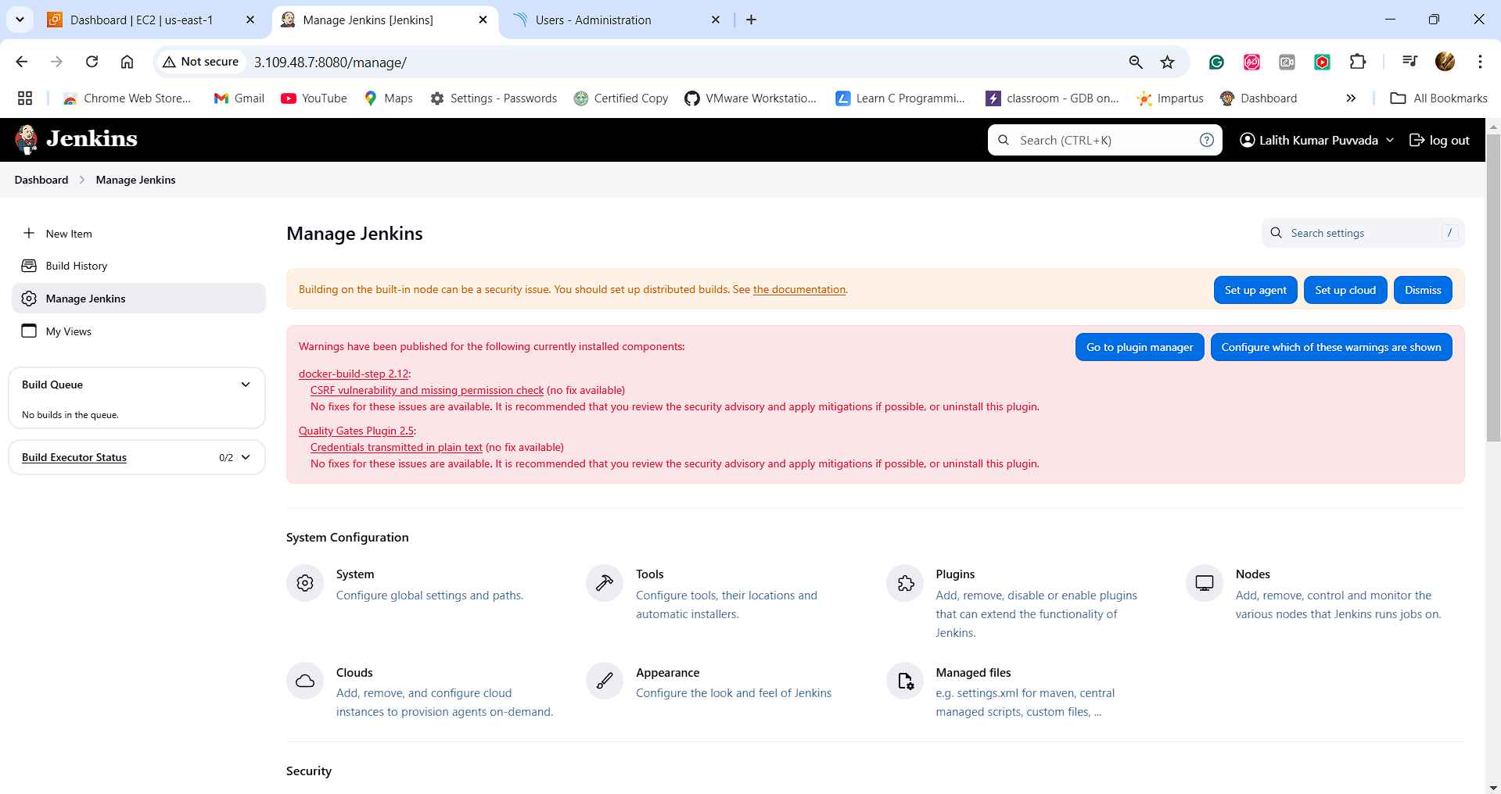

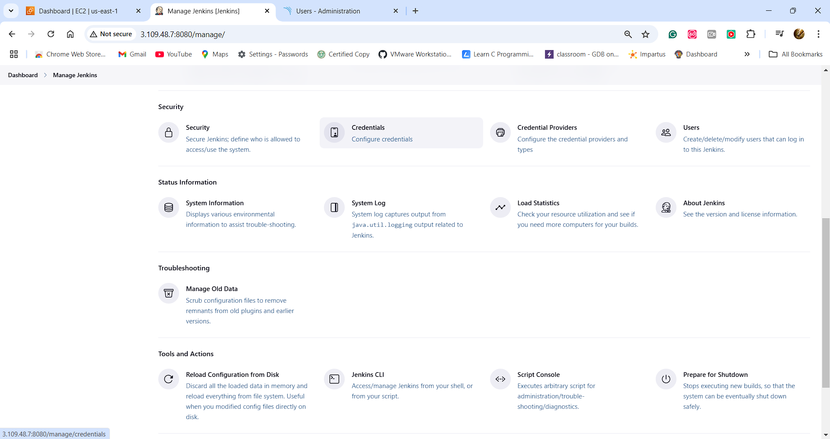

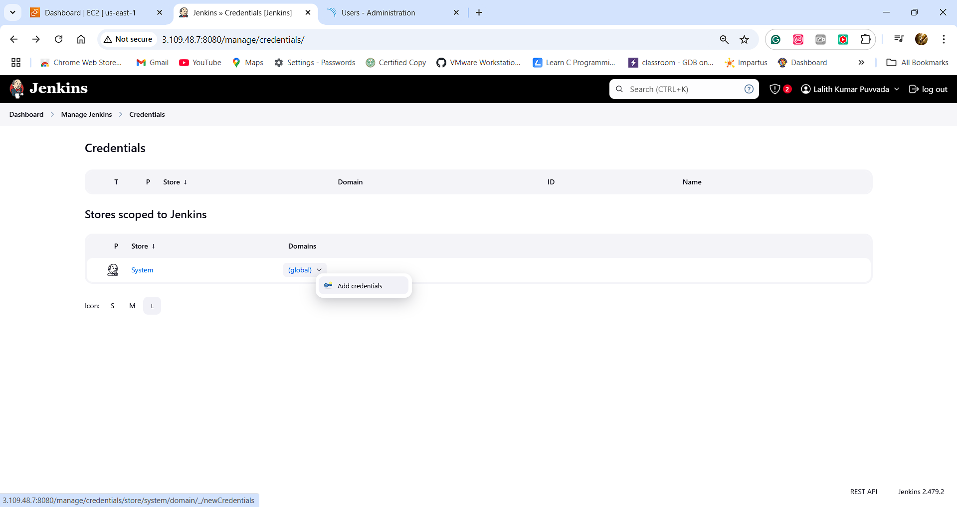

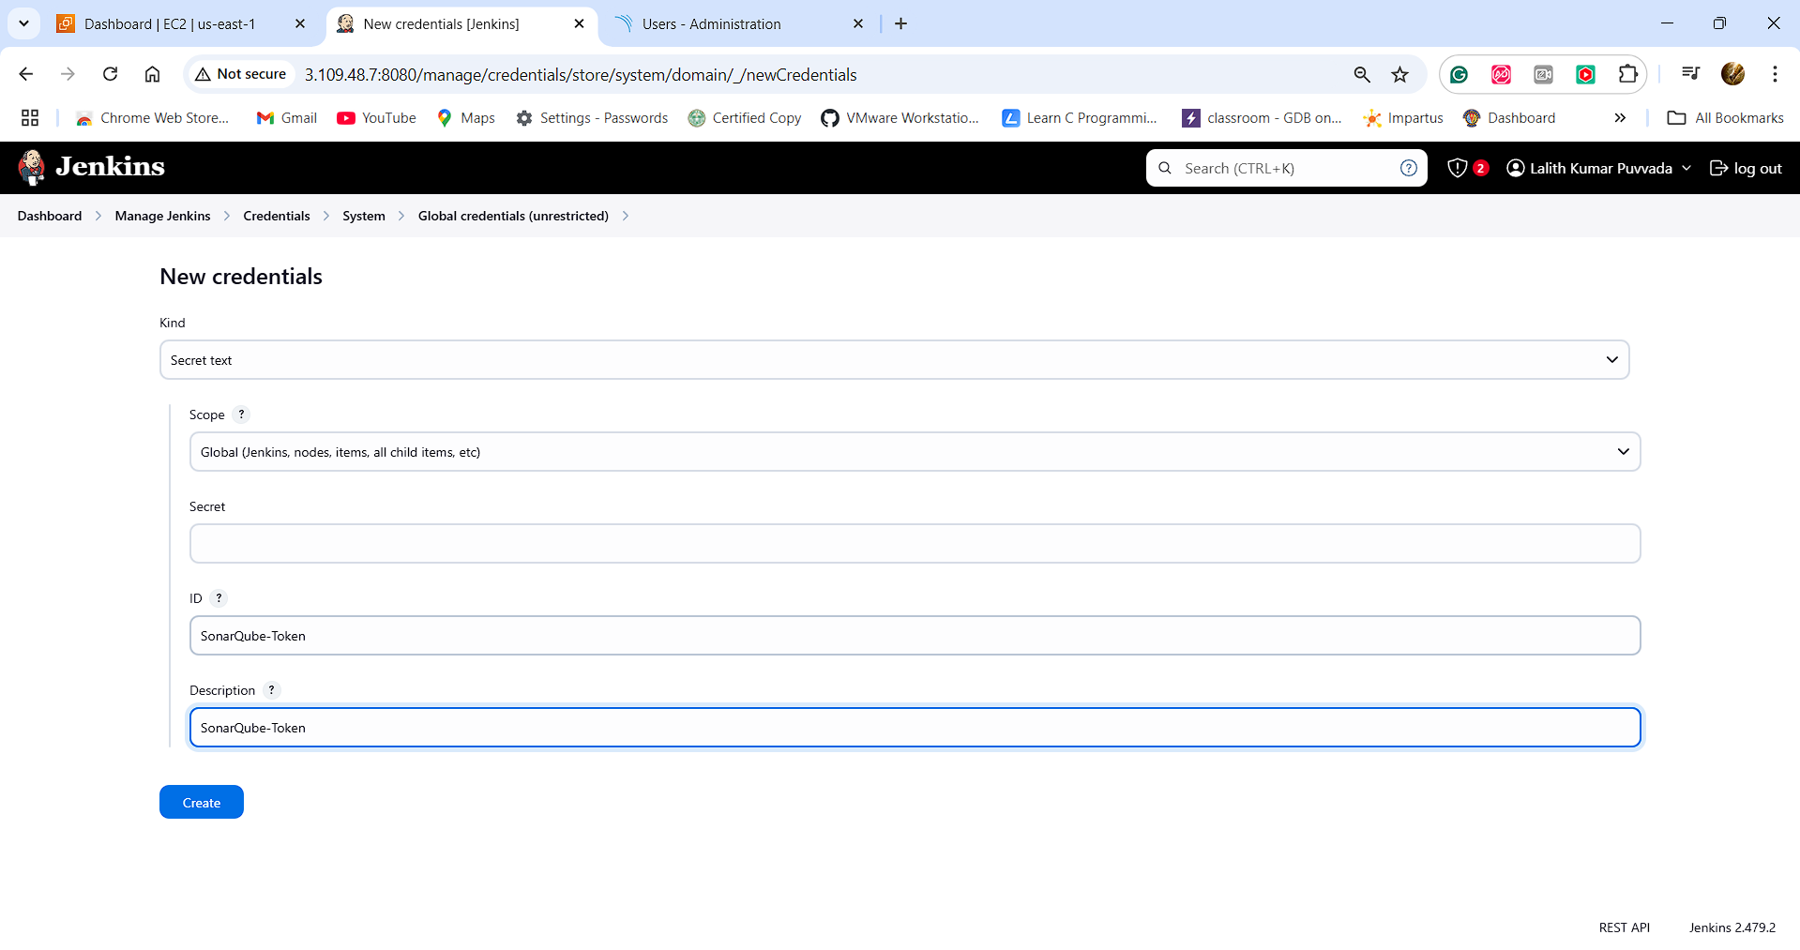

**Copied the secret:** 

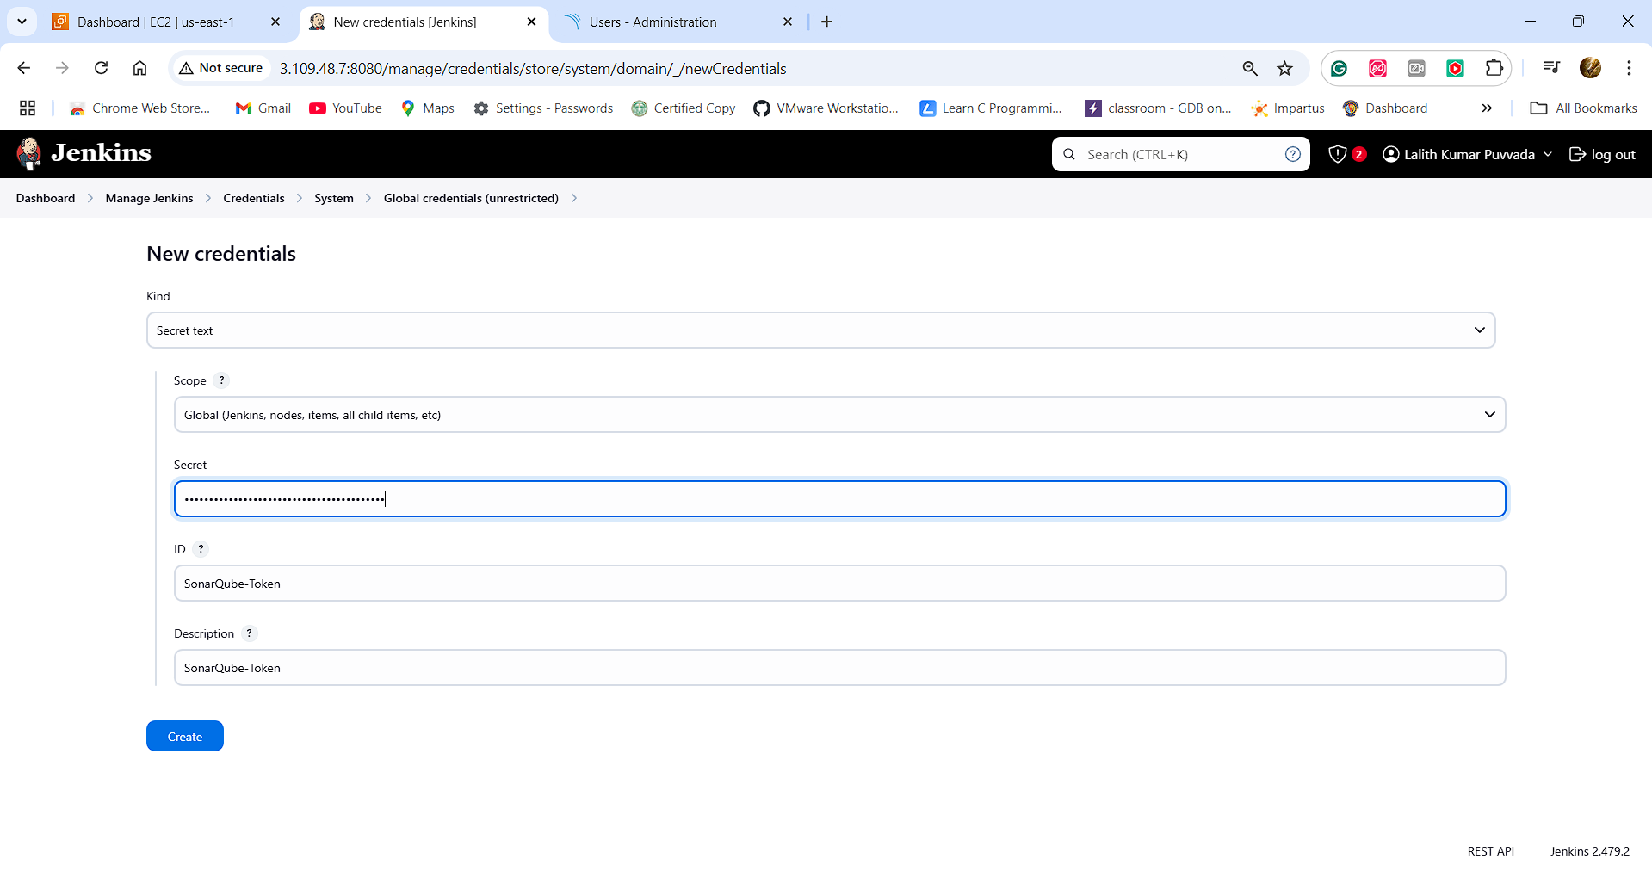

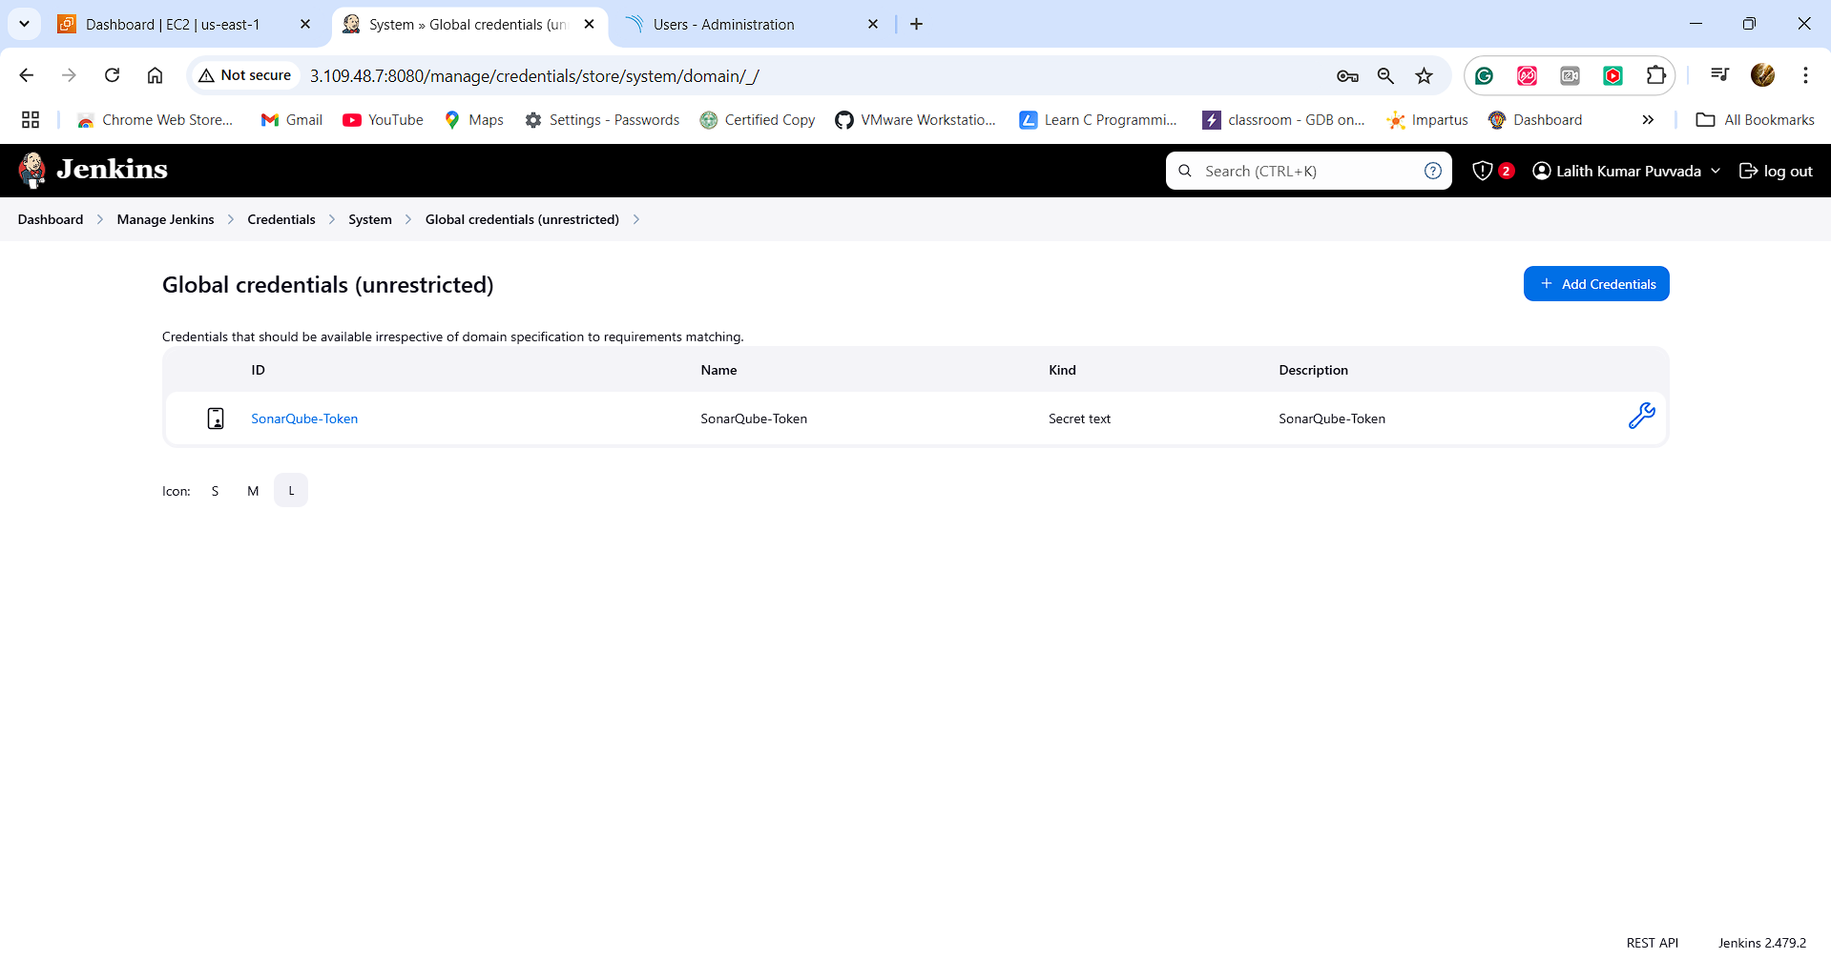

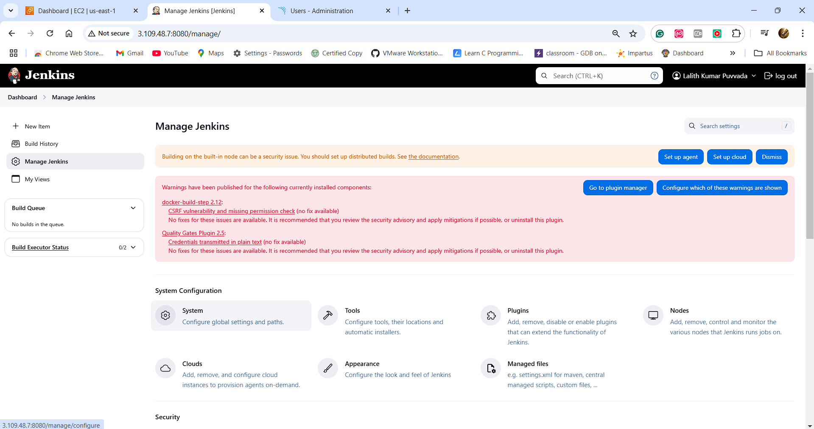

**We need to add SonarQube Server**

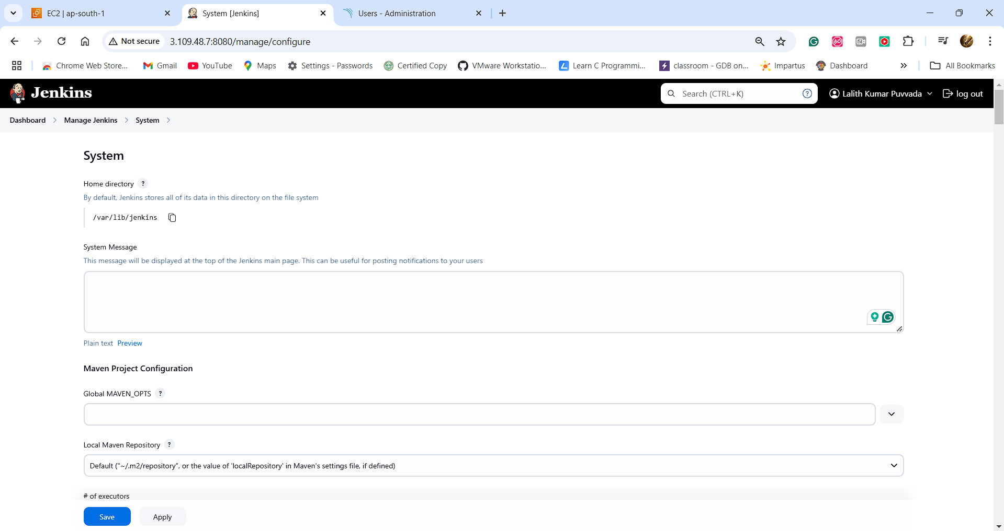

**SCROLL DOWN**

**Copy the private IP from here**

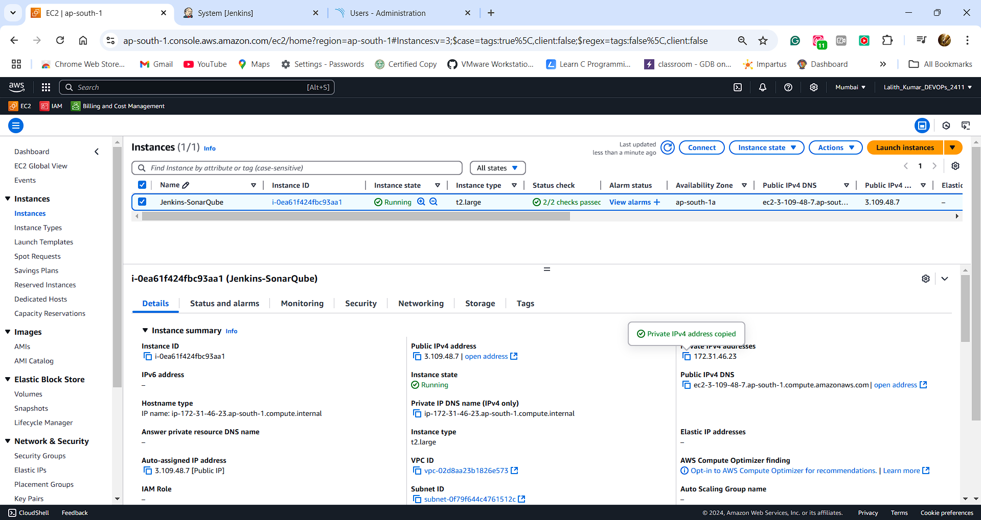

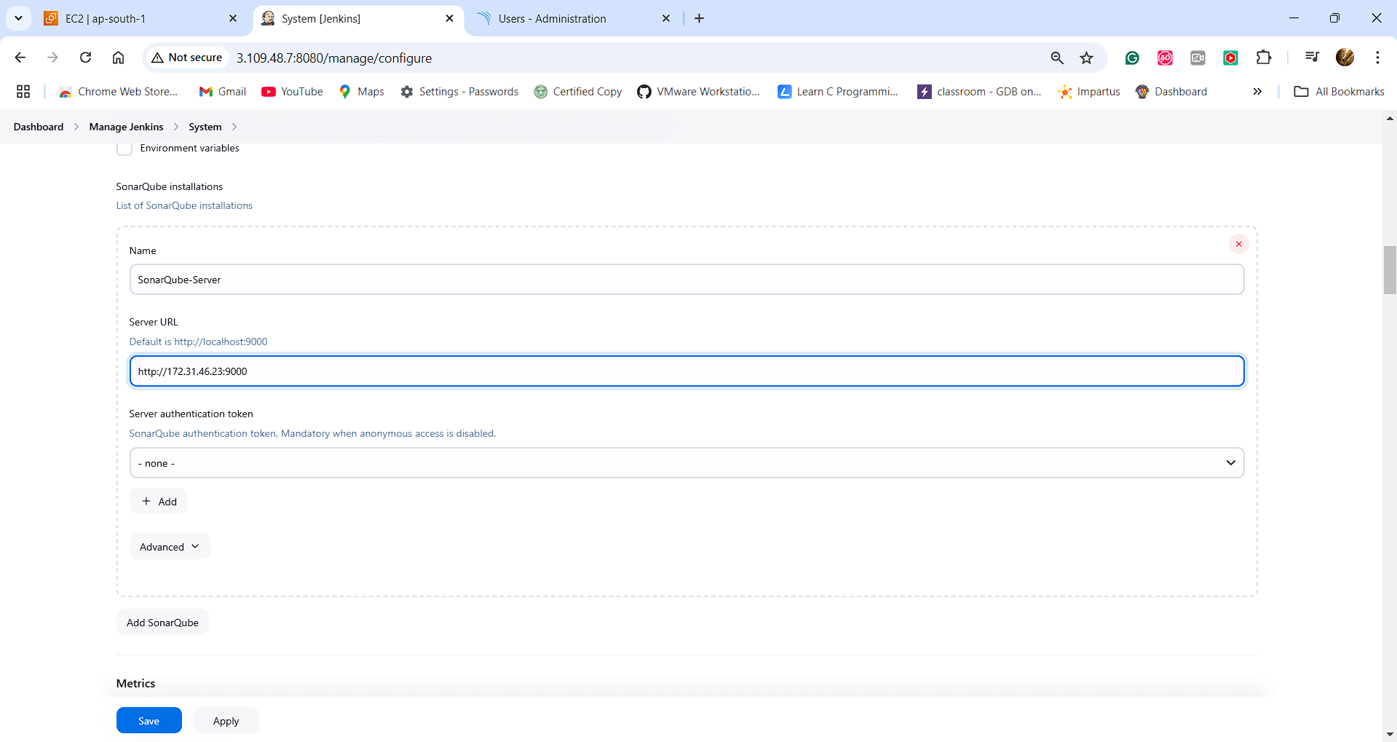

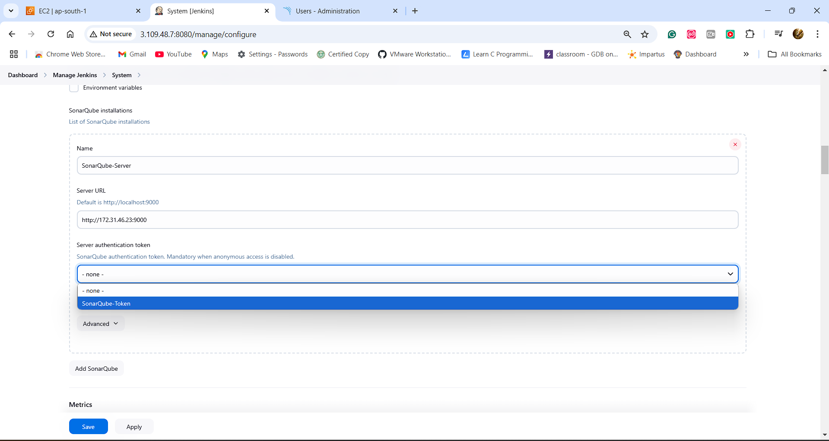

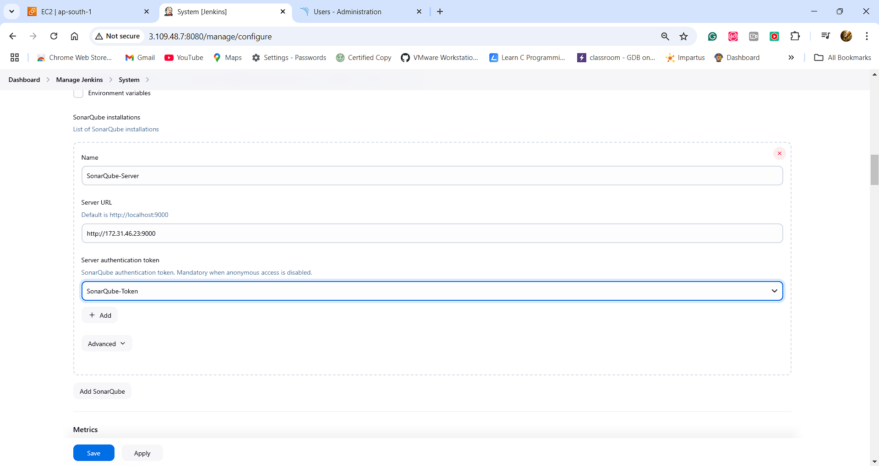

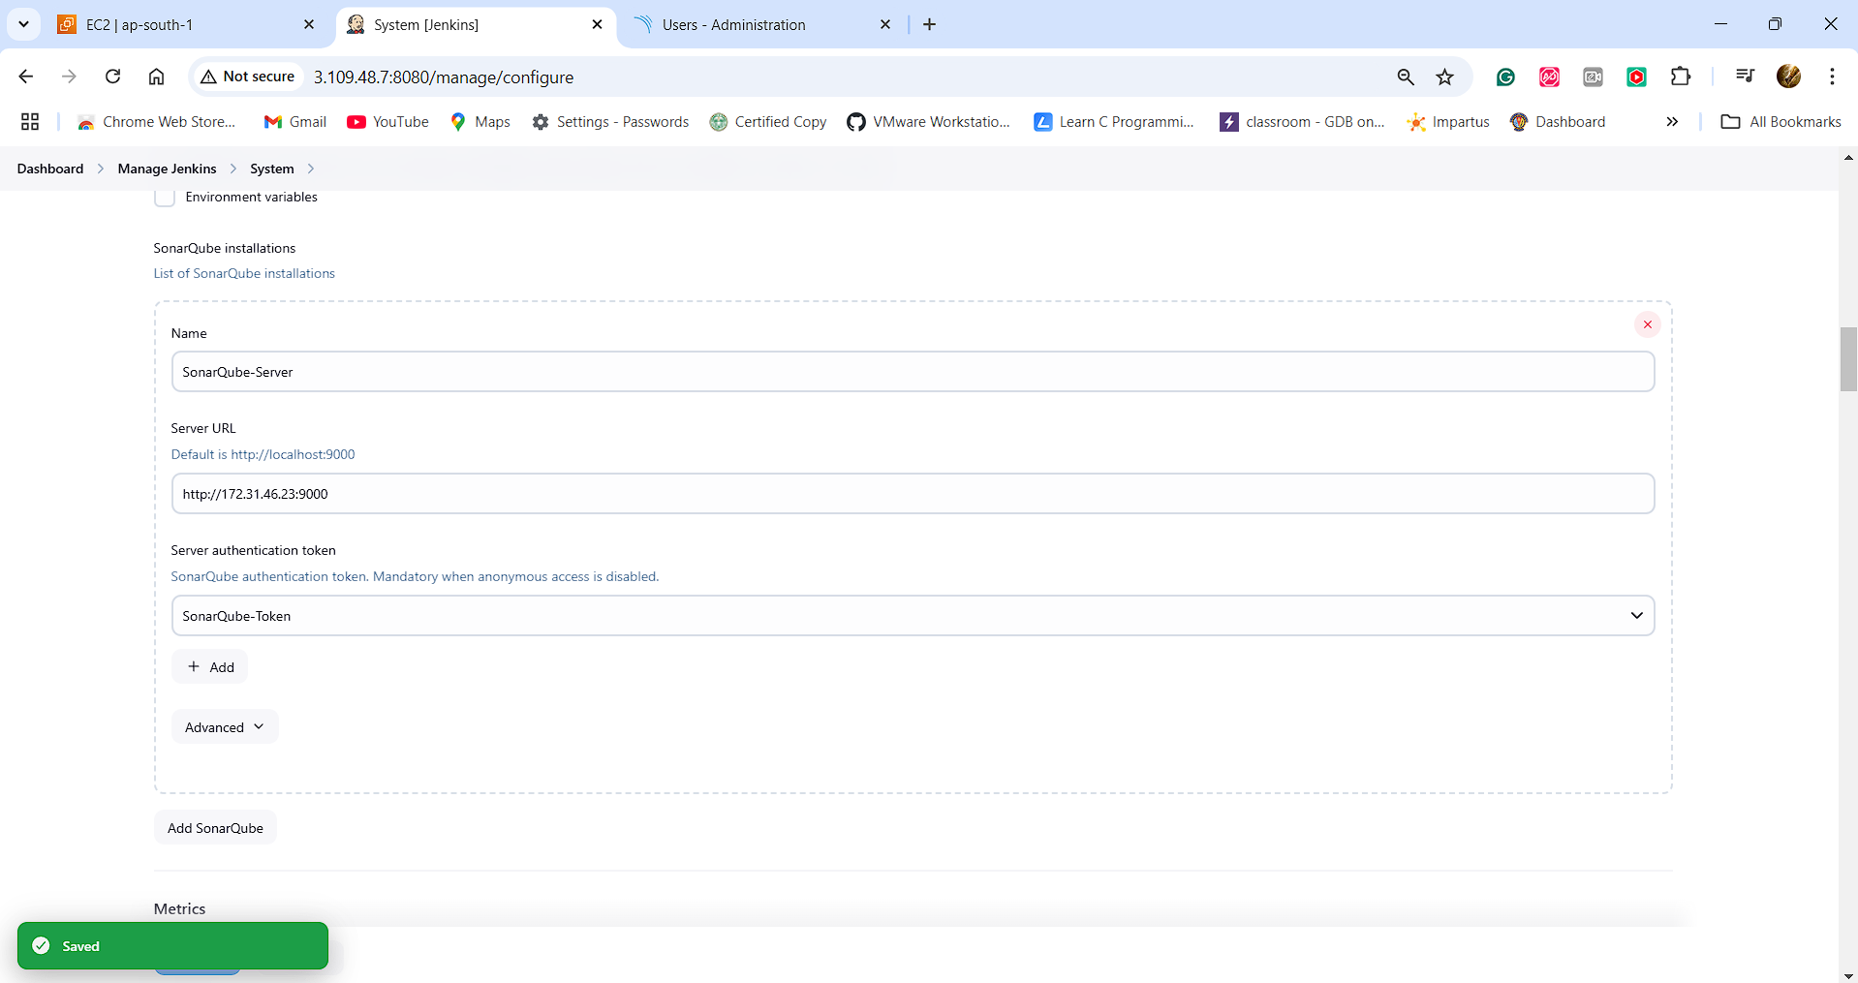

**Create Quality Gate:**

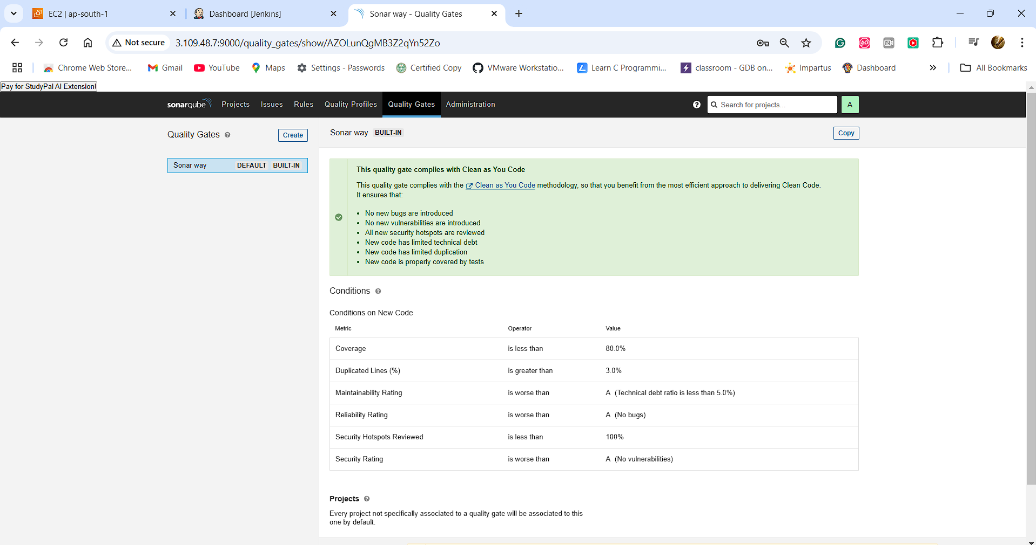

**Click on Create and give name SonarQube-Quality-Gate**

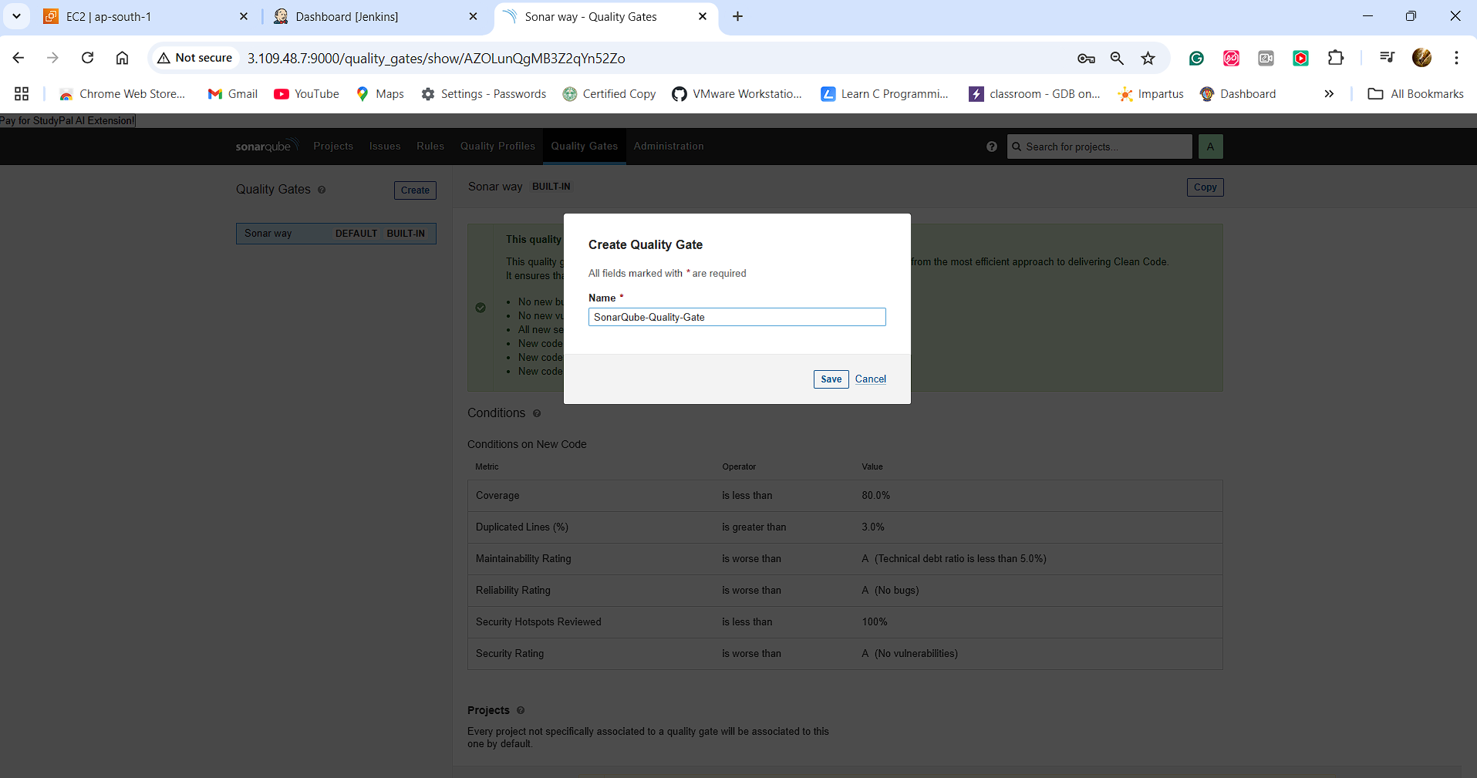

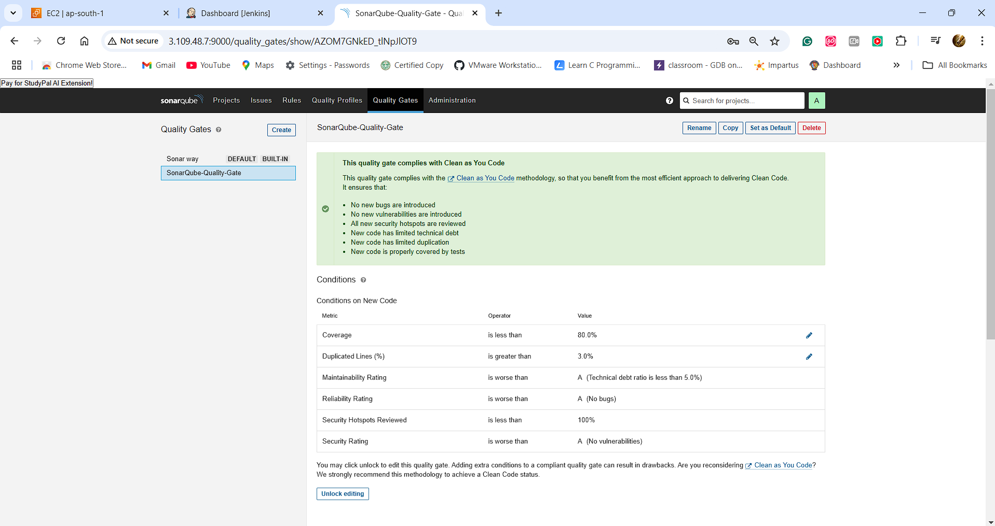

**Now we need to create a Web-hook between SonarQube and Jenkins:**

**Go to Administration and under configuration select Webhooks**

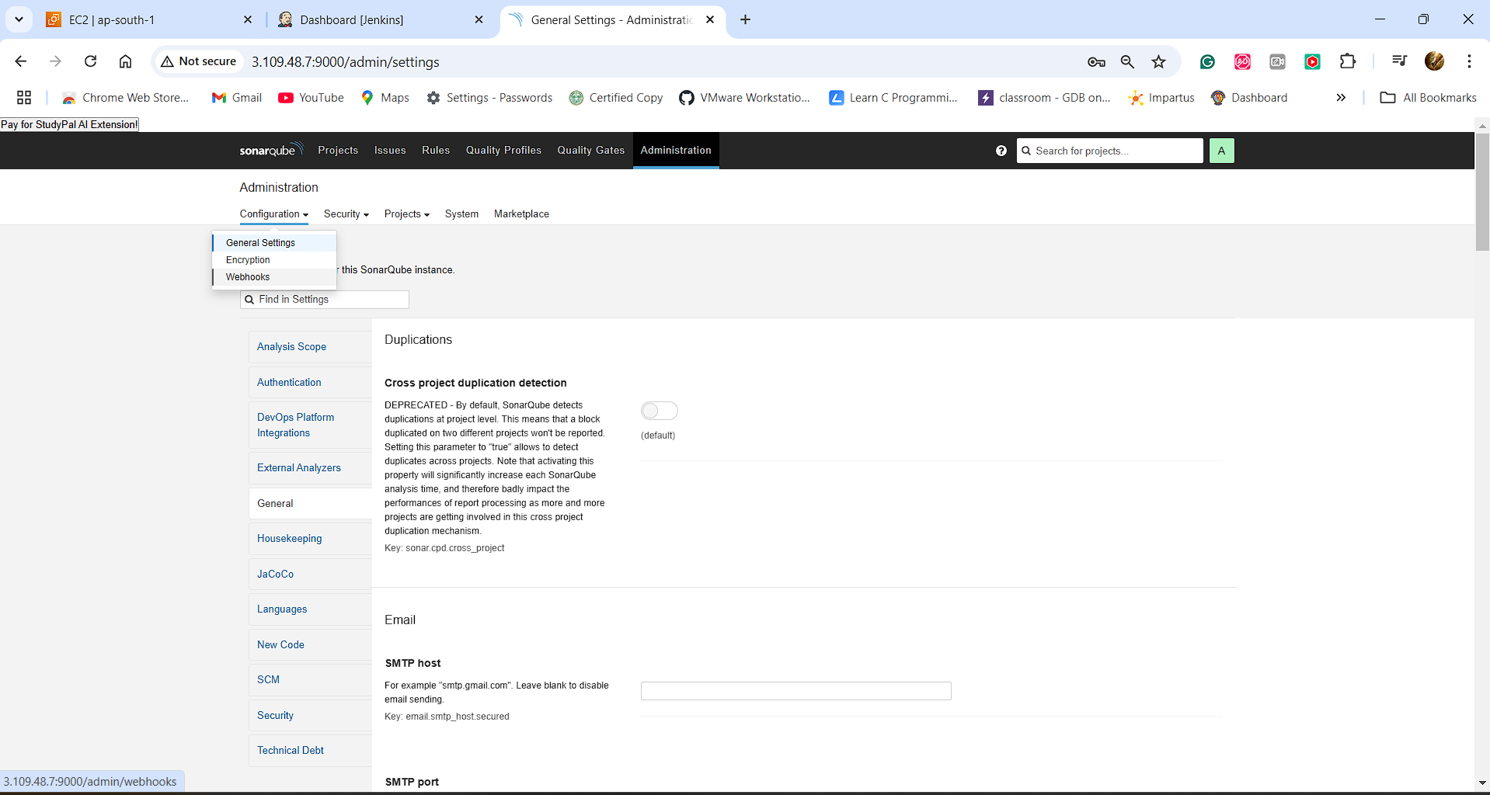

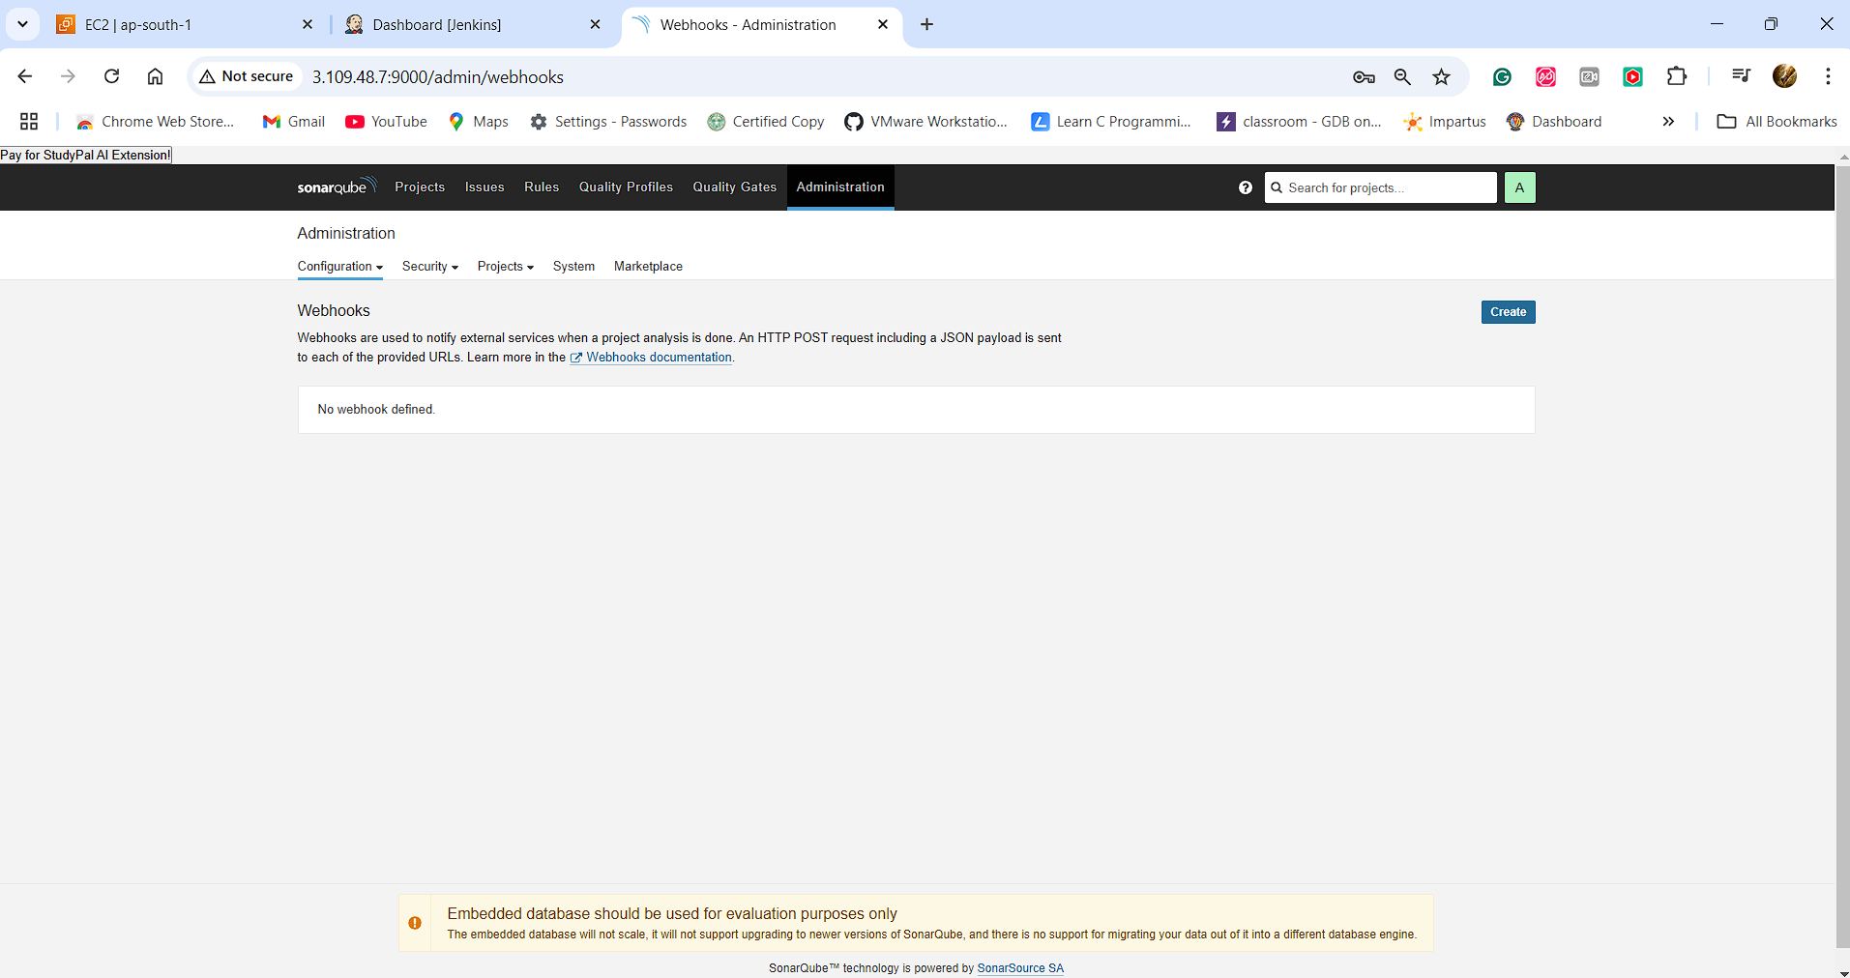

**Click on Create**

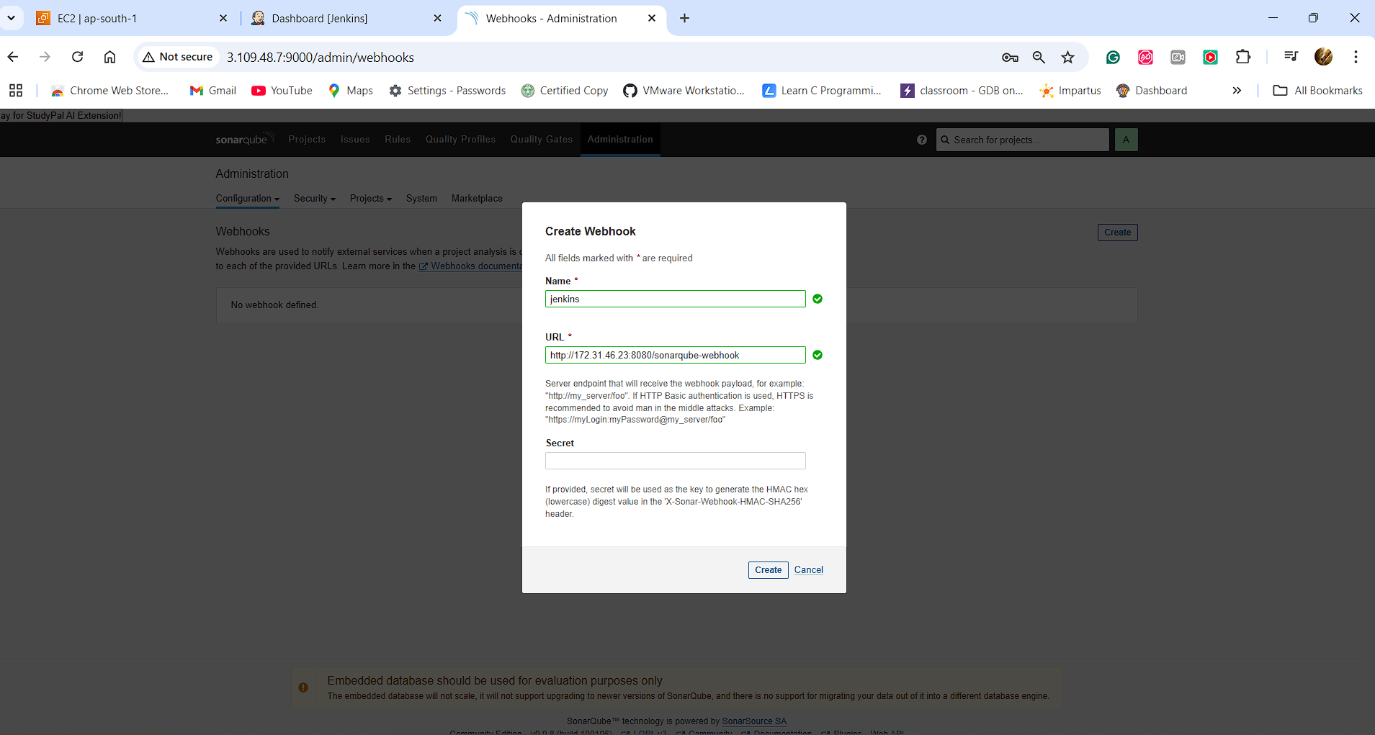

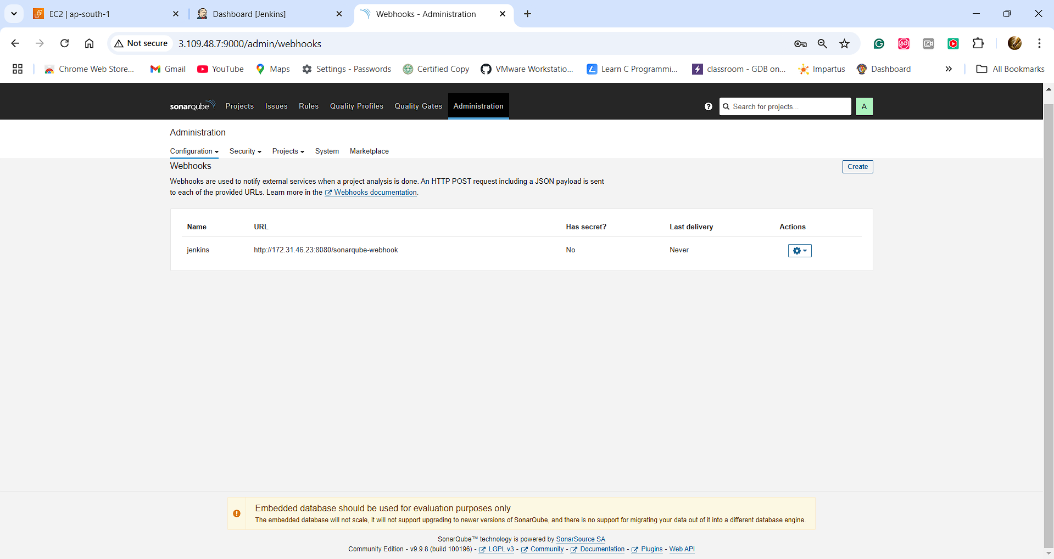

**3.Create Jenkins Pipeline to Build and Push Docker Image to Docker Hub:**

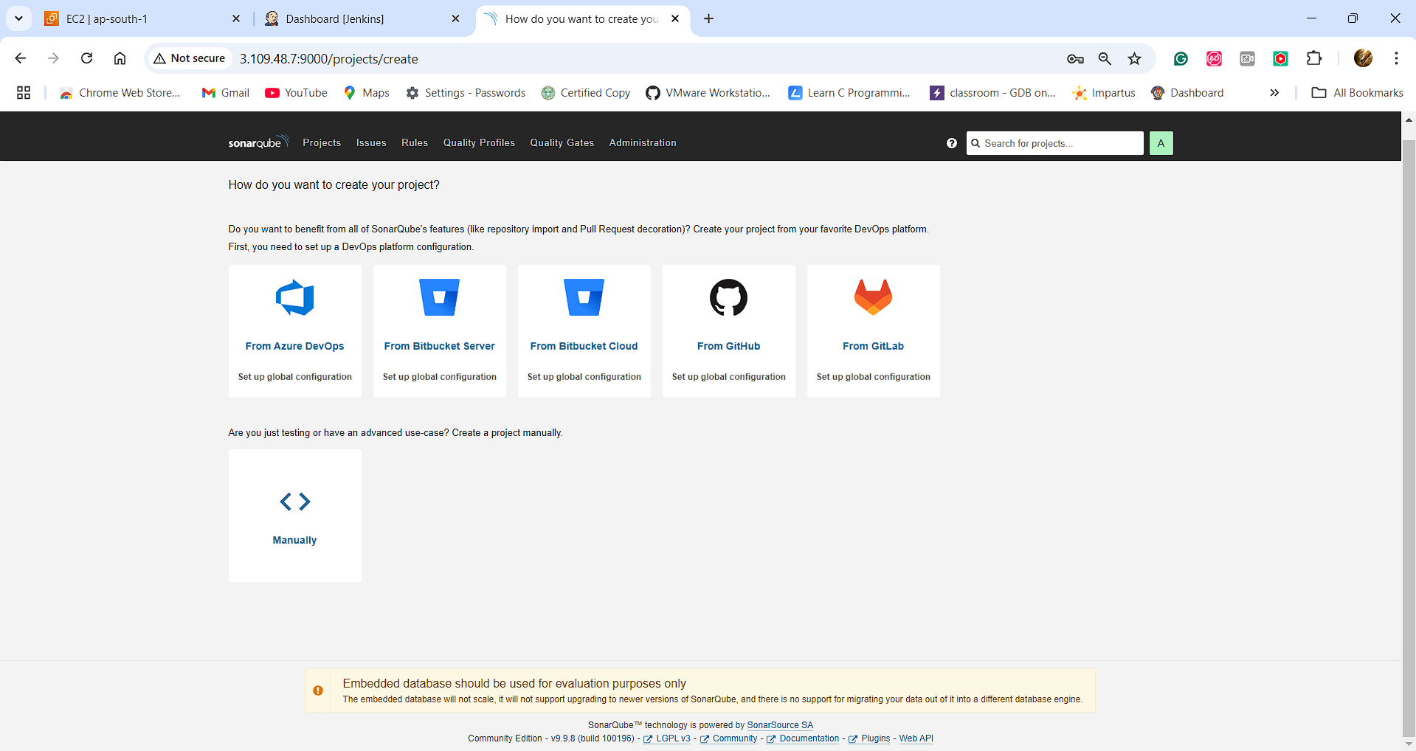

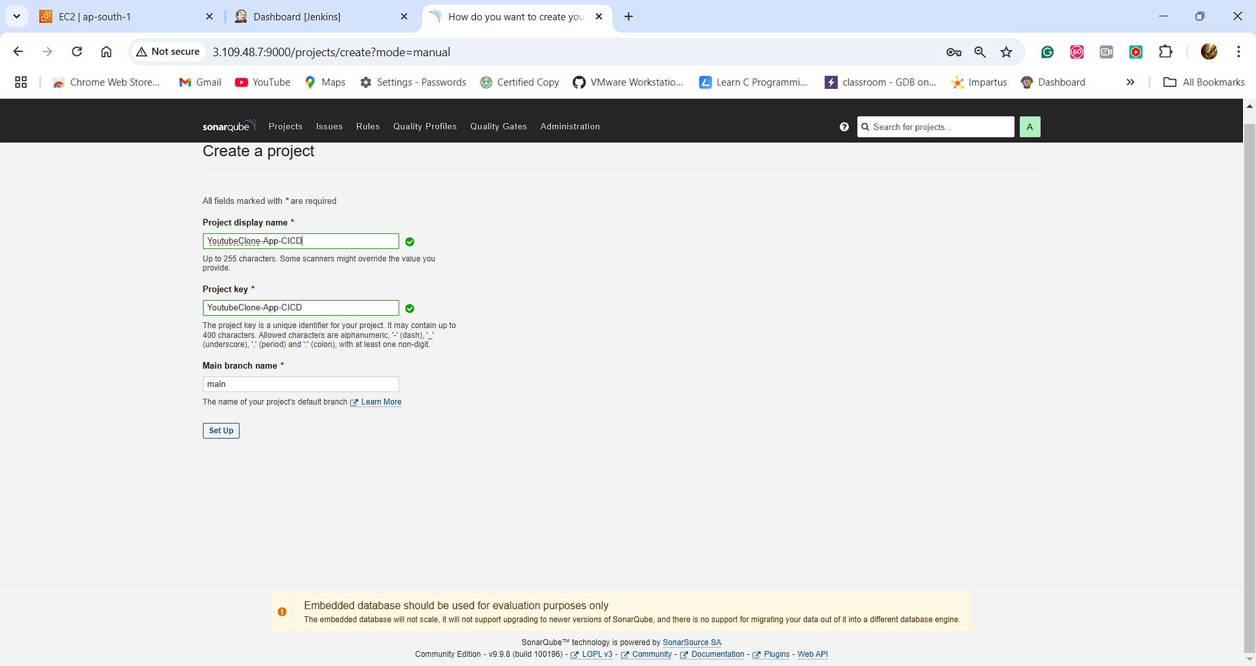

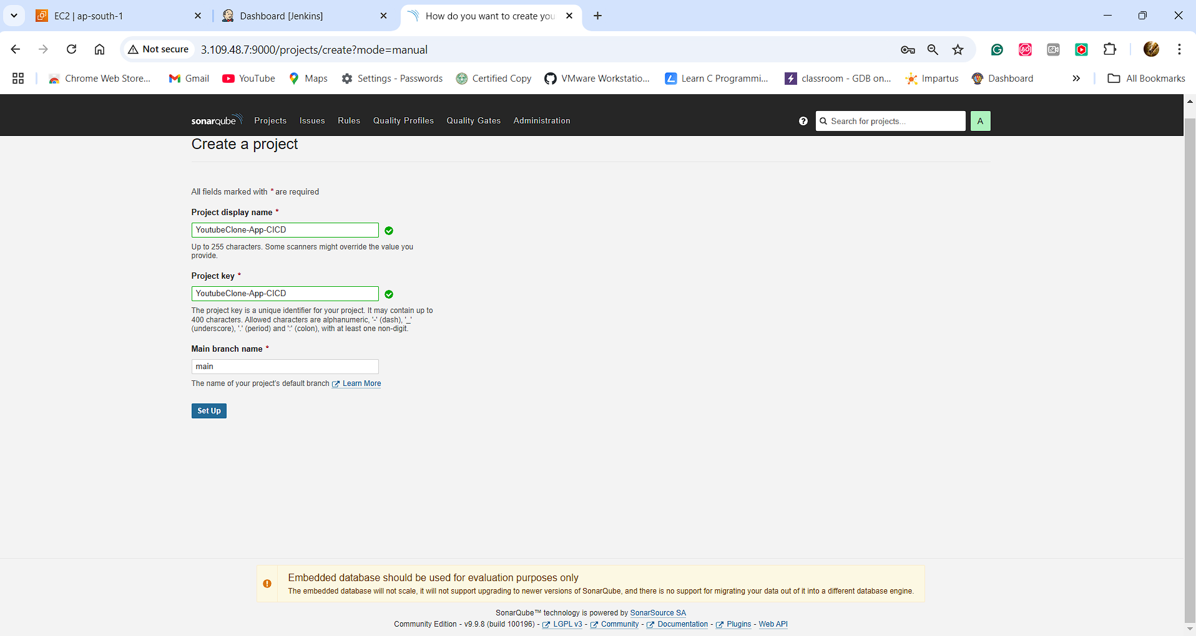

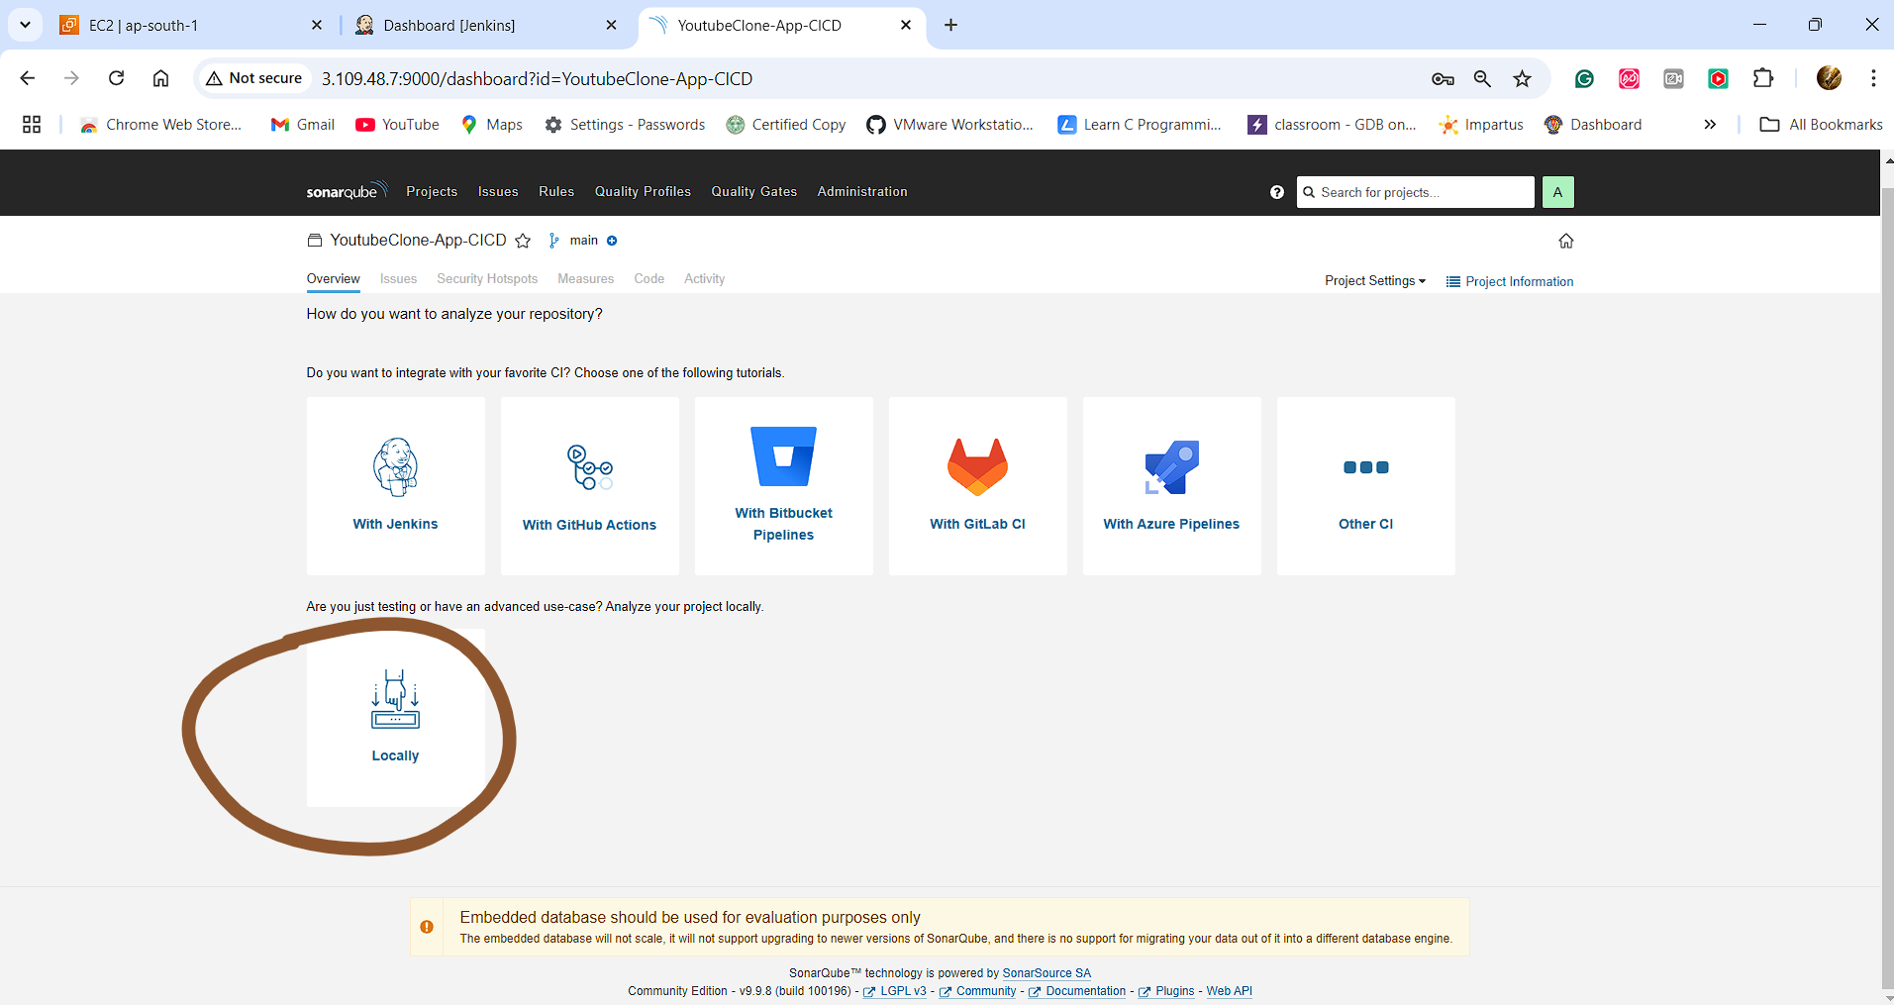

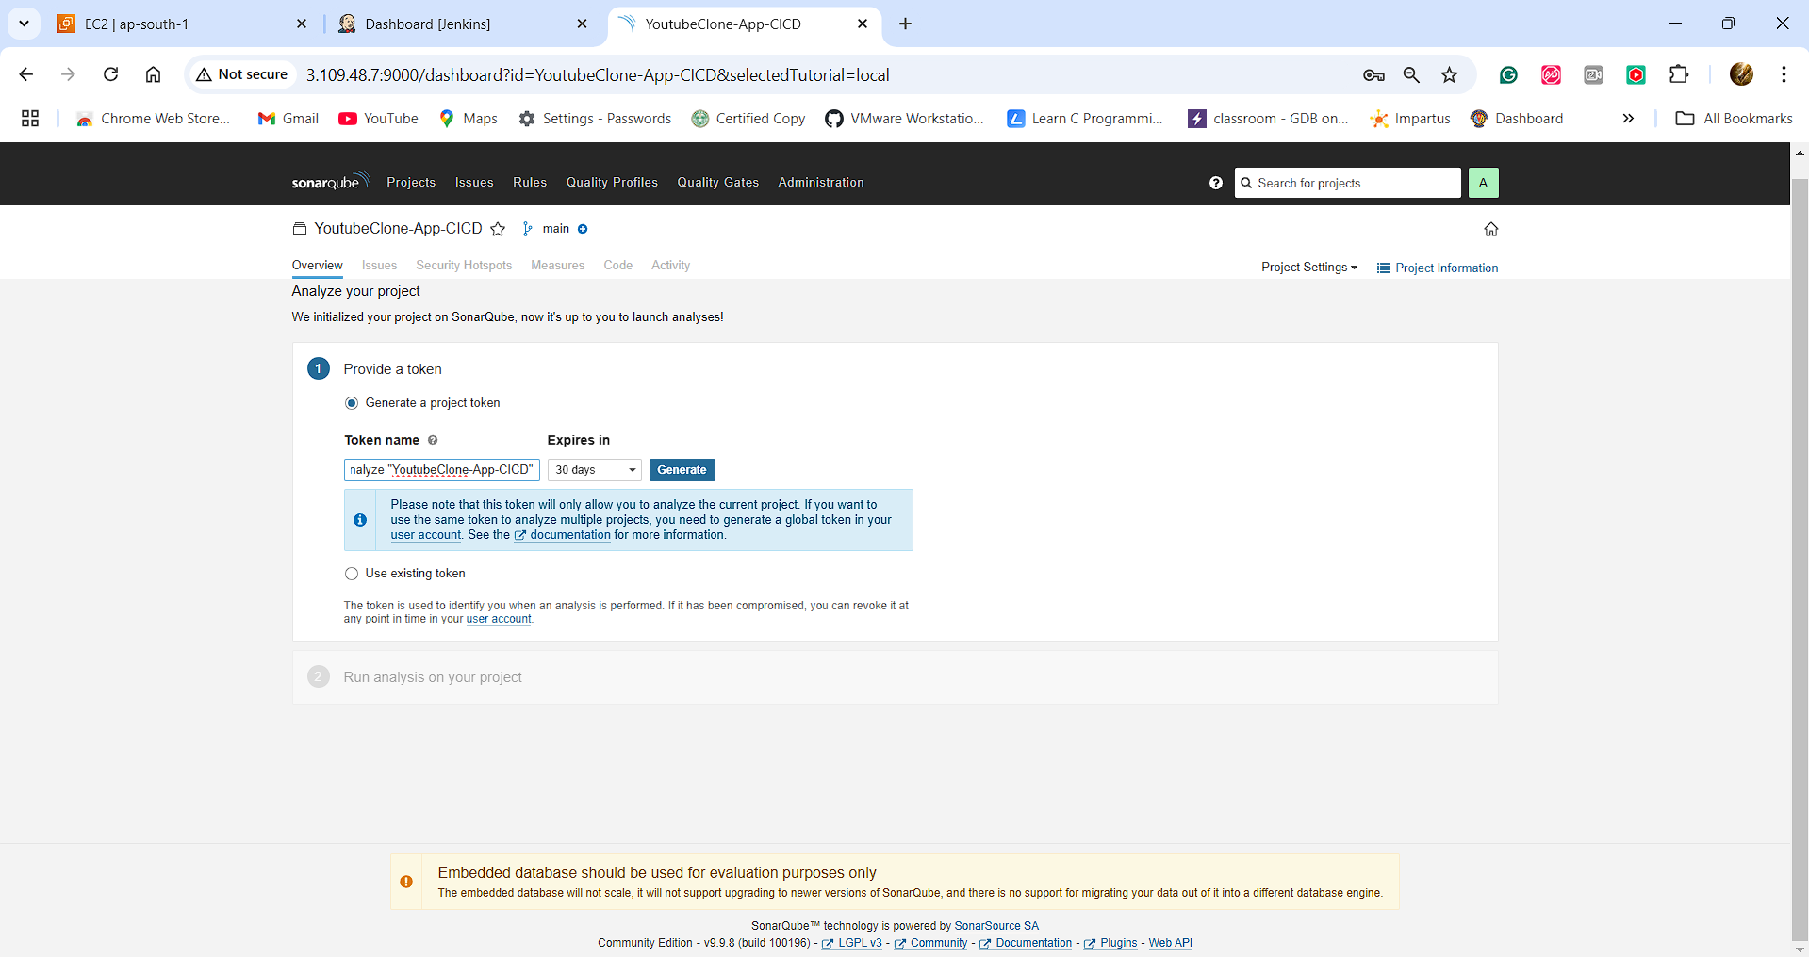

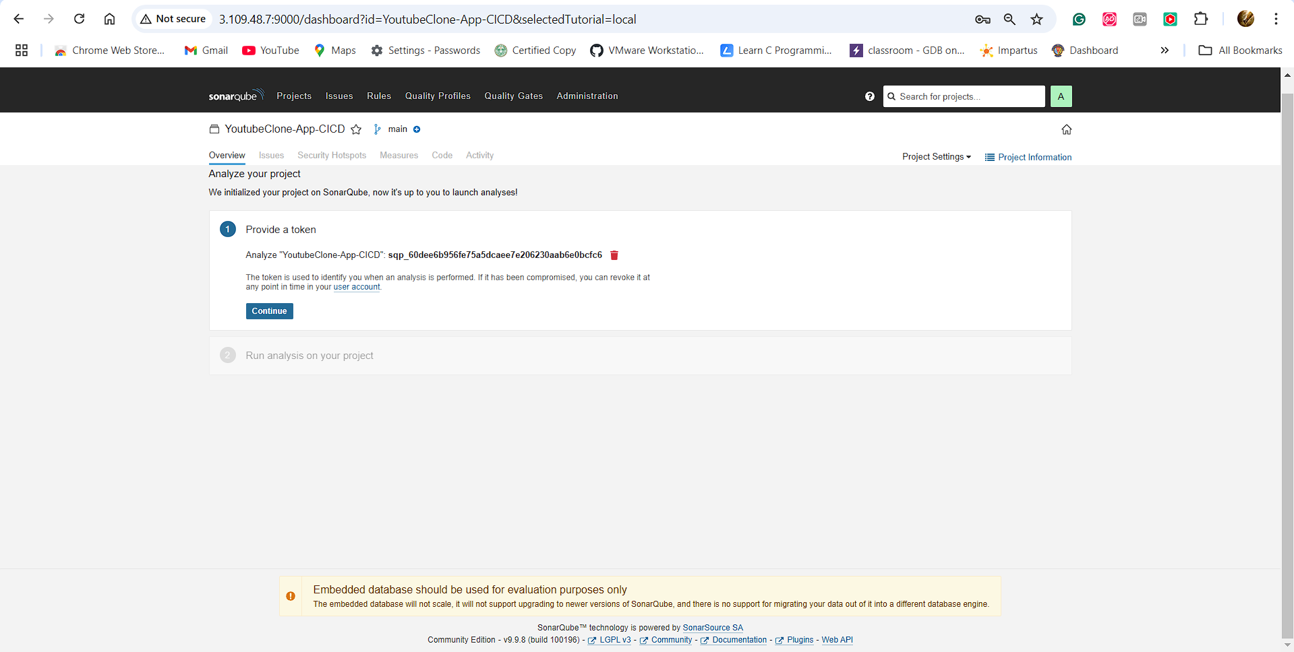

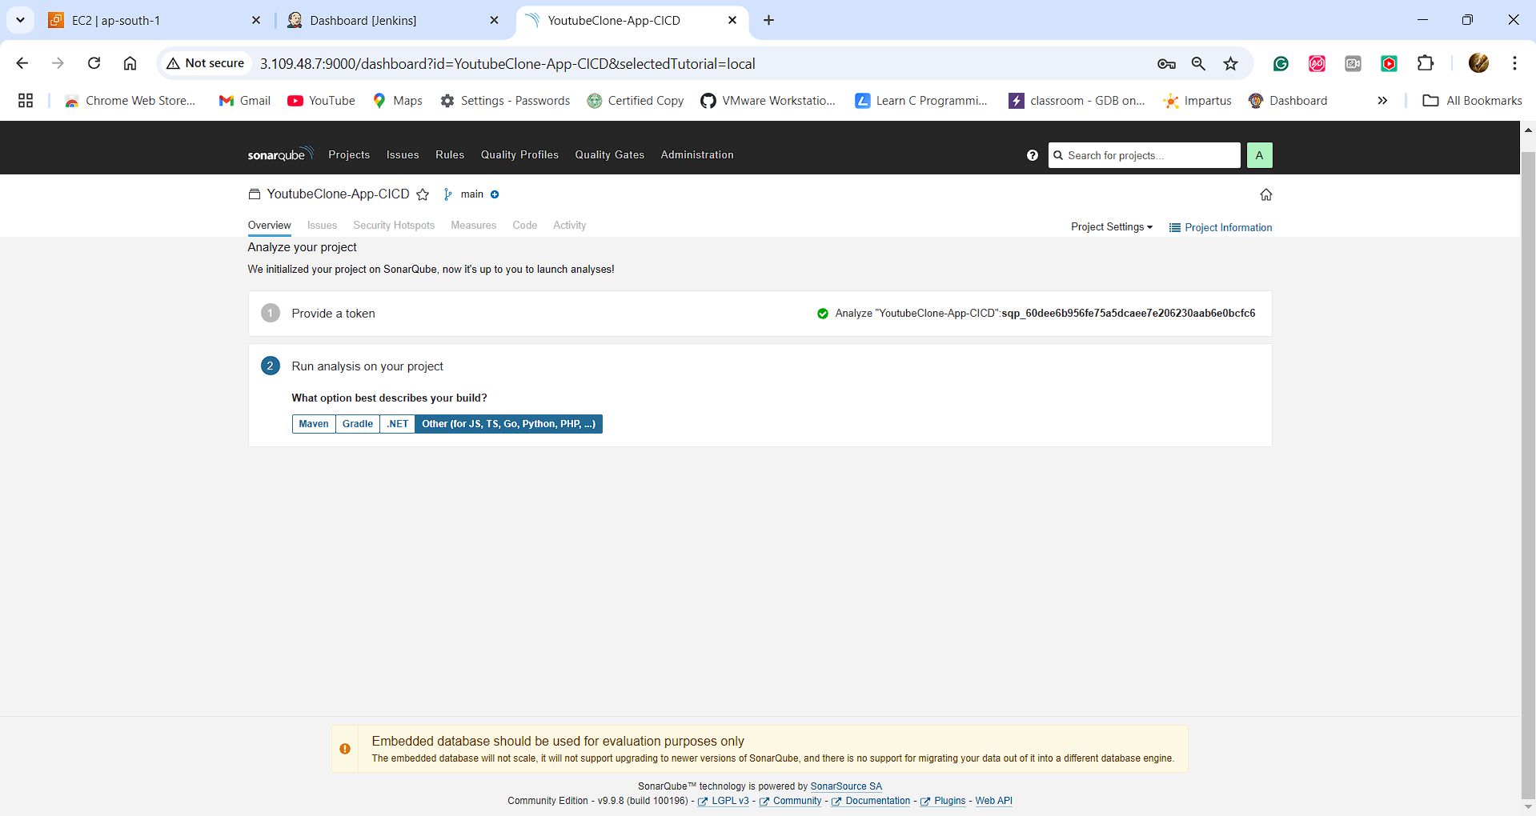

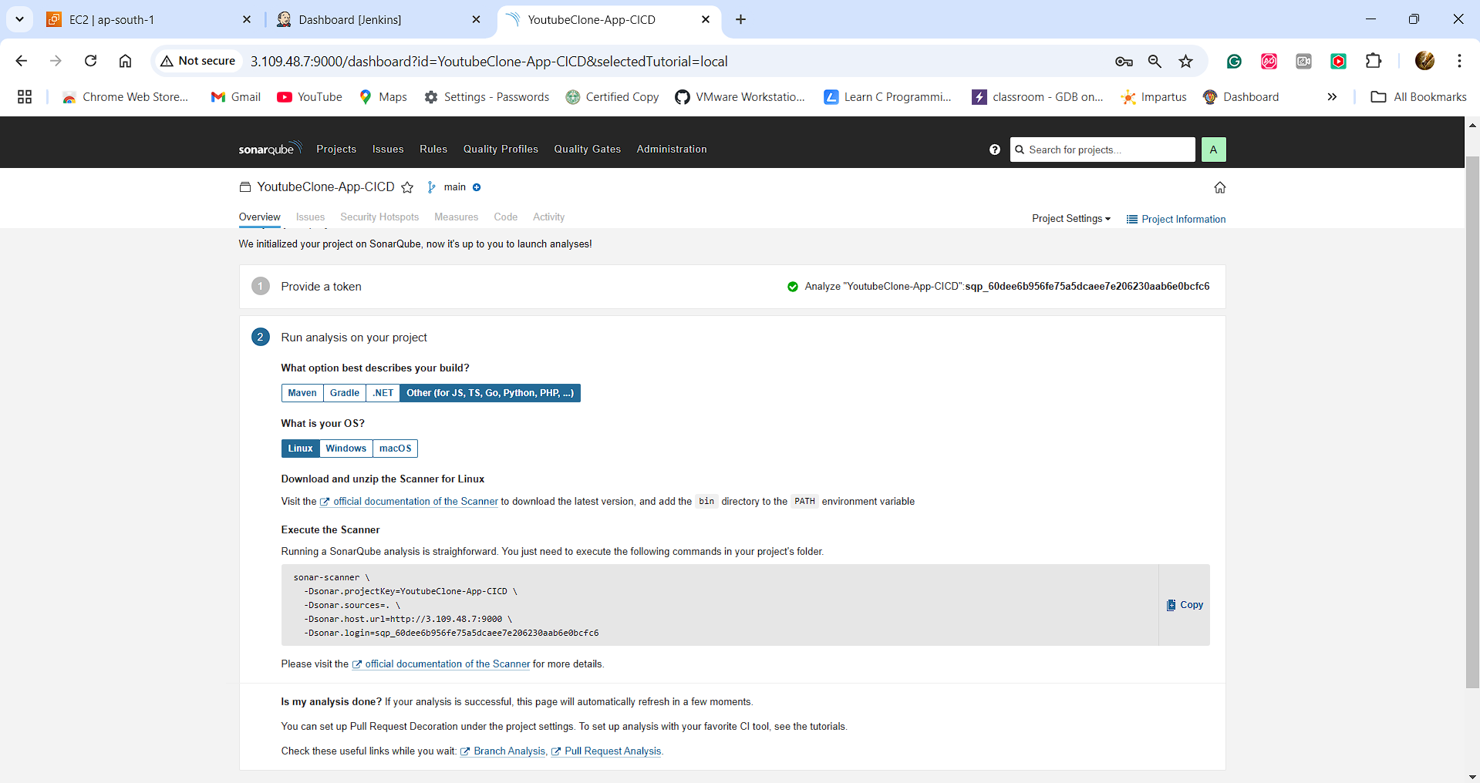

**Go to Jenkins Dashboard:**

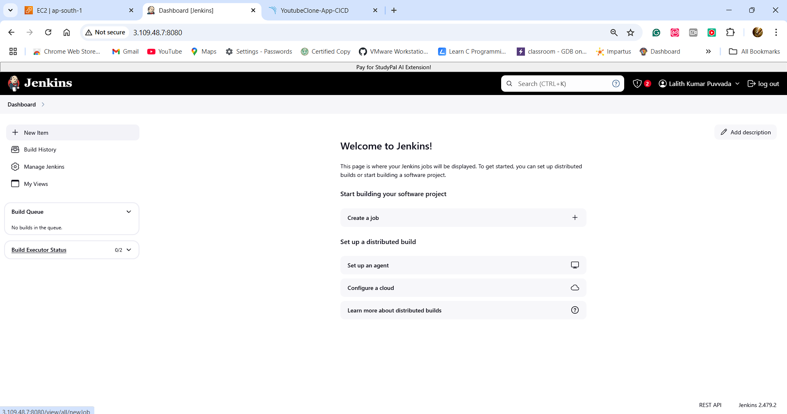

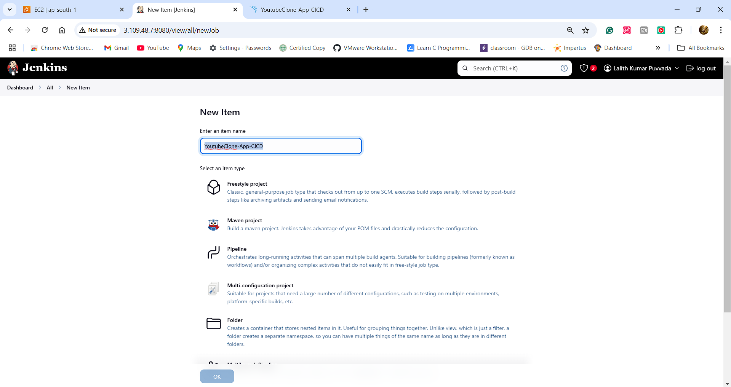

**Select Pipeline**

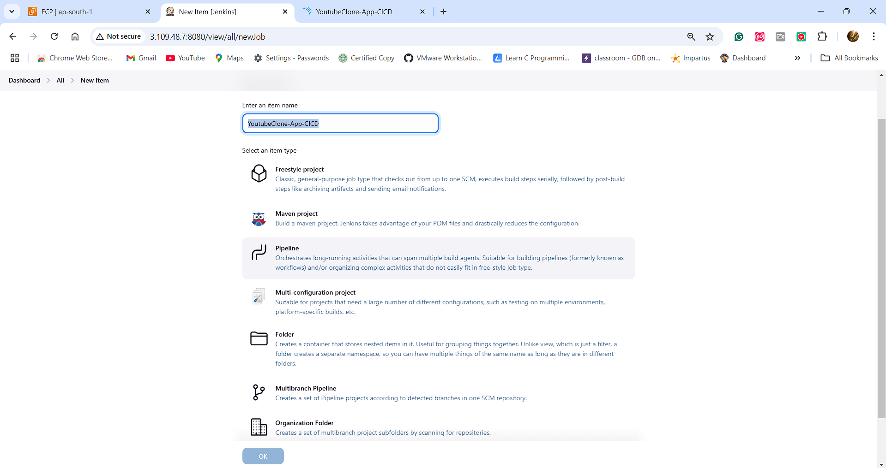

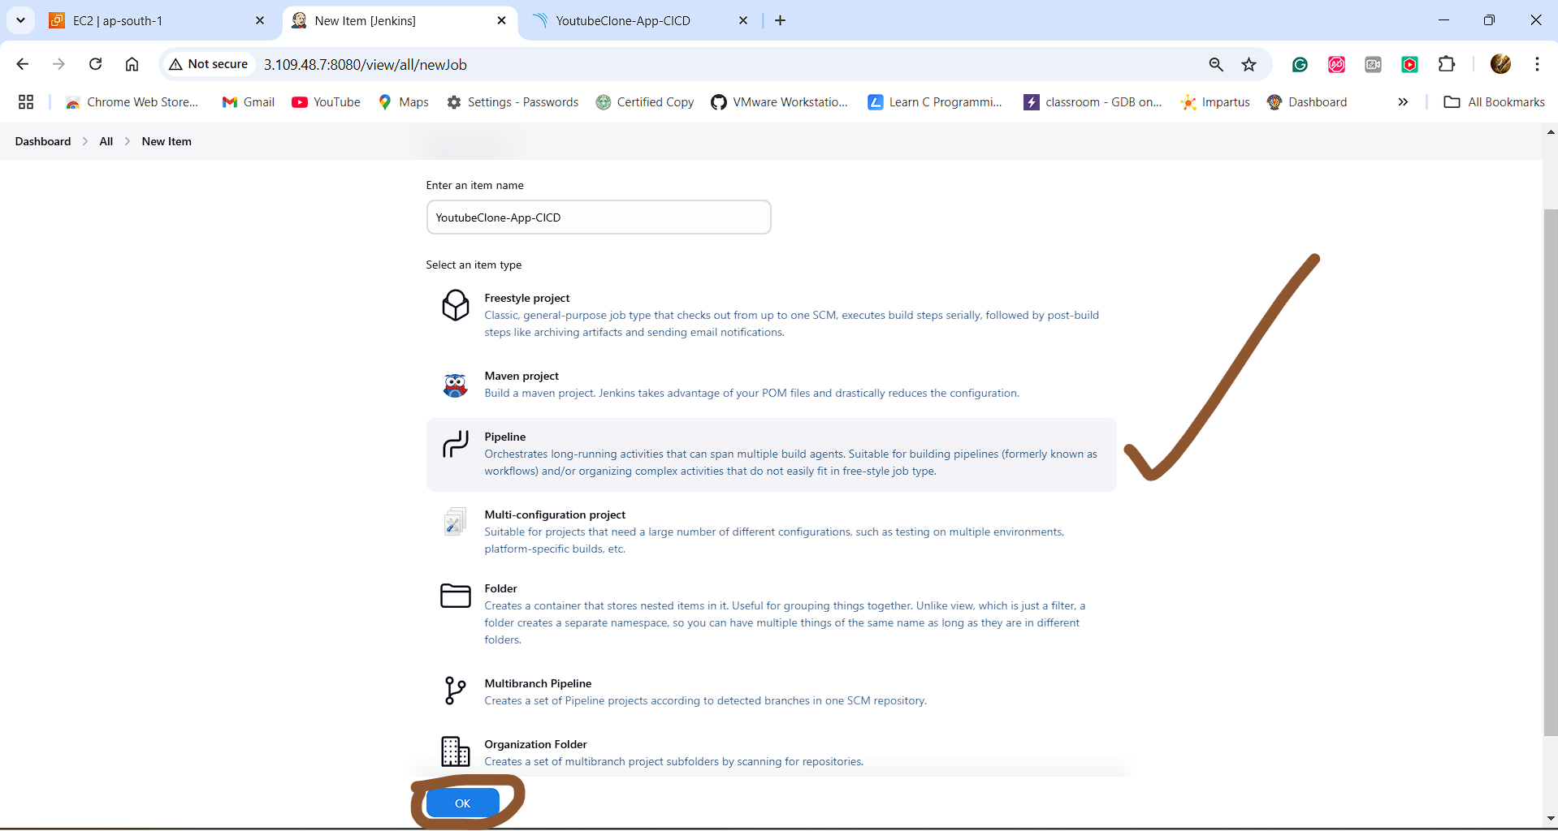

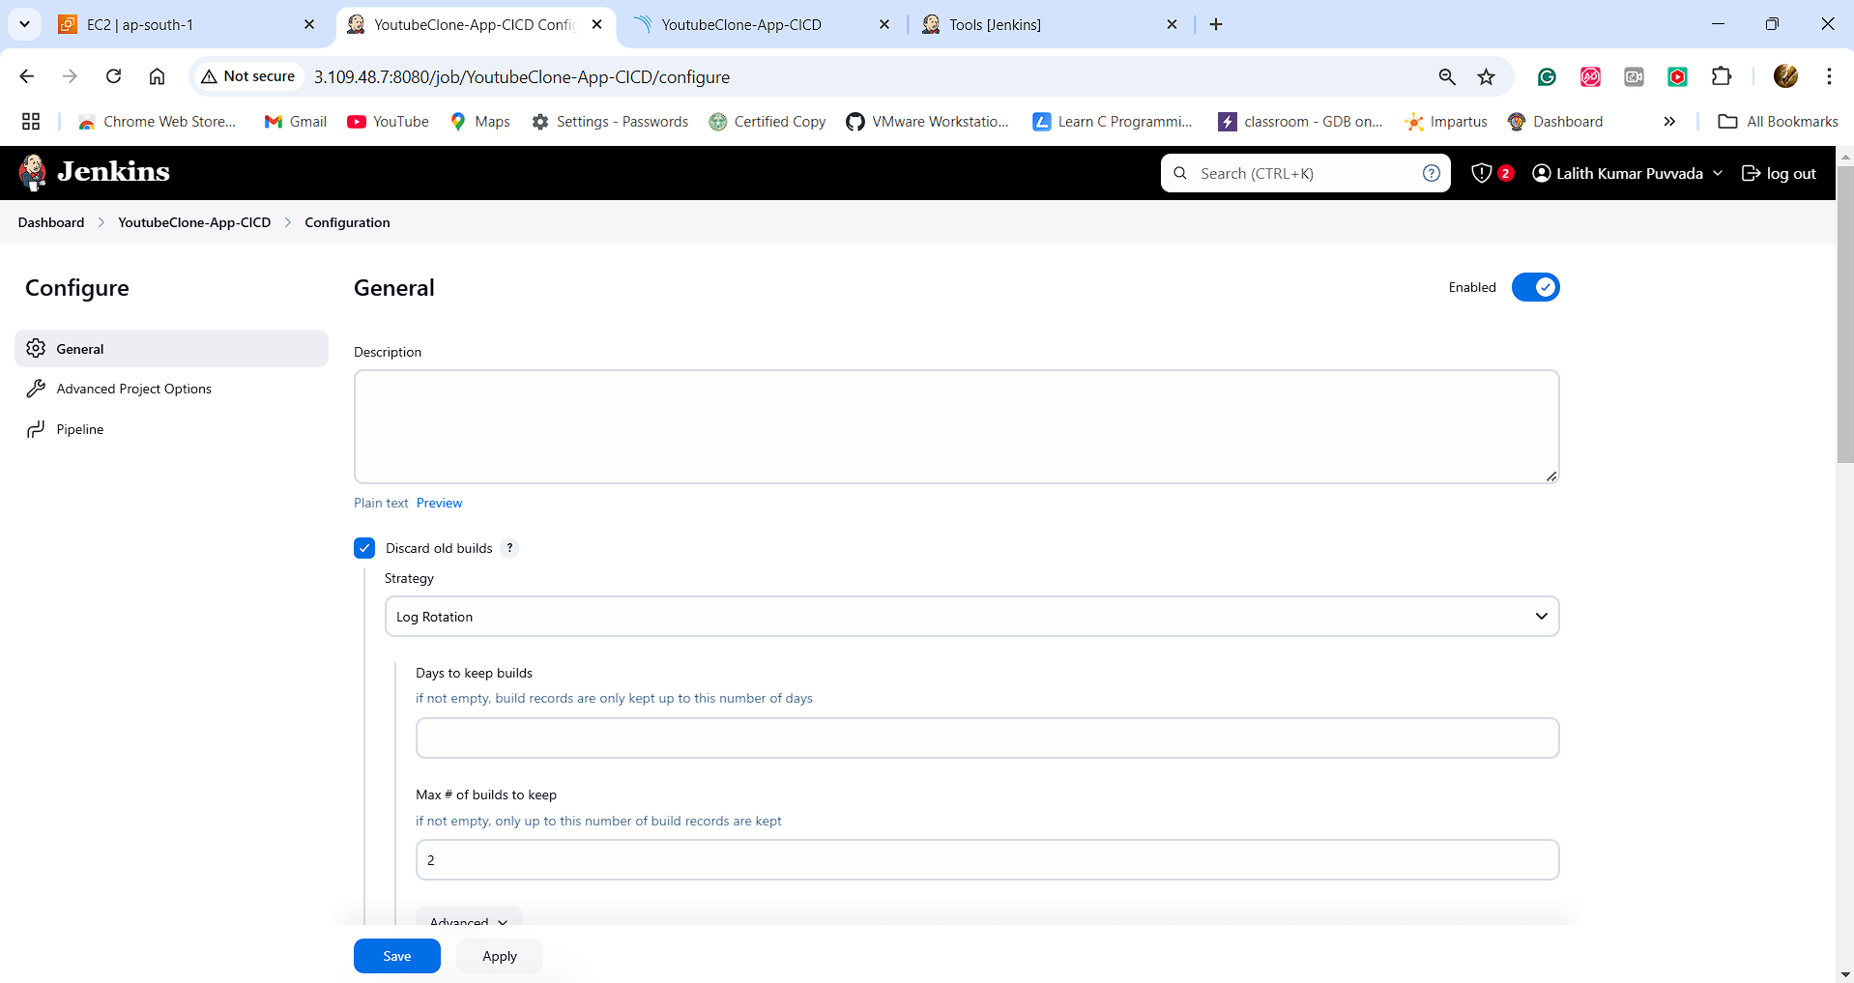

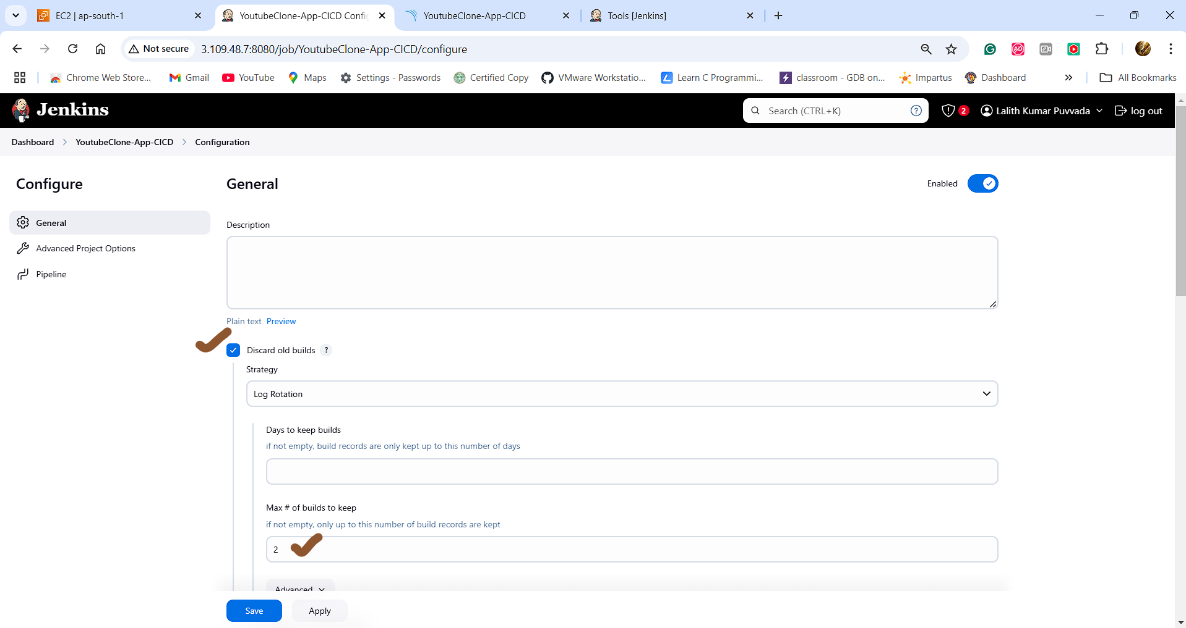

**Copy the below pipeline script under Pipeline:**

**pipeline {**

**agent any**

**tools {**

**jdk 'jdk17'**

**nodejs 'nodejs16'**

**}**

**environment {**

**SCANNER_HOME = tool 'sonarscanner'**

**}**

**stages {**

**stage('Clean Workspace') {**

**steps {**

**cleanWs()**

**}**

**}**

**stage('Checkout from Git') {**

**steps {**

**git branch: 'main', url: 'https://github.com/Lalith-Rockzz/Youtube_Clone_App_Main.git'**

**}**

**}**

**stage("SonarQube Analysis") {**

**steps {**

**withSonarQubeEnv('SonarQube-Server') {**

**sh '''$SCANNER_HOME/bin/sonar-scanner -Dsonar.projectName=YoutubeClone-App-CICD \**

**-Dsonar.projectKey=YoutubeClone-App-CICD'''**

**}**

**}**

**}**

**stage("Quality Gate") {**

**steps {**

**script {**

**waitForQualityGate abortPipeline: false, credentialsId: 'SonarQube-Token'**

**}**

**}**

**}**

**stage('Install Dependencies') {**

**steps {**

**sh "npm install"**

**}**

**}**

**stage('TRIVY FS SCAN') {**

**steps {**

**sh "trivy fs . > trivyfs.txt"**

**}**

**}**

**stage("Docker Build & Push") {**

**steps {**

**script {**

**withDockerRegistry(credentialsId: 'dockerhub', toolName: 'docker') {**

**sh "docker build -t youtube-clone ."**

**sh "docker tag youtube-clone lalithrockzz/youtube-clone:latest"**

**sh "docker push lalithrockzz/youtube-clone:latest"**

**}**

**}**

**}**

**}**

**stage("TRIVY Image Scan") {**

**steps {**

**sh "trivy image lalithrockzz/youtube-clone:latest > trivyimage.txt"**

**}**

**}**

**stage('Deploy to Kubernetes') {**

**steps {**

**script {**

**dir('Kubernetes') {**

**withKubeConfig(caCertificate: '', clusterName: '', contextName: '', credentialsId: 'kubernetes', namespace: '', restrictKubeConfigAccess: false, serverUrl: '') {**

**sh 'kubectl delete --all pods'**

**sh 'kubectl apply -f deployment.yml'**

**sh 'kubectl apply -f service.yml'**

**}**

**}**

**}**

**}**

**}**

**}**

**post {**

**always {**

**emailext attachLog: true,**

**subject: "'${currentBuild.result}'",**

**body: "Project: ${env.JOB_NAME}<br/>" +**

**"Build Number: ${env.BUILD_NUMBER}<br/>" +**

**"URL: ${env.BUILD_URL}<br/>",**

**to: 'www.lalithrockzz@gmail.com',**

**attachmentsPattern: 'trivyfs.txt,trivyimage.txt'**

**}**

**}**

**}**

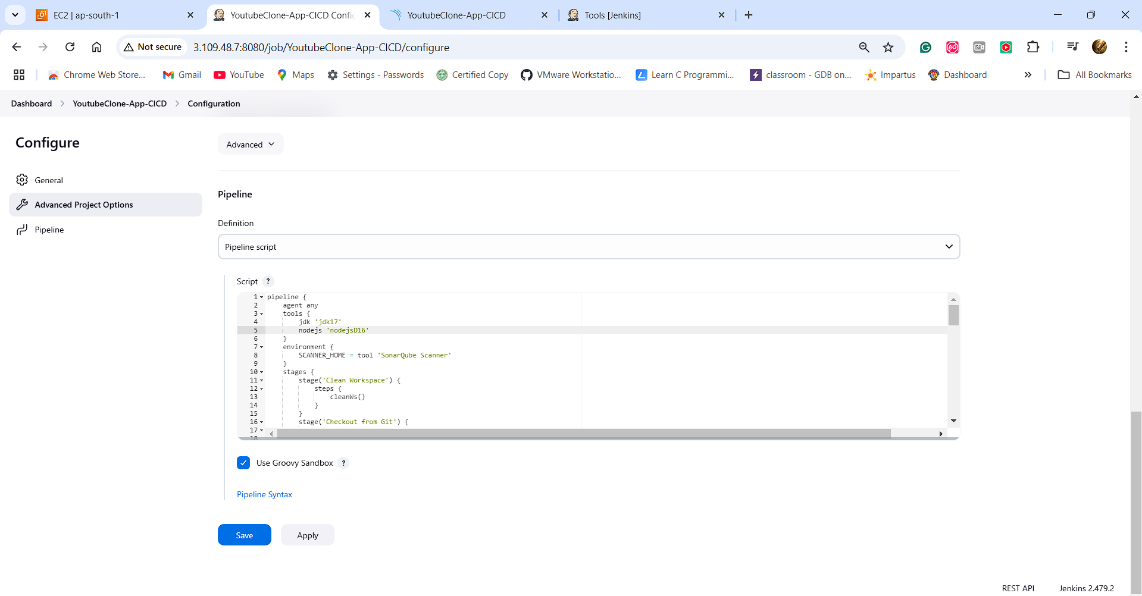

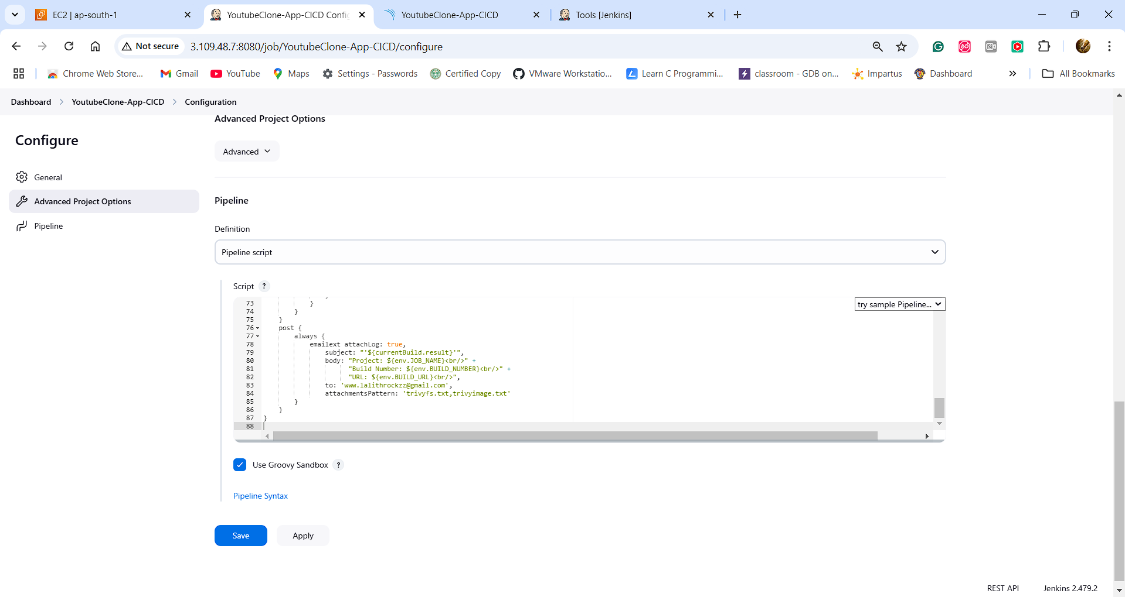

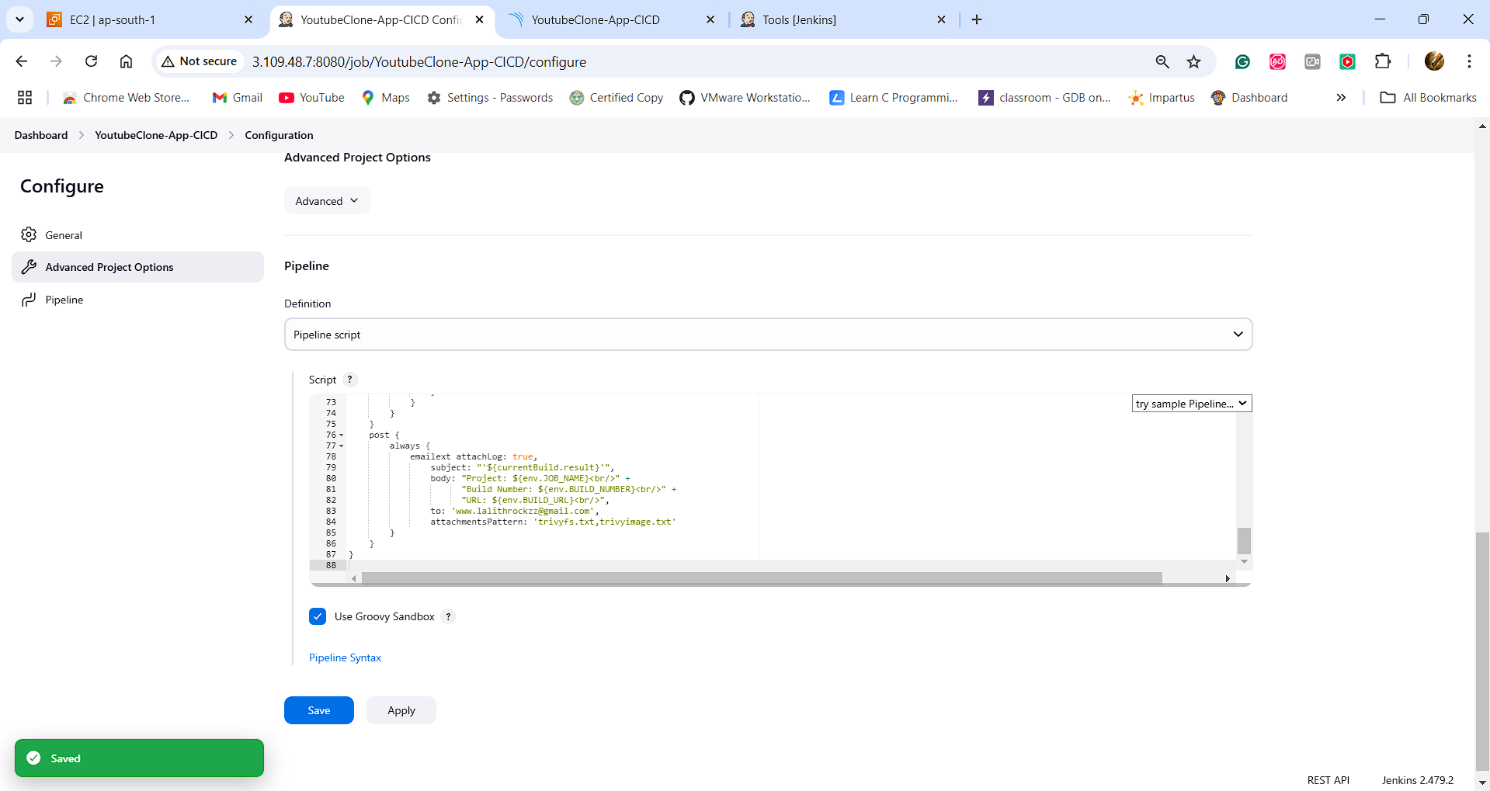

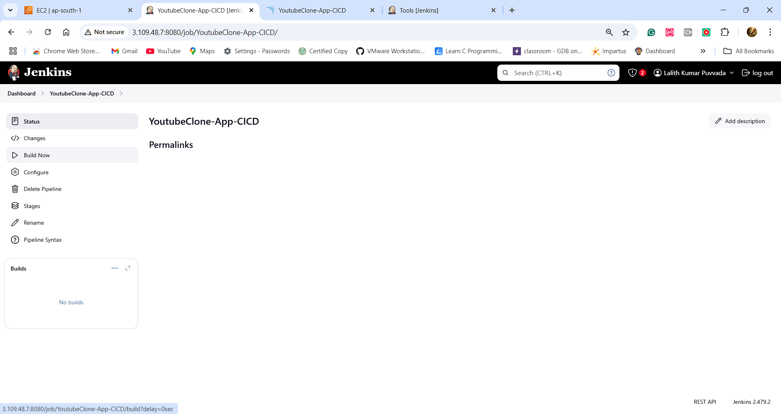

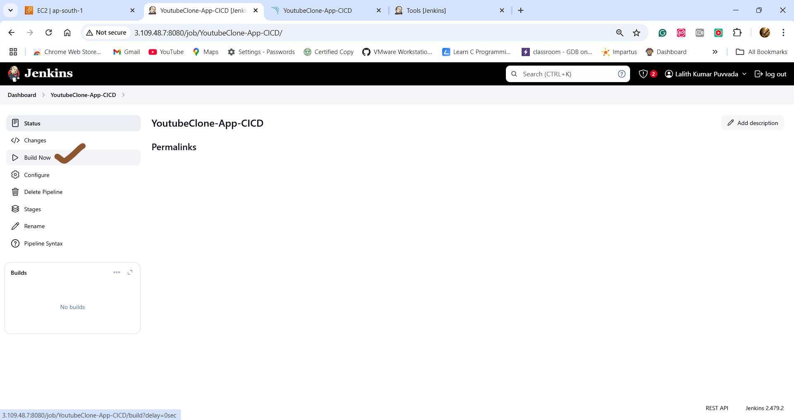

**PART -2: Yet to be Finished**

**PART-2 Next Plan of Work:**

1. Create EC2 Instance and Setup Prometheus & Grafana using Terraform Script
2. Setup Email Notification Through Jenkins
3. Create AWS EKS Cluster – (Kubernetes)
4. Integrate Prometheus with EKS and Import Grafana Monitoring Dashboard for Kubernetes
5. Configure the Jenkins Pipeline to Deploy Application on AWS EKS(Kubernetes)
6. Set the Trigger and Verify the CI/CD Pipeline